

**KAMPALA**

**INTERNATIONAL**

**UNIVERSITY**

**COLLEGE OF ECONOMICS AND MANAGEMENT**

**COURSE OUTLINE FOR STRATEGIC MANAGEMENT**

**COURSE CODE: BUS 7101**

**LEVEL: POST GRADUATE — MASTERS/ PGD**

**FACILITATOR: DR. CHRIS UKAIDI**

**Contact: ukaidichris@kiu.ac.ug**

**Phone: +2348037208660/0708266898**

**COURSE DESCRIPTION AND PURPOSE**BUS 7101 ( Strategic Management) is an interdiciplinary program for Students in various  
Departments and Colleges. The course is divided into 8 study units. This course is designed to prepare students  
for their roles as Managers, Policy makers and Business Analysts in the Industries and Commerce. It introduces them to the various Business and Management Principles and how they can be effectively applied and controlled in the industries.  
This course guide therefore provides the student with an overview of what BUS 7101 is all about, the textbooks and other materials to be referenced, what you expect to know in each study unit and how to work through the course materials. You are welcome to one of the interesting courses you will offer during your study in KIU, for the School of Online & and Distance Education in East and Southern Africa, (SODEESA), Uganda.

**COURSE OBJECTIVES**  
It is important to note that each study unit has specific objectives. Students should study them carefully before proceeding to subsequent unit. Therefore, it may be useful to refer to these objectives in the course of your study of the unit to assess your progress. You should always look at the study unit objectives after completing the unit.  
In this way, you can be sure that you have done what is required of you by the end of the study unit.

**LEARNING OUTCOMES**

On completing this course, you should be able to:

|  |  |
| --- | --- |
|  | Explain The nature of Business Strategy  Key Terms in Strategic Management Discuss the various areas of study in Strategic Management  The Strategic Management Model Explain the Benefits of Strategic Management  The pitfalls in Strategic Management  Comparing Business and Military Strategies Enumerate the Theories and Theorists of Business Strategy. What are the concepts of Global Competition The Stages of Strategic Choice, Strategic , Strategy Evaluation and Strategy Implementation. |

**COURSE CONTENTS**

**NATURE OF BUSINESS STRATEGY**

**SCOPE OF BUSINESS STRATEGY**

**PURPOSE OF STRATEGIC OBJECTIVES**

**DELIBERATE AND EMERGENT STRATEGIES**

**THE STRATEGIC STAGES OF STRATEGY DEVELOPMENT**

**EXTERNAL ENVIRONMENTAL FACTORS**

**INTERNAL ENVIRONMENT FACTORS STRATEGIC CHOICE, EVALUATION MODELS AND STRATEGY IMPLEMENTION**

**Working Through This Course**: In order to have a thorough understanding of the course study units, you will  
need to read and understand the contents and practice what is discussed in this module.  
This course is designed to cover approximately fifteen weeks and it will require your devoted attention. You  
should do the exercises in the Tutor-Marked Assignments and submit to your Lecturer.

**Teaching and Learning Materials**

|  |  |
| --- | --- |
|  | Course Guide |
| •  | Printed Lecture materials |
| •  | Text Books |
| •  •  | Interactive DVD and Tapes Electronic Lecture materials  Tutor Marked Assignments |

**RECOMMENDED READING MATERIALS**:  
1] Business Strategy By Laurie J. Mullins.  
2] **Stategic Management** By DR. MARTIN A. OPARAOCHA.  
**FORMAT OF THE COURSE:** ClassRoom Lectures**,** Group Discussions, Personal Research Presentations, Assignments, Tests and Examination.  
**COURSE WORKS /PRESENTATIONS: 20%TESTS: 20% FINAL EXAMINATION: 60%**

**INTRODUCTION**

**CHAPTER ONE**

**Nature of business strategy**

**Introduction:**

How would you feel if you were on the cockpit of a plane and the only information you had was speed?

Similarly, how would you react if you were told by your company’s shareholders to achieve a market share of 40% in 2 years?

Before you start your flight, whether in a cockpit or in business, you need to know your starting point, your destination and how to get there. This is strategic management.

**Key definitions**

The term strategy came to be associated with business after the Second World War Military and business leaders from both sides of the Atlantic assessed if the successful aspects of military campaign could be applied to business. Here are some quotes on strategy that have their roots in the military context.

The art of planning and directing military movements and the operations of war.

Brue and Langdon (2000)

A strategy maps out the future, setting out which products and services you will take to which markets and how.

Brue and Langdon (2000)

Strategy is about what we want to do, what we want our organization to be and where we want it to go.

Norton and Irving (1999)

As with military strategy, business strategy is concerned with a company’s attempts to plan its future, using a variety of techniques (as in a war) to arrive at a desired state.

Strategy can be thought of as a long term plan of action or execution designed to achieve particular objectives, such as achieving competitive advantage for an organization. It reflects the values, expectations and goals of those who are in power within the organization.

An important distinction to make at this point is between the strategic and tactical management. Tactical measures are usually short-term, whereas strategy is long-term. In the context of business, a tactical measure may, for example, involve aggressive price-cutting in order to grab market-share and remove a competitor. A strategic move, on the other hand, may be an acquisition in order to move into a new market area. As series of tactical measures can help achieve the long-term strategy.

Strategy gives business direction. This enables a firm to identify how best to match its competencies to the needs and opportunities in the market places.

Strategic management involves diverse and often creative processes in an attempt to address the increasing complexities facing organizations. It embraces a range of concepts, models and approaches.

**Role of strategy**

Without a strategy, it is argued that a firm will not know where it is going. You can appreciate the tendency for an organization to get bogged down in the day-today operations of its business, alongside the further tendency to continue operating in was it has always worked with in the past.

The central role of nay business organization is the achievement of superior long-term return on investment. Otherwise why bother being in business at all? To achieve this long term aim, a business should have a strategy.

Strategy is sometimes described as the direction and scope of an origination over the long-term: Ideally, matching its resources to its changing environment and in particular its markets, customers or clients so as to meet stakeholder’s expectations.

Strategy then is a set of guidelines that directs the managers in organization to reach their desired long-term positions. It comprises the objectives that are sought for the business and the strategic ideas that are required to accomplish the objectives. This can be summarized as;

* Where do we want the business to be? – The objectives
* How can we ensure the business gets there? – The strategy.

Strategy safeguards against short-termism; the tendency to ‘just get things done’ and get bogged down in the day – to – day operations of a business. Having a strategy means that a company can ensure that its day – to – day decisions and actions fit within the long-term ambitions and interests of the organization. Lack of strategic direction can lead to opportunities arising in the market place being missed, or inappropriate opportunities being sought at great expense.

Andrews (1989) offers a further definition of strategy

Strategy is the pattern of objectives, purposes or goals, and the major policies and plans for achieving these goals, stated in such a way as to define what business the company is in, or is to be in and the kind of company it is, or is to be.

**Top tips**

Strategic management is knowing:

* Where you are
* Where you want to be
* How to get there

My learning space activity

**The bird approach**

Start with the entire world – scan it for opportunities to seize upon, trying to make the best of what you find.

You will resemble a bird, searching for a branch to land on in a large tree, you will see more opportunities than you can think of. You will have an almost unlimited choice. But your decision, because you cannot stay up in the air forever, is likely to be arbitrary and because arbitrary, it will be risky.

**The squirrel approach**

Start with yourself and your company – where you are with the skills and experiences that you have and what you can do best in this approach you will resemble a squirrel climbing that same large tree. But this time you are starting from the trunk, from familiar territory, working your way cautiously tree fork by tree fork, deciding at each form the branch that suits you best.

You will only have one or two alternatives to choose from at a time – but your decision because it is made on a limited number of options, is likely to be more informed and less risky.

In contrast with the bird who makes single big decisions, the squirrel makes many small ones. The squirrel may never become aware of some of the opportunities the bird sees, but he is more likely to know where he is going.

1. Summarize the approaches in relation to contemporary business.
2. Make notes as to whether you recognize either of the approaches to strategic management in your own organization. Can you identify the reason for this? Who is involved in these approaches?

**Feedback**

The squirrel approach is one of incremental change or emerged strategic: small steps in response to changes in the macro-environment, matching your organizations competencies and capabilities with that of the environment. The bird approach, on the other hand, is a radical shift a big strategic change one that may require significant restricting of a company’s resources and capabilities and one that may be at variance with current direction. It is one that holds more risk but bigger returns, if successful.

Your response the question 2 will be personal and depend on your organization.

**Research activity**

Research the history and development of IKEA, or another well known multinational retailer, and write a brief report detailing the strategic direction adopted by the organization.

1. In what way could the issues facing IKEA or another retailer be described as strategic?
2. What sorts of decisions are strategic decisions and what distinguishes then from other decisions that were no doubt being taken in the company?

Using your answers, summarize the key characteristics of strategic decisions. For information on IKEA, visit their website: http/www.ikea.com. also check out references to IKEA in Johnson and Scholes (2002).

**Strategic decisions are concerned with;**

* The values and expectations of the organization’s key stakeholders.
* The direction an organization moves in the long term.
* The scope of an organization’s activities.
* The matching of an organization activities to its environment.
* Building on or ‘stretching’. An organization’s resources and competences
* The matching of the activities of an organization to its resources capability.
* The major allocation and reallocation of resources in an organization.

Strategic decisions will have implications for change throughout the organization. Changes can be complex and far reaching and sometimes require significant organizational transformation.

Another term encountered when discussing the nature of strategic management is strategic drift, it describes the variation in the circumstances of the business environment over a period of time compared with the intent of the original strategy.

**Strategic plan Strategic drift**

**Actual performance**

**Fig 1.1.1 – strategic drift**

For example, a market trend may develop which will provide a shift in the market direction, if the strategy is not adapted to conform with these changes then a significant gap will develop between the intended strategic aim and the perceived position within the market. Such a process is described as the strategic drift.

Other terms in this context are

**Knowledge check**

Strategic wear – out

Strategic wear-out describes the phenomenon of strategic lifespan. Any strategy is at risk of becoming outdated if it is not regularly monitored and evaluated. Market forces and performance may change in unpredictable ways and so the strategy formulated must be flexible. Without suitable monitoring and evaluation, the strategic direction will fail to follow any subtle changes in the market performance and hence, not provide the intended results. Strategic wear-out is a common falling of many business strategies.

Synergy

Synergy deal with evaluating the combined effects of actions resulting, for example from the addition of new product – markets to the firm. In business literature it is often described as the 12 + 2 = 51 effect denote the fact that the firm seeks a product-market posture with a combined performance that is greater than the sum of its parts.

**CHAPTER TWO**

**SCOPE OF BUSINESS STRATEGY**

**Different levels of strategy and change**

Mintzberg and Quinn (1998), in The Strategy Process, Concepts, Contexts, Cases, present five definitions of strategy. The so-called Five Ps for strategy see strategy as a;

**Plan:** A path to get from here to there

**Pattern:** Consistency in behavior over time

**Position:** Particular products in particular markets

**Perspective:** An organization’s way of doing things

**Ploy:** A particular type of plan intended to send specific signals

**Assignment:** Consider the differences between intended and realized strategies**.** Give examples of how these are, or have been evident in your own organization.

**Strategic vision:** Some organizations are led by an executive with specific visionary powers. But what exactly are such powers?

The concept of visionary management revolves around those executives with intuitive abilities and who when appointed to the organization, apply their own frame of reference to that organization.

**Assignment:** What do you consider is meant by the term strategic vision?Using the Group Learning Space, discuss your views with others.

Determine to what extent you achieved a consensus. What do the similarities or differences in opinions illustrate in terms of understanding the concept of strategic vision?

Strategic Vision

Corporate Objectives

Corporate Strategy

Business Strategy

Operational Strategies

Finance

Marketing

Production

Plans

Plans

Plans

**Figure 1.2.1 – A framework for strategy** Following from the overall strategic vision, the strategy is then developed via the associated levels within the organization.

Ansoff .H. (1969) compares the principal decision classes with references to a sample problem.

**Strategic decision**

**Problem**

* To select product-market mix which optimizes firm’s ROI potential

**Nature of problem**

* Allocation of total resources among product – market opportunities

**Key decisions**

* Objectives and goals
* Diversification strategy
* Expansion strategy
* Administrative strategy
* Finance strategy
* Growth method
* Timing of growth

**Key characteristics**

* Decision centralized
* Partial centralized
* Decision non-repetitive
* Decisions not self – regenerative

**Administrative decision**

**Problem**

* To structure firms’ resources for optimum performance

**Nature of problem**

* Organization acquisition and development of resources

**Key decisions**

* Organization structure of information, authority and responsibility flows
* Structure of resources conversion, work flows, distribution system, facilities location
* Resource acquisition and development; financing, facilities and equipment, personnel raw materials

**Key characteristics**

* Conflict between strategy and operations
* Conflict between individual and institutional objectives
* Strong coupling between economic and social variables
* Decisions triggered by strategic and / or operating problems

**Operating Decision**

**Problem**

* To optimize realization of ROI potential

**Nature of problem**

* Budgeting of resources among principal functional areas
* Scheduling resource application and conversion
* Monitoring and control

**Key decisions**

* Operating objectives and goals
* Pricing and output levels
* Operating levels; production scheduling, inventory levels, warehousing etc
* Marketing policies and strategy
* R & D policies and strategy
* Control

**Key characteristics**

* Decentralized decisions
* Risk and uncertainty
* Repetitive decisions
* Large volume of decisions
* Sub-optimization forced by complexity
* Decisions self-generative

In turn these decision classes can then be linked to the relevant levels of strategic change. Measuring Change and persistence in Human Affairs (Golembiewski et al). suggest three fundamental approaches to change.

**Three approaches to change:**

**Alpha change**, which is fairly superficial and sometimes referred to as “beauty parlour” approach to change. It really only looks at symptoms and is essentially a reactive change applied over a wide range of issues. An example, from IT-driven change at this level would be the installation of web/online access to all desktops in an office situation. This might increase efficiency and even in some cases effectiveness in the productive of required materials – although it can lead to an excess of information but little else.

**Beta change**, which goes a level deeper. It is liable to be much more systematic and planned, and can be organizations-wide in its implications. It is however, essentially single-loop in its intent – it gets an improved state of organizational operation but essentially the organization and its members do not undergo fundamental change – they are shaken but not stirred! In IT-driven change process improvement would be an example of this level of change.

**Gamma change** is fundamental change. The organization undergoes a paradigm shift so that the organization turns out to be fundamentally different. There is significant culture change and the members of the organization learn to relate to each other in different ways. In IT driven change, an example would be process innovation which is radical change. It is immediate but because it is radical it has a long time span.

**LEVELS OF PLANNING**

Planning can be viewed at three cascading levels

Top-level planning (strategic)

Second-level planning (tactical)

Third-level planning (Operational)

**Figure 1.2.2 – Cascading levels of strategy**

1. Top-level planning – this is done by top management- that is the board of directors or other chosen corporate ‘centre’ – and is often termed ‘strategic’ planning. It encompasses the long – range objectives and policies of the organization and is concerned with corporate results rather than achievements of individual departments. Top – level planning is almost entirely long-range and is closely linked to long term goals. It is sometimes referred to as the ‘what’ component of the planning activity.
2. Second – level planning – this is carried out by senior executives and is sometimes known as ‘tactical’ planning. Just as strategic planning is concerned with ‘what’. So tactical planning is concerned with ‘how’. This means that it is involved with planning the deployment of resources to the best advantage. Tactical planning is concerned primarily, but not exclusively, with long-range planning. But its nature is such that the time spans are usually shorter than those of strategic planning. This is because its attentions are usually devoted to the gradual attainment of the organization’s main objectives. In this way, the very long-range plans of top management are segmented. It is in fact oriented to functions and departments rather than to the organization as a whole.
3. Third – level planning – this is frequently called ‘operational’ or ‘activity’ planning and is the concern of departmental managers and supervisors. It is confined to very short-term activities involving departmental operations and also individual assignments, as well as establishing performance controls in some cases.

**Corporate strategy**

Corporate strategy is used to build advantage over other organizations. It relies on the effectiveness of the corporate centre. Correctly used with consistent and selective thought. Corporate strategy can have a number of benefits such as;

* Highlighting possible short-term and long-terms remedies for firms in financial difficulties.
* Determining when an organization is at a decision point and in which direction it should go for future success.
* Selecting appropriate acquisitions that will enhance shareholder wealth
* Providing a system for successfully integrating acquisitions and improving performance
* Demonstrating which businesses have the greatest value, which should be developed and invested in and which should be disposed off.

Conversely, poor corporate strategy can become unwieldy and do more damage than good. It can result in loss of corporate value and in extreme cases, lead to closure.

**Business strategy**

Business strategy is designed to provide for internal department development to reach a common goals. This is probably the most efficient use of strategy as it involves more direct monitoring and evaluation by managers closer to the operation of their particular function. Any evident of strategic drift, or wear-out, is likely to be detected quickly and also likely to be less costly to the organization than in the case of corporate strategy.

**Operational strategy**

It is important to understand the relationship between corporate strategy and operational strategy. Corporate strategy is a plan that is set out for the whole organization. It is largely concerned with the means by which an organization will be able to achieve its total objectives.

In order to achieve its overall aims, a company must ensure that objectives and subsequent strategies and adopted at each level of the business, and that is operational strategy.

**Business level objectives**

-Strategy

-Responsibility

**Corporate level objectives**

-Strategy

-Responsibility

**Divisional level objectives**

-Strategy

-Responsibility

**Unit level objectives**

-Strategy

-Responsibility

**Figure 1.2.3 – strategy relationships in operation**

Another way to consider business strategy in an organization is to divide into three levels.

**Knowledge check**

**The corporate level**

* Defining the corporate mission
* Identifying strategic business units
* Analyzing / evaluating product / service portfolio
* Identifying new business areas.

**The business unit level**

* Indentifying product market
* Implementing corporate strategies.

**The functional level**

* Implementing corporate and business unit strategies
* Extending functional expertise to assess product markets

**Inter and external links**

Managers and ‘change agents’ filter out and create their own understanding of external ‘realities’ Any triggers of strategic change are topics for interpretation so that organizational members can map out the way forward and the direction of change – and of course, they often do not agree. The basic choice, in response from triggers from the environment, is to take either a proactive or a reactive stance.

Generally strategists take a proactive stance – to be ahead of the game – in terms of making decisions about objectives, in deciding what is needed to achieve these objectives, and in bringing about the changes that are necessary in order to implement the objectives successfully. However, this is not to say that a proactive stance is always appropriate. People responsible for managing strategic change need to develop the ability to recognize when proactive and reactive change is most appropriate. It may well be that the best approach to proactivity or reactivity is to adopt an approach to change that is essentially pragmatic.

**My learning space activity**

Consider the corporate, business and operational levels of strategy as applied to your own organization. Identify examples of issues, which your organization should/does address when considering activities at each level.

Give reasons why or why not you consider a significant mismatch is evident at any of the levels.

|  |  |  |  |  |
| --- | --- | --- | --- | --- |
| LEVEL | TYPE OF ACTIVITY | ORGANIZATIONAL ISSUES (Does Address) (Should Address | | MISMATCH |
| Corporate |  |  |  |  |
| Business |  |  |  |  |
| Operational |  |  |  |  |

Figure 1.2.7 – My learning space activity

**CAPTER THREE**

**PURPOSE OF STRATEGIC OBJECTIVES**

**Purpose**

Strategic management underlines the need for organizations to have overall medium-term objectives that can unite effort and focus on what that organization as a whole is trying to achieve. The purpose should utilize the organization’s existing forward momentum (if present) and help to guide individual behavior.

**Strategic purpose is associated with Strategic direction**

Strategic direction can often be expressed in some convenient form such as Henry Ford’s aim in 1909 to democratize the automobile or coke’s objectives of having its drink within arm’s length of every consumer in the world. Even to take a more extreme case to follow Honda’s directive to smash Yamaha. Any chosen direction should incorporate a timeframe of no less than two to four years but more realistic may extent as far as ten years and beyond.

**Strategic focus**

A fundamental principle of strategic is its focus. Smaller organizations in particular must focus ob a small number of business segments where they can be the largest. Even larger organization could raise their profit and Markey value by use of clear focus on the things they do best and most profitably. an example of focus and its associated determination comes from sharp. as a pioneer of liquid crystal technology in the electronic calculator industry, it was one of perhaps forty five rival organizations. as a result of tight focus on producing narrow pocket-sizes calculators with large capacity, it has seen off almost all its rivals, leaving sharp with only one true competitor in this field.

**Strategic realignment/diversification:** Organizations need to develop strategies that will allow for product realignment in diversification. The driving force behind such a move will usually be financial, based on changing management skills or company expertise; such realignment may not always be immediately obvious. Cumin’s the world-renowned leader in diesel engines entering the ski resort development market, or coca cola buying the film industry organization Columbia pictures. However, all such realignment builds on competitive advantage in core businesses and reinforces rather than detracts from that by strengthening still further the competencies that drive success in the existing organizations. Consider the development over recent years of the product or services offered by marks and Spencer. The move to add to the existing clothes retailer business a fairly narrow in of up-marked foods, household’s goods and financial services has had a mixed reception. Indeed the need for such diversification has not yet been fully satisfied and the company continues to lose its prestige place in high street.

**Research activity**

Research two examples of organizations undertaking diversification into unusual markets. Consider how the original core businesses have been realigned in accordance with the changes

**Feed back**

There are numerous examples that could be considered. Here are a few.

**Gillette:** Extending its interests in shaving products to all toiletries, including deodorants etc

**Hanson:** Textiles growing to maximize cash in low technology business.

**Sony:** Transfer radios moving to all domestic electronics and advanced computer components.

**McDonald’s:** Realigning from simple hamburgers to a range of fast food including innovations such as salads, breakfast etc.

The emphasis on strategic management must come from the top of the organization. it is the responsibility of the leadership of the business to communicate the strategic vision and the provide the guidelines needed for implementation. Without this there will be little chance of strategies being implemented and successions.

Control is always an important function of organizational design and most importantly in the area of strategy. Control processes make it possible to ensure that objectives are being met and to mark any necessary changes to strategy as and when appropriate.

**Think about it**

Thus far it has been argued that all organizations –large or small, public or private service or manufacturing based –need a clear strategy to ensure their future. But do all organizations really need a strategy?

**Can you think of circumstances where a company would not need to adopt a strategy?**

**Explain your reasoning**

**Feed back**

It can be argued that in certain circumstances an organization will not need a strategy:

* Those organizations that do not face any competition
* Those organizations that are actually in total of their own destiny-if this is possible in today’s business world.
* Those organizations that are in little affected by changes in the business environment.
* Those organizations that are in a business environment that doesn’t change-if there is such a circumstance.

Taking account of the context of the vast majority of business organizations it is perhaps evident that the adoption and use of business strategy is that most appropriate approach. this is the standpoint that will be taken through the remainder of this module

**Synergy**

Another critical consideration in strategic management is synergy. Earlier we encountered synergy as the additional benefit gained when two events or entities can be inter related. the 2+2=5 relationships reflects the positive effect of synergy, but do not overlook the alternative approach where 2+2=4 or even 3 in the case of negative synergy!

There are two different types of synergy:

* knowledge check
* structural synergy

Structural synergy is combining resources to lower costs or increase revenues. it is not uncommon to see cost saving of 15 to 25 percent or revenue gains of 20 to 30 percent as a result of structural synergy operations.

**Management synergy**

Management synergy is where any improvement is the direct result of better management usually without any structural change. For example two forces combining will save costs, or when one company is able to sell its products through another company’s distribution network, thus raising revenues and reducing costs for both companies. When one company acquires another and put its existing management systems in place, costs may be reduced. Managers are able to have greater responsibility and budgets can be reviewed with effect that cost reduction can be effected. Management synergy will rarely directly produce revenue increase.

Synergy is often associated with acquisitions and mergers, but can be independently through collaborative initiatives. for example synergies can be gained through joint ventures, strategic alliances closer relationships with suppliers etc. Such synergies are often referred to as cheap synergies as they often cost little to achieve in financial terms.

**Top tips**

Synergy is any unrealized potential open to a group from better collaboration and more efficient mixing of resources.

My learning space activity

Describe an example of organizations working together as examples of synergy.

Explain why the link was advantaged to both organizations and what would have been the likely outcomes if the link had not been made.

Feed back.

There are many possible examples to choose from. you may have considered:

* Trust house and fort
* Kentucky field chicken and Mitsubishi
* McDonalds and Fujita
* Fuji and Xerox
* Smith Kline and Fujisawa pharmaceuticals

Strategic objectives is what you want to achieve in the long term, it addresses the question where do I want to be?

Strategy is how you plan to achieve your long-term objectives.

It addresses the question how do I get there?

However before objectives or strategy are set you need to ask the question Where am I now?

All objectives for an organization must be.

* Specific
* Measurable
* Achievable
* Relevant
* Time-driven

It is commonly stated that managers in western companies (including the UK) tend to over-simplify when setting strategy objectives for their business. This can lead to;

* Unnecessary short-termism
* Reduced competitiveness
* Heightened vulnerability

Seeking outstanding performance on one single measure such as profits or growth invariably produces major problems in other areas. as alternative approach is needed in which satisfactory performance across a balanced set of objectives is achieved. it is dangerous to base the success of a company against only one or two criteria.

**Think about it**

The infamous in search of excellence written by Peters and Waterman(1995) looked at excellent companies in terms of profit and growth.

Of the forty-three outstanding and growth.

* Only fourteen were doing well five years later
* Only five were doing well after ten years.
* Many had disappeared beyond trace.

What do the statistics tell us?

From a long-term perspective and for sustainable competitive advantage, strategic objectives of profit and growth on their own are inefficient. An alternative approach is needed to achieve satisfactory performance across a balanced set of objectives.

In setting objectives an organization need to take account of its current position in the marketplace(where am I now?) and its view on where it wants to be, strategy is how you plan to achieve your objectives (how do I get there?)

**Setting an organisation’s objective**

Internal organizational analysis: Strengths and weaknesses of an organization: Environmental scanning and forecasting: Competitive analysis: Opportunities for and threats to the organization: Internal organizational analysis.

Strategic Management Process

Most experts propose five key strategic management tasks that must be carried out in setting strategic objectives and developing strategies. These are:

1. Define the business, state a mission and form a strategic vision
2. State measurable objective
3. Design a strategy to achieve these objectives
4. Implement and execute the strategy
5. Evaluate its performance, review any new developments and initiate corrective adjustments where necessary.

These steps will be expanded in the next unit

**CHAPTER FOUR**

**DELIBERATE AND EMERGENT STRATEGIES**

Strategic thinking is centered around the questions: ‘where are we now? ‘Where do we want to be’, and `How do we there?.

Strategy formulation can be classified as:

**Emergent**

Emergent strategy is an approach to strategy formulation that emphasizes the role of experience and learning. Strategy emerges and adapts in response to internal and external factors. It is an iterative process of `thinking` and `doing`.

**Deliberate**

Deliberate strategy is an approach to strategy formulation that emphasizes planning. The detailed plan stipulates the path to achieving an objective. It emphasizes the benefits affecting intentionally.

According to Mintzberg:`organizations develop plans for the future and they also evolve patterns out of their past. organisations need to intentionally design the future, whilst, being flexible enough to explore, learn and adapt to the environment. That is the paradox of deliberateness and emergence that strategists grapple with,

In deliberate strategies a classical planning approach is adopted. Strategic analysis leads to strategic choice and implementation follows. It is not unusual for implementation to precede choice and analysis. Implementation gives rise to experience and learning and it can be argued that choice is better made on that basis.

In today`s business environment, the pace of change is phenomenal. This is particularly so in the knowledge sectors of the new economy, e.g. IT, communications, entertainment.

can strategy ever be deliberate in today`s world? Can a traditional five year strategic plan ever make business sense? What do you think? **Top Tips:** The paradox of deliberateness and emergence refers to the opposing pulls between the need to plan the future vs. the need to learn/adapt in response to the marketplace. Organizations need to balance the conflicting demands of deliberateness and emergence. Although deliberate strategies are rarely deployed on their own, it should be emphasized that there are many advantages to the quality of acting intentionally. All organisations need an element of planning, and planning is at the heart of deliberate strategies.

**Research activity**

Visit the websites below to learn more about the advantages of deliberate and emergent strategies:

[http://www.12manage.com/description­deliberate_strategy.html](http://www.12manage.com/descriptiondeliberate_strategy.html)

<http://www.12manage.com/description_emergent_strategy.html>

In any particular situation, managers need to weigh the conflicting demands of deliberateness and emergence and strike a balance that is appropriate for the organisation, its industry sector and environment

**Schools of Thought in Strategic Decision Making:** Mintzberg, Ahlstrand and Lampel (1 998) in their book Strategy Safari describe 10 schools of thought in strategy management. The first three Schools form the ‘Prescriptive Schools. The next six form the Descriptive Schools. The final group is just known as the ‘Configuration School’.

**Design School:** Deliberate and classical strategy process. The process involves:

* Internal environment analysis: e.g. SWOT, identify distinctive competences,
* External environment analysis: SWOT, BPEST.
* Establish fit between internal and external
* Identity key success factors.
* Strategic choice on the basis of key success factors and management preferences
* Implement chosen strategy.

**Planning School**

Strategy formation is a formal process of planning. Strategy is generally designed by the leader of the organisation and cascaded down to planners for decomposition and then down to implementers. Designed by Mntzherg, Anistrand and Lampel as:

‘….most (planning models) reduce to the same basic ideas: take the SWOT model, divide it into neatly delineated steps, articulate each of these with lots of checklists and techniques, and give special attention to the setting of objectives on the front end and the elaboration of budgets and operating plans on the back end, Of course, there is at least one and often several diagrams to show The overall flow...’

**Positioning School**

Strategy formation is an analytical approach combining the approaches of the design and planning schools. As the name suggests, it carefully considers its existing position in the marketplace when developing a realistic strategy to improve competitive positioning.

**Entrepreneurial School**

Strategy formation is a visionary approach. Flexible and responsive to environment, but strongly directed by an entrepreneurial leader. Risky - as its success depends on the wisdom and judgment of one person the leader.

**Cognitive School**

Sometimes referred to as the Thinking School. Strategy formation is a mental process that draws from cognitive psychology to recognize patterns and ‘make sense’ of the world. Described by Mintzberg, Ahlstrand and Lampel as: ‘….strategists are largely self-taught: they develop their knowledge structures and thinking processes mainly through direct experience. That experience shapes what they know, which in turn shapes what they do, thereby shaping their subsequent experience….’

**Learning School**

Strategy formation is an emergent process; a series of incremental adjustments made by individuals throughout the organisation ip response to collective learning. Often described as ‘muddling through’.

**Power School**

Strategy formation is process negotiation by the use of power and politics. Mintzberg, Ahlstrand and Lampel describe it as:

‘...characterizes strategy formation as an overt process of influence, emphasizing the use of power and politics to negotiate strategies favorable to particular interests’.

**Cultural School**

Strategy formation is a collective and co-operative process, reflecting organisational culture - the shared values, beliefs, norms of the organisation.

**Environmental School**

Strategy formation is a reactive process responding solely to the external environment. It is strategy imposed from the ‘outside’.

**Configuration School**

Strategy formation is a process of transformation; defined by time, place and context. The emphasis is on transforming the organisation from its existing state (which is deemed to be no longer satisfactory or relevant in the marketplace), into a new and different entity, more suited to the current time, place and context It is a radical transformation and can be highly disruptive 21stcentury workforce like ours, I don’t believe something as vital and personal as values could he dictated from the top.

‘……Clearly leading by values is very different from some kinds of leadership demonstrated in the past by business. It is empowering, and I think that’s much healthier Rather than burden our people with excessive controls, we are trusting them to make decisions and to act based on values - values they themselves shaped.’

CHAPTER FIVE

**The Strategic Stages of Strategy Development**

As we have noted, rarely do modern-day businesses adopt purely deliberate or emergent strategies. The characteristics of more than one of the Mitntzberg Schools of thought is evident in many organisations. In developing and implementing strategy, organisations generally adopt a systematic process of planning, implementation and control. We shall now take turn our attention to the stages in strategy development.

**The strategy perspectives**

Most authors have differing views on the role of operational strategy within the organization’s total strategy. Slack et al describe four main perspectives:

1. Top down reflection of what the whole group or business wants to do.
2. Bottom up activity where operational improvements cumulatively build strategy.
3. Translating market requirements into operational decisions.
4. Experimenting the capabilities of an operation’s resources in chosen markets.

The first two perspectives are examined next. The latter two draw from the rigors of analyzing the Business documents and focusing on Core competences as the key market differentiator. We shall address these later in this unit.

**In the top-down’ perspective,** the large nature of the operation necessitates that corporate strategy decisions are made at the top, and then passed down to each individual business unit, which will in turn pass on to its own business strategy to separate functions. An effective hierarchy of strategies therefore exists.

The formalized ‘top-down’ perspective was popular in the 1970s when the business environment was much more stable, and many companies adopted a deliberate approach.

***Research Activity***

Read more about the ‘top-down’ strategic planning process at:

http://www.netmba.com/strategy/process/

Corporate strategy decisions

Business strategy decisions

Functional strategy decisions

Whilst the top down perspective gives an orthodox view of how strategies should work within an organization, in reality such hierarchies are far more complex. For example, it may be necessary to consider the operation of each individual function *before* embarking on corporate strategy if it is to unite a single direction. Thus, an alternate view, ‘the bottom-up perspective’, is often adopted.

**Bottom-up Perspective:** In the ‘bottom-up’ perspective experience from functional levels is the basis for strategic development. The higher Ievel, corporate decision making takes advantage of a ‘consensus of opinion’ approach from all sections of the organisation. In so doing it encourages a philosophy of continual and incremental improvement.

**Developed as a formal strategy**

**Generalised feeling of what the strategy should be**

**Operational day-to-day experiences and learning**

**Figure 2.2.2** - Bottom-up perspective

***Assignment:***

‘Have you had experience of bottom-up planning in corporate or business unit strategy development? Identify what worked well and what worked less well. You may wish to focus your thoughts on.

* Reaching consensus
* Achieving a cross-functional perspective
* Achieving workforce buy-in
* Top management endorsement
* Speed of execution

1. Share your insight in writing and review the submissions of at least two other colleagues.
2. Describe the differences between a top-down and a ‘Bottom- up’ view of strategy.
3. Which approach does your organisation adopt?

**Feedback**The ‘top-down’ perspective views strategic decisions at a number of leveIs. Corporate strategy sets the objectives for the different businesses. Business strategy deals with indidua1 sections of the overall business. It also places the business areas within the organisation’s overaI structure. Operational strategy directs each individual function, and determines each functions contribution to the business strategy

The bottom-up perspective of strategy develops the overall strategy from individual departmental experience .

If you are unclear about which approach is adopted by your organisation talk to your Manager.   
 **Vision** and **Mission**

In practice, the first step in strategy formulation is to develop a hierarchy of objectives that define the direction of the business:

* The company’s vision
* The cornpany’s mission or mission statement.
* Corporate objective for areas such a - profit growth and scope.
* Individual market objectives.

It is the organisation’s vision and mission that link the values and objectives of the business with its stakeholders (employees, customers, shareholders. etc)

**Vision :** On August 28,1963 Dr. Marlin Luther King Jr shared his vision of racial equality in America in historic I Have a Dream” speech. You can

to which all employees and other stakeholders will subscribe, and to which they will enthusiastically direct their efforts.

Vision is different from a company’s mission, in that read the contents of his speech at:

http://www.stanford.edu/group/king/about_king/

His historical vision of racial equality led to admission of non-violent social change.

Can you draw any parallels between the vision of Martin Luther king (and ensuing mission) with that of organizational vision and mission?

The primary role of company’s vision is to establish a dream it is an attempt to establish an ideal future - rather than provide a challenging but strict guide for management decision making. Mission will be looked at in details in the next section.

Creating a vision calls for creativity. Lambert(1956], suggests that to create a vision. answers to a series of probing Questions on the future should be sought

These questions might include.

* What will the organization be like in 5 to 15 years time?
* What will be the major products and services?
* Who will be employed?
* What will be their key attitudes or behavior?
* What will be the shared values of the organization?
* What will be the culture of the organisation?
* What will it feel like to be a member?
* How will those involved talk about or present the organization to outsiders?
* How will the organization be perceived by:

A] Its customers /clients? B] Its community? C] Its Employees & Members

**Assignment**

Find out what your organization’s vision is for the future

You may find it useful to use the Lambert questions posed above. Talk to your HR Manager, or a member of your senior management team, and establish as many answers as you can to the questions.   
Capture your findings.

**Feedback**  
Hopefully your current employer has a vision for the future. In your discussions with your HR Manager or other senior Manager within your organization, it may well be that you were able to gain enough information to identify the vision of the company.

Even though your organsation may not have had answers to hand for all of the questions asked, it should be a key part of any company’s strategy to have a vision for the future. If it is apparent that your organization doesn’t have a vision, perhaps your work on this course will help your organisation in going forward.

In his book Thriving on Chaos, Peters T (1987) highlights the key features of effective vision.

* Effective visions are inspiring.
* Effective visions are clear and challenging
* Effective visions make sense in the market place, and, by stressing flexibility and execution, stand the test of time in a turbulent world.
* Effective vision must be stable but constantly challenged and changed at the margin.
* Effective visions are beacons and controls when all else is up for grabs.
* Effective vision are aimed at empowering our own people first, customers second.
* Effective vision prepares for the future, but honours the past.
* Effective visions are lived in details, not broad strokes.

Having considered the specific questions that help to form an organisations strategic vision, why does a shared vision matter anyway?

***Top Tips***

A strategic vision is widely shared among the workforce in a way that is similar to the way a magnet aligns iron filings. When all employees are aligned and committed to the firms long-term direction, optimum choices on business decisions are more likely so that

* Individuals and teams know the intent of a firms strategic vision.
* Daily execution of the strategy is improved

**Mission**The broad vision of an organisation is communicated through its mission or mission statement.   
The mission statement is the embodiment of a company’s vision, or the potential end-result of strategy. It spells out the central purpose and shared values of the organisation. Though it can help to encapsulate an organisation’s goals or objectives, the mission statement does-not represent an actual strategy for an organisation.

The mission statement should have clear functions, objectives and intent.

**Functions**

* Define the key stakeholders whom the organisation will seek to satisfy.
* Describe in broad terms what strategy it will pursue to meet their objectives.

**Objectives**

* Contribute to motivating the loyalty of those on whom the success of the business depends.
* Encourage management to evaluate their policies in the light of their stakeholders’ expectations.

**Intent**

* A statement of beliefs and values
* Customer needs that the business will fulfill.
* Markets within which the organisation will trade
* Attitudes to growth and financing

Mission planning is where strategy, organisation and HR issues come together. Managers take a holistic view of their organsatton and its environment before developing a plan of action.

***assignment*:** Using suitable sources of reference (web, company brochures and annual statements, books management Journals), find out the mission statements used by two different business organizations.

Compare your findings with the following ***examples:*** Glaxo Smithkline - ‘Is an integrated research based group of companies whose corporate purpose is to create, discover, develop manufacture and market throughout the world, safe and effective medicines of the highest quality which will bring benefits to patients through improved longevity and quality of life, and to society through economic value’.<http://www.gsk.com/>

MCI - ‘MCI’s mission is leadership in the global telecommunications services industry. Profitable growth is fundamental to that mission so that we may serve the interests of our stockholders and our customers.’ http:/www.mci.com/

Avis Rent –A-Car- Our business is renting cars. Our mission s total customer satisfaction.’ <http://www.avis.com/avisweb/home/avisHome>

American Red Cross –The  **mission is to** improve the quality of human life; to enhance self-reliance, concern for others, and to help people avoid, prepare for, and cope with emergencies’. <http://www.redcross.org> Below are mission statements that McDonald’s and Wal-Mart have used in the recent past:   
McDonald’s - To offer the fast food customer food prepared in the same high-quality manner world-wide, tasty and reasonably priced, delivered in a consistent, low-key decor and friendly atmosphere.   
Wal-Mart - ‘To offer all of the fine customers in our territories all of their household needs in a manner in which they continue to think of us fondly.’

Show how each mission statement comprises

* an identification of the key market.
* A contribution
* A distinction

**FEEDBACK**   
McDonalds

**Key market**; To offer the fast food customer...

**Contribution**: food prepared in the same high-quality manner world-wide, tasty and reasonably priced..   
**Distinction**; delivered in a consistent, low-key decor and friendly atmosphere.

Wal-Mal  
**Key market**; To offer all of the fine customers in ur territories.

**Contribution**; all of their household needs...

**Distinction**; in a manner in which they continue to think of us fondly.

CHAPTER SIX

**EXTERNAL ENVIRONMENTAL FACTORS**   
Auditing the macro-environment, like other managerial action must have a clear cost benefit: the benefits must exceed the cost of the effort.

Macro-environmental analysis enhances strategic planning. It does so, by raising management awareness of the impact of external influences through industry and market analysis. Macro-environmental analysis focuses attention on the primary influences of strategic change and provides time to anticipate opportunities and develop responses to change. In essence, it acts as an early warning system.

The necessity for macro-environmental analysis increases when organisations are large**.** have diverse product lines and require large investments. Also when they face complex and turbulent markets, and experience a high propensity to competitive threats.

***Strategists suggest that there are seven criteria for deciding the extent of macro-environmental analysis required in any organization***:

1. Does the external business environment influence capital allocation and the decision making process?

2. Have previous long-range plans been scrapped because of unexpected changes in the environment?3. Have there been unpleasant surprises in the environment?

4. Is competition growing in the industry?

5. Is the business more market- oriented and more concerned about the ultimate customer’?

6. Do more and different kinds of external forces seem to be influencing decisions and does there appear to be more interplay between them?

7. Is management unhappy with past forecasting and planning efforts?

***Exercise:***

Using your current orgnanisation or another with which you are familiar, complete the matrix below.

|  |  |  |  |  |
| --- | --- | --- | --- | --- |
|  | Totally disagree | Somewhat disagree | Agree | Totally agree |
| 1. The environment affects our capital allocation decsions |  |  |  |  |
| 1. The environment has led to some long –term plans being shelved. |  |  |  |  |
| 1. The environment has thrown up some unpleasant surprises |  |  |  |  |
| 1. Our competition is growing |  |  |  |  |
| 1. Our business has had to become more marketing / market oriented |  |  |  |  |
| 1. In business we need to take much more notice of the customer |  |  |  |  |
| 1. The environment becoming much more influential to our business. |  |  |  |  |
| 1. Managers within the dealership have been unhappy with forecasting and planning efforts. |  |  |  |  |

Figure 3.1-2- Copy and complete this matrix. **Feedback:** There is no specific feedback to activity. Your answers will be unique to your organization. In the next section we will consider questions covering the extent of environmental effects on any particular business.

We can however, make some general comments.

* If there are answers ‘yes’ to any of the questions in the activity, macro – environmental analysis needs to be prioritized.
* It is not sufficient to only monitor trends and events in your own industry.
* Scanning, monitoring, forecasting and assessing should cover at least those aspects of the PEST or PESTLE that affect your business.

Think about it.

Today, over 30% of a new car’s cost is accounted for by aerospace –style computer electronics. The percentage is higher in the luxury car market.

Auto manufacturers scan and monitor the technological environment in order to ensure their cars take advantage of all advances in this area of technology, and in doing so remain competitive.

In the example of the automobile industry, technological advances in electronics is a critical external factor for competitive advantage . Is there a parallel in your industry or for your market offering? You must decide what areas of the macro - environment need to be scanned , monitored , forecast and assessed.

**External environmental influences on the business**

External environment influences fall into a number of categories including:

**Industry Situation**

Threats from other organizations in particular new entrants into the area of business can have a significant affect. In some industries businesses constantly enter or leave the marketplace. This is most apparent in retailing and more recently, in internet-based businesses. In other markets, it may be difficult for newcomers to enter the market because of existing entry barriers. These represent a series of influences which make it difficult for businesses to enter. Porter in his work on the competitive forces framework idenitifies these influences.

**Economic and Cultural**

Changes in the economic climate clearly have an effect on businesses. Factors such as inflation, unemployment levels, economic growth rate, stage in the business cycle (recession, prosperity) all impact business. Most western countries are experiencing a swing from manufacturing to service type industries. This trend particularly in the US, is attributed to the growth in high-tech areas and the pervasive nature of information Technology in all sectors of the economy. Both the public sector and the private sector view information technology as crucial in improving the efficiency of their business processes and in achieving competitiveness. There is thus an enormous focus on this aspect of the service sector, which is having a significant impact on business generally. The increased reliance on computerization in western nations has led to major ‘delayering’ and staff reduction. These changes have also led to the belief that there is a cultural transition from relationships based on social class to those on economic class. The result of this may be an organizational priced for increased dialogue between management and the workforce - a democratization of the organization.

**Technological**

Of all the environmental impacts, technology is the one changing at the fastest pace. Development as recent as the late 1990 have been outpaced by current developments, particularly in the IT and communications sectors. Not so long ago managers warned about the need to keep abreast with technological developments in order to remain efficient. Nowadays keeping ahead of the game is a precursor to gaining competitive advantage.

Despite the key impact of technology on most businesses today. It is unwise to assume that technology is the answer to all problems in environment, nor that it is always the way forward. the internationalization of markets and products. The end of the twentieth cent

**International environment** Another key area of change in the macro –environment is the internationalization of markets and products. The end of the twentieth century is recognized as the period when large-scale businesses ‘went global’. Global products and marketing strategies and activities are mirrored by the transnational approach taken to the workforces and shareholders of these global businesses.

Globalization has a profound effect not only on the exchange of goods and services but also on the processes of business and industry. Optimizing the global supply chain, through tight integration of business processes from supplier to customer, is a critical area of focus. We live in a large global market place, which is rapidly being made smaller by competition and advances in technology. In the European context, the liberalization of the former Communist economies, the development of ecommerce, the growth of new and advanced trading blocs, and reductions in transportation, information and communication costs are all evidence of this. This growing interdependence means that development in the local political, economic, social or technological environments can lead to ripple effects throughout the increasingly sensitive global society

The key consideration when pursuing a global strategy is to identify with the financial and marketing opportunities that such a strategy can offer. This should be done alongside the realization of the fact that even though some consumers will accept ‘global’ products, other more diverse markets will expect the product offering to meet their own individual needs. It is a case of balancing the cost savings and revenue generation that can be generated by a global strategy on the one hand, with the localized customer requirements of a company’s products on the other. It is, therefore, essential for management to appreciate the global drivers as well as the importance of local and regional differences, when formulating strategies. -

**Knowledge check**

**Education**

At present our understanding of technology and the development of both scientific and business knowledge have become astonishing. The capacity to transmit knowledge through such devices as the internet has become formidable. There are those who would suggest that all this exchange and development of knowledge has not necessarily been accompanied by an increase in wisdom. An interesting aspect of the improvement in education and the subsequent growth of knowledge has been professionalism of workforces in general. Although not universal, generally speaking, there has been a reduction in highly routine and basic manual work and the development of a need for more sophisticated approaches to work tasks and processes. In consequence, there has been a greater interest in educational programmes such as the Learning Organisation. Accompanying this, there has also been the development of interest in two concepts: knowledge-based industries and knowledge in knowledge-based organisations. There is an attempt to improve the operation of a particular process; for example, by a higher standard of education in the form of training. The concern is primarily with product and process development. By contrast, for knowledge industries, the knowledge itself is the commodity that is traded. Firms in knowledge industries compete with each other in terms of ingenuity with which they can configure knowledge.

**Political**

Political effect can be looked at in two ways. One driven by the government of the day or by multinational political initiatives, and one that is concerned with political shills within the particular business environment. Popular trends at the moment are towards an emphasis on partnerships and alliances aimed at the community rather than the purely market driven political ideology. It can also be argued that another politically driven area of a strategic change has been emergence of the primacy of the customer / consumer and their satisfaction as a key political goal for organizational activity.

**Legal**

Organization need to anticipate and prepare themselves for changes in legal procedures. The introduction of more restrictive regulations with regard to health one safety standards is an example.

The direction of current legal thought enables organizations to prepare for such changes well in advance and as part of the developing strategy.

**Ethical**

Ethics concerns the moral principles that should govern human relations and conduct. It attempts to define the meaning of human well-being and to identify the factors which cause human contentment. Ethical considerations in formulating strategy involve subjective personal feeling about human behavior. All decision-makers possess some sort of moral philosophy, even if they are not actually aware of the act. This philosophy helps to determine personal objectives, identify good and bad occurrences and evaluate the desirability of various courses of action.

**Media**

Within an organization strategy, it is beneficial to consider the effect of media interest in the activities of the business. This can work in two conflicting ways: Interest in the success of the organization, and subsequent positive feedback can lead to greater public awareness and interest. Conversely, media interest in proposed developments that might be unpopular in the community will probably be presented in a negative counter-productive way. It is therefore worthwhile for the organization to ensure that public relations and deliberate and carefully planned with a sustained effort are made to ensure a mutual between the organization and the public through the media.

The influence of effective public relations on the opinions of a wide range of groups will enhance the likelihood of success for a newly implemented strategy. It must form an integrated part of the entire communications mix and indirectly support its sister activities within that mix.

**Stakeholders**

Stakeholder can be defined as ‘….. those individual actors and parties, organisations, professions, and institutions that have a bearing on the behavior of the organisation as revealed in its policies and actions on the environment. Mitroff (1933)

A stakeholder is therefore anyone who is likely to have some interest in the organisation. They can be divided into two categories;

* those that have an internal interest, and
* those viewing the organisation externally.

External stakeholders include competitors, customers, suppliers, shareholders, government departments etc. they are all involved to varying degree in judging the efficiency of an organisation and trying to influence its activities, and therefore it is important that the organisation determines the outputs required by the stakeholders.

Various forms of stakeholder analysis have been documented, but it is of little use purely to generalize about who are the stakeholders affecting an organisation’s strategic development, and to list such without analyzing whether they are key, supportive, evil, benign, etc

***Feedback***

Sony set out with global ambitions right from the beginning. However, within the worldwide market it recognized US market as its key battlefield. Its early focus was thus on the US market (over that even of its local home market). The globalization process was progressive moving from the US outwards.

Sony was not inhibited by its own cultural ‘bag and baggage’. Indeed to counter this issue it deliberately set out to woo the American consumer. It established a global brand, with the name ‘Sony’ chosen to appeal to its key battlefield the US. Sony realised that to succeed in the world market it needed a global name and its brand is a competitive asset on the world stage.

‘Sony’ also had a Global Management Team. By 1989 there were many foreigners on the main board. As early as 1972, the Head of Sony in the US was an American. It adopted local strategies within its overall global strategy.

To achieve a balance between sales and production across its key markets. It established the production and marketing. The location of production facilities was selected on the basis of the comparative advantage of the country. Thus, much of its component production is based in the low-cost countries of South East Asia. However, for its sales push it located product assembly sites in markets, in order to be close to the customer. Note that although Sony achieved huge efficiencies through standardized production, it does not necessarily offer standard market offerings worldwide. Based on local market intelligence, different value propositions were adopted in different different countries. There is also a level of differentiation, in many of their product range, to cater for local /regional differences.

Sony later established R&D centers worldwide. Location was partly on the basis of its main markets and party on the basis of access to relevant skills, competencies and knowledge.

Sony’s global positioning was also based on having a clear differentiating factor from its major competitors. It prides itself on superior quality and functionality, and this is well accepted throughout the world-wide market.

**Assignment:** Today, ethical issues are very much in focus in the business environment. Customers often differentiate on the basis of ethical standards when making purchasing choices.

1. Identify a range of ethical problems that can arise in managerial work as environment issues.
2. Suggest how an organization would be able to deal with the issue in order to enhance any future Strategic formulation.

**Research activity**

An example of a commercial development arising from an ethical question is that of the Fair trade foundation. This was developed from an idea in 1994 to provide an alternative to offering aid to Third world enterprises, such as Green and Blacks Maya Gold chocolate. The idea of’ ‘trade, not aid’ has become increasingly popular with a number of supermarkets now stocking a range of Fairtrade products.

Investigate the launching of the Fairtrade concept and research the business benefit to both the he Producer and the Retailer Check out these websites

<http://www.fairtrade.org.uk/>

http://www.airop.ac.uk/downloads/bcfCo-opGroupFT.pdf

Tesco is not a company that comes to mind as a leader in green issues. Indeed it has been criticized for being part of the problem. So when it recently launched a major strategic initiative to tackle climate change one would have expected a highly skeptical response. Read the announcement at:

<http://green.itweek.co.uk/marketing/index.htm>/

Tesco predged to slash carbon emissions from its stores, distribution centres and supply chain and announced it will place “carbon labels” on its products so that shoppers can compare the carbon cost of a production the same way they check a product’s calorie content.

The announcement could have been viewed as a gimmick and a cynical ploy to capture further market share by getting the green bandwagon. However, the response was largely positive. How was this public relations planning play a large part?

Think about what your organisation could achieve with the media on your side. Could hostile/ /negative reaction in the past been avoided with more careful public relations planning?

***An organisation’s relationship with its stakeholders is influenced by two fundamental issues:***

1. The power of stakeholders for example.

* Possession of resources such as supplies, labour, etc and the possible monopoly over such resources.
* Authority e.g the government or regulatory agencies.
* Influence, eg lobbying etc.

1. The level of interest which is shown by stakeholders, eg. Do they prefer to adopt a distant approach in terms of the organisation’s development or are they actively involved in the organisation’s affairs?

Greater knowledge of the position of key stakeholders leads to more focused predictions and scenarios. It enables career strategies for managing the key stakeholders to be formulated and implemented.

In terms of stakeholders influence upon the strategic direction of an organization, there is a need to find answers to some important stakeholder questions.

* Do we accurately know what the key stakeholders’ expectations are, or are we making assumption?
* What are the conflicts and possible political responses?
* What could / should they be?

**MY LEARNING SPACE ACTIVITY**

Intel has been at the centre of the electronics industry for over thirty years. Almost everyone is familiar with the caption ‘intel inside’ intel is said to be the fifth most valuable world – wide brand.

However in recent years with the decline of the desktop PC, INTEL HAS SEEN ITS REVENUES FROM DESKTOP sales drop significantly. Intel’s management realized that a dependence on a single processor was a risky strategy in the rapidly changing external environment. Read the article identifying and creating environment to formulate its new strategy. It can be found at.

<http://www.nytimes.com/2005/12/30/technology/30chip.htm?_=1&oref=slogin>

what lessons can you learn from the intel case study? Can you apply these to your own organisation in its external environment?

**CHAPTER SEVEN**

**INTERNAL ENVIRONMENT FACTORS**

By internal environmental factors we mean those factors that are internal to the organisation that influence its strategy. ***Factors such as organisational culture and structure*** fall into this category.

Before going any further, it is worth exploring the role of ***systems analysis*** in the organisational context.

1. **SYSTEM**

Firstly what is a system in the context of organisational analysis? At its simplest, ***a system is a thing with interrelated parts***. Each part is conceived as affecting the other and each depends upon the whole.

The idea of interrelated parts (in systems theory these are called subsystems) emphasizes that, while systems can be broken down for the purpose of scientific study their essence can only be identified when the system is confronted as a whole.

Systems have many layers. So it is possible to carry out a systems analysis at the level of a society, an organization, unit or department or at the level of an individual person. The first issue is that one needs to be aware of the particular level. The second issue is that the system is understood differently by different levels of the organization.

One of the great advantage of undertaking a systems analysis as a group activity is the development of the organizational system and its subsystems from a multiplicity of perspectives. What follows is a sample of factors that are instrumental to the internal environment.

System analysis , as well as other forms of more informal analysis help to identify the different organizational perspectives on the internal factors that impact strategy. Let us now look at the key internal environmental influences on strategy.

1. ***ORGANISATIONAL POLICY***

Any organisation must have a primary purpose –‘a reason for being or existing’.

The mission statement of an organization should set out the purpose of a business. Over time the mission statement must be refined. This is needed so as to reflect any developed or enhanced capabilities of the business, or as a way of re-examining the relationship between the company and its markets or the broad external environment.

Bruce and Langdon (2000) suggest that a purpose statement for the business should be written regularly. This is different to the broader mission statement Purpose statements range from weak to strong statements

|  |  |  |
| --- | --- | --- |
| Weak statement | Question raised | Strong statement |
| ‘We will operate on exploiting our considerable experience in food products’ | Will you only be selling products?  Where do you intend selling them? | “we will supply food products and services to North american markets ( mainly Canada) in the first two years of our overseas operation’. |
|  |  |  |
| ‘We will become the centre of execellence for the company in information technology’ | Who are, where are your customers?  What do you think you will be doing for the,? | “we will provide computer hardware, software and application systems to all the departments in head office” |
|  |  |  |

Figure 3.2.1 purpose statement

Defining the scope of organisations activities is a fundamental element of strategy. Scope relates to the extent of the market into which a company sells its products and/or services. It is important for a firm to identify what areas of activity to pursue in its markets. This is related to the market segment. For example, the market segment of Saga is the affluent over 50s

Saga is an organisation that was originally set up to provide lifestyle holidays for the over 50s. Targeting the more affluent of these early retirees or semi-retirees, the company has continued with its or 50s strategy for many years.

Although the company has not attempted to target younger customers it has widened its scope to offer more products and services to their original audience. Home, life, and car insurance are now offered, and the provision of the Saga radio station has opened up more opportunities not only to sell more to this target audience, but also to entertain them.

An important aspect of strategy is for a company to identify the positions held by their products and services in the marketplace. Such assessment of position involves an analysis of what customers feel about your product as compared to other competing products.

Such positions come from the marketing practice of positioning - putting your brand or product or service into the minds of customers (i e. what does the product service or brand mean to them?).

**Top tips**

* Describe the essence of your business in words your workforce and customers can understand and remember.
* Have a purpose statement that your workforce commits to,
* Focus on specific activities and dearly target your markets/market segments.
* Identify sour market positioning and ingrain it in the mind of your customers.

Obviously the more efficient an organisation becomes, the more able it is to compete in the marketplace - particularly if the company is playing in avery price-competitive market. There are two key considerations when examining organisational efficiency:

**C Synergy**

Synergy relates to a company’s ability to coordinate resources, capabilities and competencies through different products, business units and services of the firm. The Royal Bank of Scotland (RBS) and Nat West merger is an example of a marriage to create synergies,

**D Value Chain**

The value chain can be described and defined as:

An organization’s coordinated set of activities to satisfy the customer, beginning with relationships with suppliers and procurement and going through production and selling and marketing, and delivery to thecustomer. Each link in the value chain must seek competitive advantage either by creating lower cost, or through differentiation.

The value which customers place on goods and services can be determined by the way in which the activities required to design, produce, market, deliver and support the product are performed.

In essence, the successful firm is the one that manages to build a strong value sschain with effective linkages between suppliers and the customers and end-users of the products.

**Top Tip:** Taking the explanation of synergy given above, consider the RBS and Nat West merger. What do you think the operating efficiencies or synergies were in this merger?

**FEEDBACK**

In combining together, the two companies were able to bring efficiencies to back- office roles such as: administration.

* Bank statement and charges processing.
* Marketing and advertising actions.
* HP roles co\ring the management and training of internal staff.
* Saving in publishing, stationery and IT costs

In addition, synergies could also be delivered in the front office or customer aspects of the business. For example

* Bank closures.
* Reductions in staff in branches and support staff to these branches.
* Combined synergies of Internet banking operations
* Reduced operating expenses as a result of many of the above actions.

Today in many mature industries, mergers and acquisitions are rife in the quest to exploit synergies. Improve business performance and gain competitive edge. But such synergistic benefits cannot automatically be assumed. Indeed there are high risks associated with mergers and acquisitions. Read the following articles on best practices on mergers and acquisition:

<http://www.vistage.co.uk/programs/best-practices/merger-and-acquisitions.htm>

**E Communication**

The effectiveness of the communication of change can be determined by three questions

1. Does informal communication tend to be more significant than the formal?
2. Are there divisions in the organization between those who are in the know and those who are not and what are the effects of these divisions (or lack of them) on effectiveness?
3. Do the communications help people to understand the way ahead for the organization? (An example of failure is that of a large store making less effort to help ‘difficult’ teenage shoppers. Head Office is very clear that these shoppers are the big spenders of the future and they need to be nurtured –even if they can be a bit of a nuisance ! Although this policy has been communicated to the store managers, it has not been impressed upon the security staff)

F **Culture**

As a broad definition, culture can be seen as

‘…..the deeper level of basic assumptions and beliefs that are shared by members of an organisation that operate unconsciously and that define in a basic taken for granted fashion an organisations view of itself and its environment.

**E H Schen (1985)**

It is evident that for a strategy to be successful there must be a blend of rational logic together with considerations of cultural fit if a strategy is dominated by either of these extremes it is likely that what may be produced is one of the following;

A clever strategy that will not stick

Or A cosy strategy that ignores the hard headed realities of business.

**KNOWLEDGE CHECK**

**Rational logic:** Clearly there is a view that strategy is the product of a set factual, logical considerations, eg..what shape of the organisations product life cycle is, what the balance of the product portfolio is. what the synergistic benefits associated with a new venture are. etc.

**Cultural fit** The dominance and coherence of culture is an essential quality in an organization. It is quite simply, at roan of at strategy creation and implementation

Culture is a key factor in the strategy formulation process, and should not be underestimated. Culture defines the way that people are chosen, developed, interrelated and rewarded. The kinds of people attracted to an organization and the way they can effectively deal with problems and each other are largely a function of the culture a place builds - and the practical systems that support it. In some organizations, the culture may become so strong that it is best referred to as an ideology that dominates all else.

***G Stakeholders***

We have noted that external stakeholder’s include customers, supplier’s government departments etc. internal stakeholders, on the other hand, include ***owners. Managers and employees***. In large companies there can he thousands of joint business owners shareholders. All have a vested interest in the success of the business. Hence it is essential that their input and degree of influence on the strategy success is taken into account.

A business needs entrepreneurial activity for innovation and risk taking. Without these, the organization would not exist in the first place. Similarly, shareholder activity, if the organisation is large enough, will have varying amounts of control over the directors and employed managers and other members of staff, all of whom have differing amounts of influence over the running of the organisation.

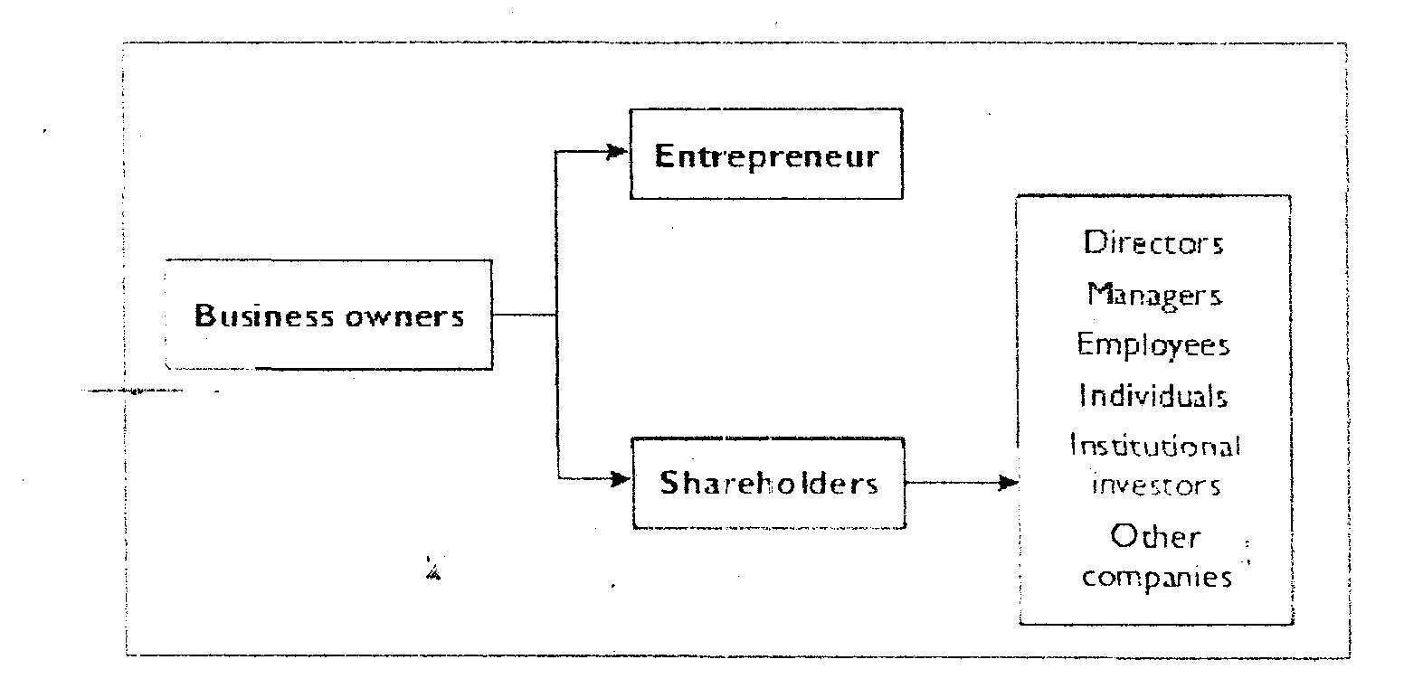 Figure 3.2.2 A summary of Business owners

**How the External Environment Impacts on the Internal**

We have noted that external triggers bring about different responses from different organisation. The resulting internal strategy depends on the characteristics of the organisation and its internal environmental influences. eg. Culture. Organisationat structure. Shareholder influence. etc

The response of an organisation to external environmental factors is influenced by four key dimensions:

**Sensitivity to context**

Managers are deeply aware of their own organisation in terms of its market possibilities and internal resources/organizational capabilities. This might include a deep knowledge of how the organisation behaves best in relation to change. Some organisations have a long history of achievement through being second (or third) placed in innovation - but then producing first rate service that are so thought through that they beat the market leaders every time. Other organisations have a history, or tradition of being first the field, proactive and achieving dominance that way, this is a matter of sensitivity to culture and capability.

**Willingness to make do**

Managers use their ingenuity, creativity, crafting and experimentation in coming to good solutions. The decision to be proactive of reactive to change is based on considering possibilities and use of available resources to find workable solutions; an emergent approach. This implies a willingness to take actions without a clear sense of how things are going to unfold in the future

**Focus on outcomes**

Managers are pragmatists. They are very concerned to ensure results but are not too concerned about the means of achieving them. This means that decisions as to whether or not to be proactive would be based on an assessment of the outcomes from each of these stances as strategic choice rather than automatically going for one or the other. It might also be in the case of some large scale change, choosing to be proactive in some respects and reactive in others.

**Openness to uncertainty**

Many of today’s off-the-shelf management innovations disguise a discipline that discourages managers from dealing effectively with the unexpected. The fashionable emphasis on being proactive can give a false sense that all circumstances can be anticipated. More often than not, managers are thrown into situations in which they must act quickly and without the confidence of certainty

**Top tips**

Both the internal and external environment mould an organisations strategy. In understanding these influences, it is necessary to draw upon a variety of perspectives; from the chief executive to employees, customers and others who rely upon the business.

**CHAPTER EIGHT**

**STRATEGIC CHOICE**

Strategic choice

Environmental factors, both external and internal, strongly influence strategy. many of these factors are outside the control of the organization, but nevertheless the organization must study it and analyze it, in order to come to the right decision on strategy.

Having identified the mission and strategic objectives and developed an understanding of the environment, there are probably several strategic direction that an organization can pursue in order to develop its competitive advantage. ***what criteria can an organization use to judge the relative merits of strategic direction?*** Johnson and schools propose three evaluation criteria.

**Suitability**

In assessing suitability an organization has to consider how well the strategy fits the situation identified? How well does it match the organization? Does it exploit organisational strength in pursuing opportunities? Does it address the threats in the marketplace?

**Feasibility**

In assessing feasibility, the organization needs to ask is the strategy realistic and achievable in resource terms? Does the organization have(or have access to) Does the organization have the financial resources to see through this strategy.

**Acceptability**

In assessing acceptability, the organization needs to be confident that it will get the buy in and indeed commitment of its workforce in pursuing the strategy. it also needs to ensure that the results of pursuing this strategy will be acceptable to its stakeholders at large. Management need to be satisfied that the risks associated with the strategy are accepted.

In the following sections we shall look at a range of techniques to address these evaluation criteria. when management invest time and effort in analyzing these areas, the future becomes more predictable and the organization is more likely to make the right strategic choices.

**Techniques and Options**

Before we look in depth at the techniques and options available in the strategic choice framework, let us briefly revisit process of strategy building.

**The process of building strategy**: Increasing line managers in organizations are being asked to think and plan and behave strategically. in business terms, this implies forming a long term view of the role of the department or function for which the manager is responsible and developing strategic plan to get there.

**Strategy building process**

**Developing strategic purpose:** the reason we are here.

**Developing strategic intent:** Where we will fit in a future environment.

**Analysing:** Where we are now.

**Planning what we have to do to get there:** our strategic plan.

**Planning how we are going to do it:** our tactical plan.

The art of strategy development has attracted some of the best business brains, people like Porter and Levitt of Harvard, Ohmae of Tokyo University and McKinsey, along with more recent contributions from Hamal of London Business School and Pralahad of Michigan, have given us a wealth of sophisticated tools which facilitate the process of strategic development. We shall look at some of their techniques in the remainder of this unit.

**PEST/PESTEL analysis**

If we start with the view that the strategy of the organisation or unit is to assure its long-term effectiveness, then we have to form some sort of view of what the future will be like. PEST analysis (or PESTEL or even PESTLIED) simply lays out four, six or eight basic headings under which you should be thinking of the future. *PEST or PESTLIED*, includes the following considerations:

**Political considerations**

These may fall in the sphere of national or local government. Or, if you are developing a unit strategy within an organisation, they may consider the political climate of the organisation, itself.

**Economic considerations**

These embrace the expectations of the economy as it affects the markets served by the organisation, or the economic climate in which it will be operating. Since the emphasis is future focused, probably over say a five-year period, economic considerations usually involve a cyclic rather than a stable condition.

The organisation's ability to respond to the differing strategic needs in any cycle becomes important.

**Social factors**

These cover the societal trends likely to affect the organisation or unit items like changing tastes,

changing values, changing habits, etc. Their effect on the organisation, its products and services is, of course, crucial to building a viable strategy.

**Technology**

What will the impact of technology be on your organisation, in the products or services it will provide, in the internal processes and IT it will use, or in the way in which it approaches its markets?

**Legislation**

What is the likely legislation which will affect your organisation? This could be your own country, or within larger groups like the European Union.

**International:** Business is becoming increasingly global. Your competitors may no longer be just up the street, they could be half a world away. The probable effect on your organisation of increasingly global business needs to be thought through.

**Environment**

Green issues are becoming increasingly important, affecting some industries much more than others.

They need to be reviewed and their impact on the organisation assessed.

**Demography**

These trends will affect your organisation's markets, as well as its workforce. Its significance needs to be assessed.

Any strategy building exercise relies for its effectiveness on getting as clear a focus as one can on the future. The days where business planning could be predicated on business-as-usual and extrapolation are past. In comparison with then past, changes in the operating and competitive environment are likely to;

Be more radical.

Be less predictable.

Happen faster.

Any strategic development exercise which does not take this as axiomatic is likely to be flawed.

PEST is a means of exploring the future in a directed fashion by simplifying the environment into a few important dimensions. It provides a measure of intellectual discipline in forcing an organisation to consider the environment along these dimensions.

PEST analysis, however, is somewhat simplistic in what is today a highly complex and interconnected world. A much more searching investigation of what it is about the environment that organisations have to notice, monitor and manage is required.

One way of enhancing PEST analysis is to include a specific business dimension referred to as **BPEST**, which ensures that suppliers, competitors and shareholders are included. Analysis of the business dimension encompasses market share, mergers, failures, alternate products, new entrants, supplier influence and new suppliers. The analysis of the business dimension in itself is a large topic and there are a range of tools and techniques to do this. We shall examine these later in this unit.

**Assignment:** Carry out a PEST exercise with a group from your own organisation. Include in your group, people who will be responsible for delivering the plan to support the strategy. Dividing one or more areas for definition between syndicates and sharing the feedback of the syndicates provides a good shared view of the future within the group and usually stimulates good debate. Capture your findings under the PESTLIED headings.

The formulation of strategy is concerned with matching the capabilities of an organisation to its environment. This is not a simple task and there are issues associated with this. To manage these issues managers must use their evolved wisdom about their industry, its environment and what are sensible responses to different situations. In addition, there is the opportunity to gain a more accurate understanding of the environment through the use of analysis models - we shall examine these shortly.

Two key issues emerge from matching capabilities to the environment:

1. The environment involves very many different influences:

Deciding which influences have-or may have -the most effect on the organisation is not simple.

Merely making a list of influences is of little value. An analysis of these influences, their potential impact and their interactions is required. Only then will you get an overall picture.

2. There is also the question of uncertainty: Understanding the history of external influences on an organisation is problematic. It is also extremely difficult to understand the likely future influences.

**Dealing with uncertainty**

It is evident that a key problem of strategic management is coping with uncertainty - so any analysis must begin by asking some searching questions

How uncertain is the environment? What are the reasons for that uncertainty?

How should the uncertainty be dealt with?

Figure 4.1.1 – environmental uncertainty

Increasing un certainty

Low levels of uncertainty

**Environmental dynamism**

Environmental dynamism is to do with the rate and frequency of changes being experienced. It is the degree to which the environments of a company change, and is measured by the speed of customer demands and responses. The greater the speed of change, the more dynamic the environment is. Environmental complexity

Environmental complexity refers to the range of environmental activities that are relevant to what an organisation does, e.g. different customer groups, different supplier companies. The greater the number of these, the greater is the environmental complexity being experienced.

Complexity may exist for a number of different reasons:

The diversity of the environmental influences faced by an organisation.

The amount of knowledge required to handle the environmental influences faced.

The level of interconnectedness of the environmental influences faced.

As an example, if influences such as exchange rates, the nature and levels of competition, political changes and consumer spending are all related, it is more difficult to understand the influence patterns.



**Figure 4.1.2 - Environmental complexity and dynamism**

Read the following article: Dealing with uncertainty in strategy and valuation at

http://www.valuebasedmanagement.net/articles_dejonge_strategy.pdf

The article addresses the impact of uncertainties on the financial sector.

What lessons can you learn from the article regarding strategy formulation?

Do intangible assets such as knowledge, intellectual capital play a key role in your organisation's future strategy?

**SWOT analysis**

SWOT is a mnemonic standing for: **Strengths**, **Weaknesses, Opportunities** and **Threats**

It is a commonly used tool, familiar to most line managers. Its primary purpose is to locate the organisation in its operating environment and try to assess its internal and external capabilities and vulnerabilities. Its purpose is diagnostic. Read more about SWOT analysis at:

http://www.netmba.com/strategy/swot/

Using a SWOT analysis after a PEST session is a good way of organising all the data you may have gleaned into a format which makes it easier to assimilate.

As SWOT analyses are put together there is usually no difficulty in discriminating between, on the one hand, strengths and opportunities and, on the other, weaknesses and threats. There is often confusion as to the difference between a strength and an opportunity. Strengths are internal, opportunities are environmental. Similarly, weaknesses are internal; threats are environmental. Figure 4.1.3 makes this distinction**.**

Grasping this distinction is more important than mere semantics. Strengths and weaknesses are usually within your control, i.e. to consolidate the former and eliminate the latter. Opportunities and threats are not within your control. They call for the organisation to adapt, to take advantage of the opportunities and to minimise the effect of the threats.

Carrying out a SWOT analysis is a good group activity. You can use syndicates working on strengths and weaknesses (internal) and a second syndicate working on opportunities and threats (external). This helps reinforce the basic discipline of the exercise.

SWOT analysis serves a number of purposes, and can provide new insights into your business and guide you in formulating your strategy. These are:

**SWOT analysis:**

1. Enables you to put shorter-term plans together to consolidate strengths and address weaknesses.
2. Identifies areas for more research, analysis and idea generation about the environmental factors of threats and opportunities.
3. Helps in the development of a strategic plan that is consistent with your resources and

organisational capability.



**Figure 4.1.3 - SWOT analysis**

Figure 4.1.3 shows what a SWOT analysis might look like. It is a relatively lean example of a SWOT analysis. Most carry a greater level of information, and most actually build over time as people think of other things to add.

The tool remains a standard in most managers' repertoire and rightly so, for it provides a good basis for recording a great deal of information and organising it in a way which is a good precursor to planning and strategy development.

**The competitive forces framework**

Much valuable insight can be gained about the marketplace from the competitive forces model. We touched on this in Unit 2. ***Porter's Five Forces Model*** was devised by Michael Porter and is widely acknowledged as one of the classic strategy-building tools.

The model is used to channel thinking into five major areas from which competition might potentially arise in the future. By focusing carefully on these five areas the strategist is likely to be able to estimate the probability of competitive threat, speculate on its nature and, as a result, formulate a strategic response.

As with many of these models, the exercise can be undertaken as a group activity, individually or simply used as a personal discipline.



**Figure 4.1.4 - Porter's five competitive forces**

The model compels the use of the imagination to view the market not only from your own and immediate competitors' perspective, but from that of other players, actual or potential. It also, in the substitute products area, opens the mind to thinking about the particular products or services you are providing and how they might be superseded not only by better or cheaper alternatives, but by radically different ways of satisfying customer needs.

To use the model well, the following advice is worth noting;

Take time over it - while a first pass will give you a good intuitive response, reflection will greatly enhance the value it provides.

Concentrate on each of the five areas individually, thinking hard about them to get into the mindset or perspective each would have.

Seek advice, input, collaboration; talk to suppliers, customers, people in related industries or companies who might enter the market.

Assemble as much research as you can about your known or existing companies. How profitable are they? How important is the market to them? What emotional commitment might they have in the market? What would you be doing in their shoes?

Think globally about each of the five areas. If the market is intrinsically profitable, predators may be anywhere.

***Assignment: Think of the impact of technology in each of the five areas***.

As you form a picture of the likely competitive environment in which you will be operating, reflect on the consequences of what the model reveals. You will be hatching a strategy to deal with your findings, and it is important that this strategy is imaginative and includes the possibilities of partnerships and collaborations as well as competition. There is no doubt that strategic alliances have a major role in strategic management today. Such alliances often include suppliers but can also include potential competitors.

The complexity of business is such, that strategic collaborations are often the smart and rapid means of acquiring new capabilities and gaining competitive advantage in the marketplace. Furthermore, in the knowledge-based sectors of the 21st century leveraging knowledge across strategic alliances in order to compete more effectively will be a key differentiating factor.

Read the following article Leveraging knowledge management across strategic alliances and capture any notes you wish to make in My Learning Space.

<http://www-935.ibm.com/services/us/imc/pdf/g510-1670-00-leveraging-knowledge-management.pdf>

**Porter's generic strategies**

No set of strategic tools would be complete without a look at Michael Porter's definitive thinking on generic strategies. The idea first appeared in 1980 and it has enormously influenced strategic thinking.

At the heart of Porter's generic strategies is the assumption that the organisation will seek to dominate a segment or segments of the market, seeing off all competitors by the excellence with which they serve those segments. Porter advocates, '...gaining and maintaining competitive advantage...'. In the hypercompetitive climate in which we now operate this is increasingly difficult to achieve. More probably an organisation gains temporary domination of the market and holds that position for a short (and decreasing) period of time until it is lost to a competitor. The contemporary climate probably corresponds more accurately to the definition of Richard d'Aveni; '...gaining and regaining competitive advantage...'.



**Figure 4.1.5 - Porter's generic strategies**

**Differentiation**

This implies that the organisation pursues a strategy where it offers a product or service which is unique compared with those of its competitors. Further, this differentiation must be known and, to at least a segment of the market, valued above the offer of others. Differentiation can be achieved through a totally different product (which is increasingly rare) or it can be achieved by the way in which the product or service is offered.

**Cost leadership**

This is a strategy where the organisation enables itself to provide the product(s) or service(s) at a cost less than any other competitive organisation. This may or may not be reflected in the price it charges to its customers. The essence of cost leadership is not price but the ability the organisation has to price below competitors if and when it needs to.

**Focus**

This is a strategy where the organisation targets its products or services at a given sector of the market with great accuracy and with a depth of capability and knowledge to support its position in the sector.

Focus can be cost-focus or differentiation-focus.

You can read more about Porter's Generic competitive strategies at:

<http://marketingteacher.com/Lessons/lesson_generic_strategies.htm>

Each of the strategies of cost leadership, differentiation and focus, has particular benefits and concomitant organisational commitments not only in the way the organisation approaches and positions itself in its markets, but also in the way it develops its internal capabilities and competencies to support the chosen strategy.

Each strategy also has its risks and these are increasingly difficult to anticipate in a hyper-competitive environment where organisations will compete with the object of displacing the extant market leader rather than winning the market with a sustainable alternative strategy.

The key to the use of this model is as a tester. The logic behind it is excellent. The question is whether, as an organisation, we could actually sustain any of these strategies longer term. Evaluating that decision may, of itself, provide a strategic insight of importance to the organisation.

***Is your organisation 'stuck in the middle'?***

The problem with many organisations is that they try to pursue all three strategies of differentiation, cost leadership and focus. This is a recipe for disaster, and usually leads to poor business performance and eventually business failure or acquisition.

So is your organisation 'stuck in the middle'. If not, what strategy do you think it is pursuing?

Strategy is of course particular to each organisation; in fact those with clearly defined or unique strategies are more likely to succeed long term. All organisations are confronted with an environment of change which, if not identical for each, is at least similar for classes of organisations.

A number of generic strategies have emerged which are defining the modern organisation. We now look at some of these strategies in the context of what we know of the organisation.

**Reducing cost base**

Many organisations are aiming for a reduced cost base - a leaner organisation, less expensive to run and more productive or effective. The thinking behind this is that in the event of a price war with competitors, the organisation has more flexibility to respond if its cost base is lower. Alternatively, it could use its lower cost base to initiate a price war to take out a competitor. At least if its cost base is lower it can survive for longer in the event of an unanticipated market downturn or margin squeeze.

**Improving quality**

Most organisations now hold the view that consistent incremental quality improvement is an essential precondition for serving a market. Customers insist on improving quality, competitor pressures pace quality improvement, and the market is very unforgiving of quality failure or disadvantageous comparison with competitors.

**Getting closer to the customer**

Customers are whimsical, customers are fickle, customers are not loyal. All these things are true. The ability to anticipate this fickleness is a strategic strength. The ability to respond fast to changing customer fashion and the ability to create customer fashion are powerful strategic attributes. Knowing your customers well can also enable you to lead demand, to create fashion, to pre-empt competitors in developing market niches and to fill them fast.

**Shorter cycle times**

When product life cycles are falling, recovering the development cost of the product fast becomes a necessity. Keeping the cycle time short (i.e., the time from conceiving the product to hitting the market with it) is a way of keeping development cost lower. The ability to enter the market with a new product before or very shortly after competitors is also a key cost recovery and profitability strategy.

**Strategic partnerships**

Being able to add value (or reduce cost) to your product or service by entering a mutually advantageous partnership provides an excellent increase in capability. Strategic partners can also take you to markets too expensive to enter directly, or they can provide capacity too expensive to invest in yourself. Isolating the areas for strategic partnership, identifying the partners and managing the partnerships are a source of advantage.

**Ability to change fast**

Some organisations are just better able to embrace change than others. Being able to point the organisation in a different direction, being able to march the troops down the hill when you have been vigorously marching them up the hill, is a great strategic advantage. Being fast on your feet and being able to learn fast are organisational competencies of great strategic value. The learning organisation, the athletic organisation, the responsive organisation, the creative organisation are all names for this strategic strength.

It may be that some of the generic strategies organisations are following are also material to your organisation.

Rate the importance of these generic strategies to your own organisation by selecting the following responses to each strategy;



**Figure 4.1.5b - Rate the importance of these generic strategies to your own organisation**

Now list the three most important strategies you think your organisation is pursuing, or should be pursuing.

**The value chain**

This is among the more difficult tools to master: not that it is especially hard to understand, but rather that you keep having to 'unpack' it at greater and greater levels of detail in order to make it work.

The **value chain** shows the broad categories of activity which go on in an organisation as it takes in raw materials at one end, adds value through its internal processes, and delivers its goods and services at the other end.



**Figure 4.1.6 - Activities within the value chain**

**Inbound logistics** covers everything the organisation does to receive goods and materials, to store them and to readythem for use.

**Operations** covers all the internal activities and processes of the organisation as it produces its product or service.

Obviously this includes manufacturing, but in a retail environment it would cover how goods were priced and displayed, point of sale IT, etc. In a consultancy it would deal with facilities provided for consultants, how research was conducted, how reports were prepared, etc.

**Outbound logistics** has to do with the collection and storage of goods, and their entry into the supply chain, the systemswhich get the goods to the customers.

**Marketing and sales** addresses how the organisation promotes and takes its goods and services to the markets.

**Service** usually implies after-sales support and maintenance.

**Organisation infrastructure** covers the way the organisation is structured, managed, how it plans, etc.

The keys to value chain thinking are:

Each part of the internal processes of the organisation can improve the overall competitive advantage.

The interrelationships or links between the activities of the organisation can be enhanced to improve competitive advantage.

The interrelationships between the internal processes and the upstream (suppliers' chain) and the downstream (customers' chain) can be examined to provide competitive advantage.

You can read more about Porter's value chain at:

http://www.netmba.com/strategy/value-chain/

Many, indeed most, companies are organised by functional units; although increasingly cross-functional activities are replacing the traditional 'organisational silos'. Part of what organisations are trying to achieve by cross-functionality is efficiencies in the value chain, and a better focus on strategic imperatives, such as customer satisfaction.

What we are looking for when we use the value chain model are links which we can establish between:

The various elements of the value chain, primary activities and support activities and elements of the value system, that is the upstream elements of the system (suppliers feeding the organisation) and the downstream elements (the supply chain feeding the customers).

**The links we are looking for are those that will:**

***Enhance value*** - e.g., improve the product or service at a cost less than the customer is prepared to pay.

***Reduce the cost to the organisation*** - e.g., reduce waste, waiting time, storage cost, improve process efficiency, etc.

There are a number of examples of links within the value chain, as well as extending links across the value system (supply chain). These include:

Kan Ban systems (automatically on-demand) inventory replenishment used in internal production processes has enormously reduced the operating capital and storage cost of component inventory holding in many organisations.

***Building links between after-sales servicing and research and design*** has improved product reliability and repair costs in large sections of white goods manufacture.

Pharmaceutical distributors frequently provide a raft of support services to the individual chemist shops they supply. These can cover inventory control, computer-linked ordering systems, even staff training.

The relationships between some Japanese car manufacturers and their component suppliers cover not only joint specification and design of products but also Just-In-Time inventory arrangements.

**Assignment:** Study the value chain and value system within your own organisation. Use the tips below to carry out a simple analysis.

Be clear that you are looking for cost saving and process improvement within the value chain (internally) and within the system (upstream and downstream from the chain).

Set up the nine-box graphic (as per the illustration on activities within the value chain) and capture the main activities which your organisation performs in that component of the value chain - go easy on detail! You may wish to use PowerPoint for this exercise.

When you have completed the graphic, look hard at possible links between items which might repay closer investigation (i.e. detailed work analysis or process re-engineering possibilities).

Consider carefully the potential for linking with suppliers to your organisation. Consider what those links might look like, what payoff they would provide you, and what payoff they would provide the supplier(s) with which you link.

Think about the elements in the supply chain which take your goods and services to your ultimate customers or users. Do links suggest themselves? What is the payoff and for whom?

While value chain analysis is complex and can be time consuming, it does allow for imagination and assists thinking across complex systems. Remember too that you have two great consultancy allies to help in value chain analysis. These are:

The IT providers, particularly those involved in what is called **enterprise resource planning**.

The potential help of **process re-engineering**.

Research the terms 'enterprise resource planning' and 'process re-engineering'.

For your research, you may wish to visit the websites of SAP and Oracle, leading providers of

Enterprise Resource Planning (ERP) software.

http://www.sap.com/solutions

http://www.oracle.com

Briefly describe the functions of enterprise resource planning and process re-engineering.

**FEED BACK:** Enterprise resource planning deals with radical revision of the information systems within anorganisation and within its extended value system. Since IT is often a key element in optimising links in the system, there is considerable expertise to hand.

Process re-engineering involves examination of internal processes within the organisation and seeks to eliminate redundancy, waste and duplication. Most organisations suffer trauma as a result of extensive process re-engineering, but cost is usually shed and efficiency enhanced.

**The nine specimen strategies**

Kenichi Ohmae's Nine Specimen Strategies model helps to amplify an important component of strategy building. He argues that the strategy followed will, in large measure, develop from the intrinsic skills within the organisation. While this may seem blindingly obvious, Ohmae's strategy building processes place a higher priority on 'what we are' than on 'what we might be'. This philosophy does not preclude aspiration; it probably just makes aspirations more realistic.

The model compares market attractiveness against corporate strengths, in defining strategic behaviour.

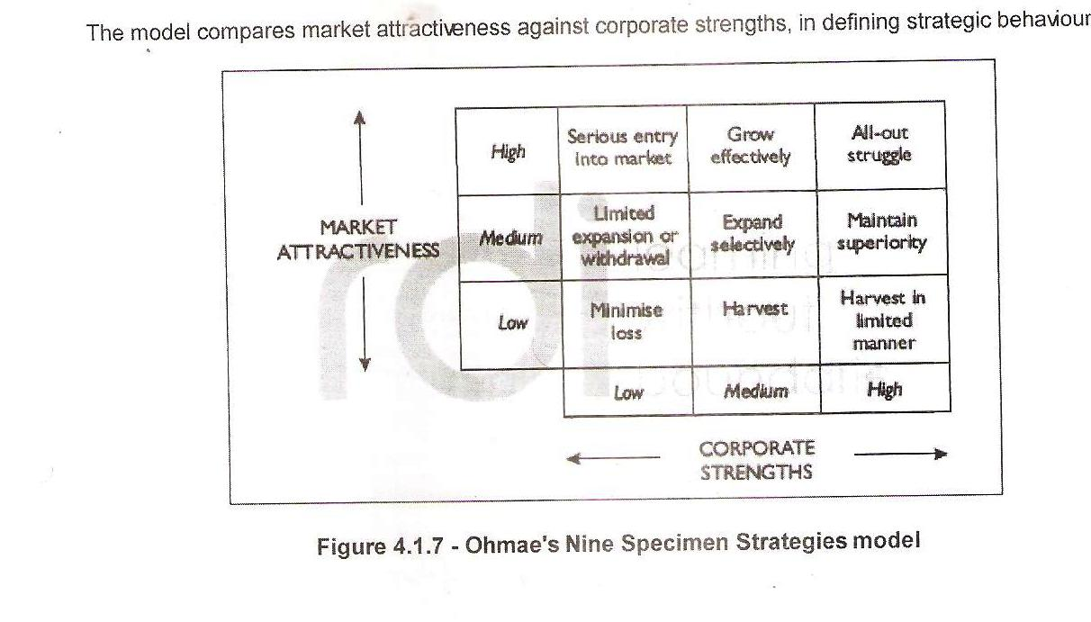

**Serious entry into market**

High market attractiveness, low corporate strength - would imply that the organisation would have to invest in developing skills and capabilities to serve the market well. It is likely to be competing against competition stronger than it is, and in a market which is attractive. So to perform well, the word 'serious' is serious. If it failed in the market it might withdraw, or it might intensify investment.

**Grow effectively**

High market attractiveness, medium corporate strength - organisational behaviour would be looking to expand selectively, probably as opportunity presented itself, not necessarily in pursuit of market dominance.

**All-out struggle**

High market attractiveness, high corporate strength - this scenario would require familiar strategic slugging match behaviour. Since the market is attractive it probably has a lot of players in it. Competing will require continuous product or service enhancement, continuous adding of value, possibly price wars, etc. Position in the market and profit from it must be protected.

**Limited expansion or withdrawal**

Medium market attractiveness, low corporate strength - the organisation is probably looking at a tradeoff of resources here. If no more promising opportunities exist for it elsewhere, it might stay in the market and grow opportunistically. If better opportunities exist, it might withdraw from this segment and deploy its resources more effectively.

**Expand selectively**

Medium market attractiveness, medium corporate strength - this will probably look like expansion into relatively low risk areas of the market.

**Maintain superiority**

Medium market attractiveness, high corporate strength - here the organisation will maintain its presence. It will look to limit investment in the market, but try to improve profitability.

**Minimize loss**

Low market attractiveness, low corporate strength - here corporate behaviour would involve minimum development or investment in the market or the products/services supplied to it. The organisation would have to be wary of incurring loss (loss of focus on more important market segments being just as serious as financial loss) in continuing to service the market.

**Harvest**

Low market attractiveness, medium corporate strengths - here we are looking to get as much profit as possible out of the market with minimum investment. In accounting terms this might be treated as a variable cost market rather than fixed cost.

**Harvest in a limited manner**

Low market attractiveness, high corporate strengths - here the corporation would protect its profitability even at the cost of market share. It would not seek to lose ground in the market, but it would not defend its position if cost were involved.

The Nine Specimen Strategies represent a subtly shaded description of strategic behaviour. The major use of the model is to plot your own organisation's positions and then reflect on the appropriateness of the strategic behaviour you are evincing in the light of your plot.

Note that any organisation probably has a number of different plot positions on the model reflecting different markets, products or services it is supplying. Plainly, it is possible for the organisation to behave differently in respect of each of the plots.

**The Ansoff matrix**

This well-known model is a classic in strategy building. Its primary purpose is to analyse the

organisation's approaches to its products and to its market to ensure that an appropriate marketing strategy is being pursued and possibly to reveal opportunities.

Within this model is an assessment of the risks involved in pursuing given strategies. The model also prompts consideration of synergy which might exist on both the product and the market axes.



**Figure 4.1.8 - The Ansoff matrix**

**Market penetration**

This strategy involves the firm looking to increase its products' share of the markets currently served by the company. Various methods are available to the firm under this broad market penetration strategy:

More purchasing and usage from existing customers - new products are added to the existing product line, for example Coca Cola and cherry coke, Kellogg's crunchy nut cornflakes, Virgin bank and Virgin trains.

Gain customers from competitors - marketing and strategic efforts directed primarily at taking customers away from the competition. For example, the recent attempts by new entrants to the gas and electricity industries trying to take customers from British Gas and other established 'players'.

Convert non-users into users - special offers for people to try Health Club membership serves as a good example of this.

**Product development**

Product development incorporates three broad areas of activity. These can be described as:

***Product modification*** via new features - examples include, fan assisted ovens, combined TV and DVD, car breakdown recovery services incorporating hotel accommodation for customers with an unserviceable car, mobile telephones incorporating web and photo technology, and ready meals that are microwaveable in the packaging.

Different quality levels - some product modifications can be said to offer different quality levels to different customers. Other examples could include car tyres, Tesco selling their basics (own label) and finest brands of goods in the same store, and British Gas offering customers different levels of service care to its customers - from 3-star to 5-star cover.

***New products*** - DVD technology and vehicle telematics could all be considered to be new products.

***Market development***

Offering existing company products to new markets is referred to as market development strategy.

Again, three broad areas of market development can be examined:

New market segments - examples could include McDonalds offering their products with special add-on offers to the teenage market, or solicitors offering their services to non-traditional customers - particularly the 'no win, no fee' segment of the market.

***New distribution channels*** - Mercedes offering their vehicles and brand through shop outlets rather than just dealerships, as seen at Blue Water shopping centre in Kent. A further example could include the large-scale development of home shopping and smaller Express stores by Tesco.

New geographical areas - this is, as it says, where a company offers its products in new areas. The recent battle to purchase Safeway represented an example of this, when Morrison's, the Bradford based chain, purchased the company's stores to give the company an in-road to the south of the country. The Royal Bank of Scotland purchase of Nat West extended their market coverage from their traditional heartland.

***Diversification***

This involves a company looking at entering new areas of business. For example, Building Societies buying Estate Agency businesses, or the train and bus company Arriva buying car dealerships (which were re-sold in 2003).

While the benefit of the Ansoff matrix lies primarily in examining strategic product/market strategy, it also has value in:

Causing long-term evaluation of markets.

Revealing the potential opportunities for product synergy and for market synergy.

Focusing on competitor activity.

You can read more about the Ansoff matrix at:

<http://www.quickmba.com/strategy/matrix/ansoff/>

Other market strategies adopted by companies today are:

**Market leadership**

**Survival**

**Mergers and acquisitions**

**Business redefinition**

**Market leadership**

If a company pursues a strategy of market leadership, it is trying to get to a position where competing companies are always 'playing catch-up'. Research strongly suggests that market leaders enjoy not only higher sales, but also higher profits as well.

Market leadership presents many disadvantages to rival companies in the industry. The level, to which these disadvantages will show themselves, will largely be dependent on the industry being considered.

As an example, market leadership in an oligopolistic industry (where there are a large number of

competing firms) that is also facing over-supply, can actually bring advantages to followers in the industry. Another example is that of the

**Ford corporation.**

Ford's pursuit of market share and retention of market share leadership is placing the advantage in many of its rivals hands. The company is facing rapid erosion of its market share by smaller, better customer and product focused companies. These smaller companies are very satisfied if they can move their market share from 4 to 5 per cent, for example. In absolute terms a rise of 1% for a small company represents huge gains. Ford, meanwhile, is facing an erosion over the past ten years of around 15 percentage points.

The disadvantages are:

* Economies of scale.
* Research and development costs.
* Recruitment of the 'best' employees.
* Advertising and promotional spending capabilities.
* Access to market research.
* Brand management and brand proliferation.

**Survival**

This strategy can be described in terms of the avoidance of loss.

Survival may be for the short or the long term. In the short term, it could be a strategy that is pursued because of difficult market conditions. In the long term, the company may well have curtailed profits as they innovate and grow. The intention being that they actually begin to achieve profitability further 'down the road'.

Marks and Spencer is a company that has had to put survival on its agenda in recent years. In its 'difficult years', it did have to go back to basics in order to ride the wave of bad fortune. Marks and Spencer rode through the storm with its survival strategy and now the company is seeing significant sales growth and improved profits.

**Mergers and acquisitions**

Merging with, or acquiring, another company can often be an attractive proposition for a company strategy wise. Either to build on core competencies or to buy in required core competencies to meet the demands of a changed external environment, a company pursuing this kind of strategy will be looking to gain advantage in the marketplace.

The main ways to deliver integration - vertical, backward and so on - were considered in the activity included in the earlier section on Ansoff growth strategies. In this section we will not re-visit your findings from the activity.

**Business redefinition**

The business redefinition strategy is best illustrated through an example. Needham et al (2002) cite the example of ICI using the business redefinition strategy:

'ICI has redefined its main focus of business activities from being focused on heavy industrial chemicals to one on high value-added consumer-oriented chemicals. It made this switch because of the weakness in its older market and the potential in its newer market.'

Today innovation is at the core of competitive strategy. In fact, it can be considered as a survival strategy in many high-tech areas. Read the article Survival strategies: Innovate or Die at

http://www.economicswebinstitute.org/essays/survivalstrategies.htm

Capture any lessons learnt or notes on parallels for your organisation in My Learning Space.

Diversification through acquisitions is another strategy pursued by many companies today. Read more about the types of diversification undertaken at:

http://ventures.powweb.com/business_guide/im_diversification_strategies.html

**CHAPTER NINE**

**EVALUATION MODELS**

Using the Arosoff matrix in conjunction with the BCG matrix, the organization can conduct a useful strategic review of production/ market strategy and what that implies for achieving the organistion’s vision. In this way, a seamless transition is made towards techniques that are more directly concerned with strategic evaluation.

The BCG matrix

So called because of its use of the Boston Consulting Group, this matrix is a valuable tool that is widely used . Its primary purpose is to analyse the organisation’s product portifolio. A again the purpose in doing so is to to be certain that organization’s strategic behavior is consistent with the positioning and expectations of its products within its markets.

The definitions used in the BCG matrix are very precisely expressed in terms of generation and use of cash. This makes the matrix asharp -edged tool.

The BCG matrix can also illuminate the need for product or market development and so an organization can with value switch between BCG and Ansoff to help build its strategy.

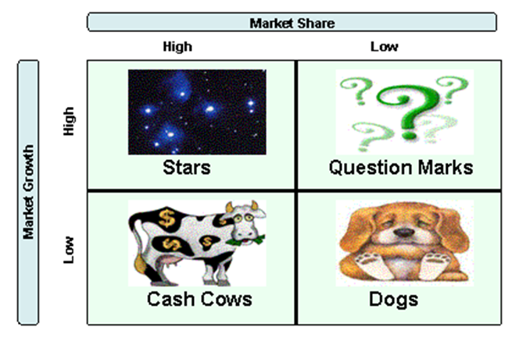

**Knowledge check Stars:** These are products that are performing well. Generally this means that they are generating positive cash and their cost of manufacture is fatling because of scale. These products will usually require continuous update to maintain their market share. The organisational task is to manage three riables share, margin and over all revenue.

**Problems:** Problems (srnetimes referred to as ‘problem children’) are products which are not performing, which means that they are achieng a low share of growing markets. In cash terms they are probably not generating sufficient cash to maintain them in their markets Decisions will hae to be taken as to whether to identify instment or withdraw.

**Cash cows:** These are products which are performing well in markets which are *growing* slowly or static. They are probably generating more money than can be profitably invested in them. Unit costs are at least static, at best falling. Margins are steady.

**Dogs:** Dogs ha low market share in markets which are growing slowly or static. They may be consuming more resources to maintain their ailability than they can generate margin to sustain. Decisions will he needed as to what to do about them. **Research activity:** You can read more about the BOG matrix at: <http://wwwnetmba.com/strategy/matrix/bcg/> **Top tips:** If Ohmae’s Nine Specimen Strategies and Ansoffs matrix provide a check against the organisations strategic behaviour, then the EGG has great value in determining the strategic allocation of resources.  **Activity** As a useful activity to apply your knowledge to your own organisation, utilize the Ansoff ratrix and BOG matrix to analyse the products or services of your organization. Carryout the analysis on a product-by-product rather than trying to place the whole organisation on either rnatrix. If your organisation is like most others, you will find that you have products and services all over both matrices, While the plotting exercise is valuable, recognizing the consequences is more intrusive. Capture your findings and document them accordingly. You may wish to revisit your analysis on completion of the course. There have, though, been criticisms leveled at the BOG matrix. Many of the criticisms arise from the difficulties associated with taking accurate measurements of market share and market growth rates.

**Directional policy matrix**

The directional policy matrix was developed to overcome the criticism of the BOG matrix. It achieves similarities as to the Boston Matrix, hut uses slightly different parameters. Shells were among the first organizations to develop the matrix in an attempt to identify key relationships and advantages that had become dispersed throughout a multifunctional business. These key skits (especially in exploration and engineering ) may represent a very large part of the firms value added.

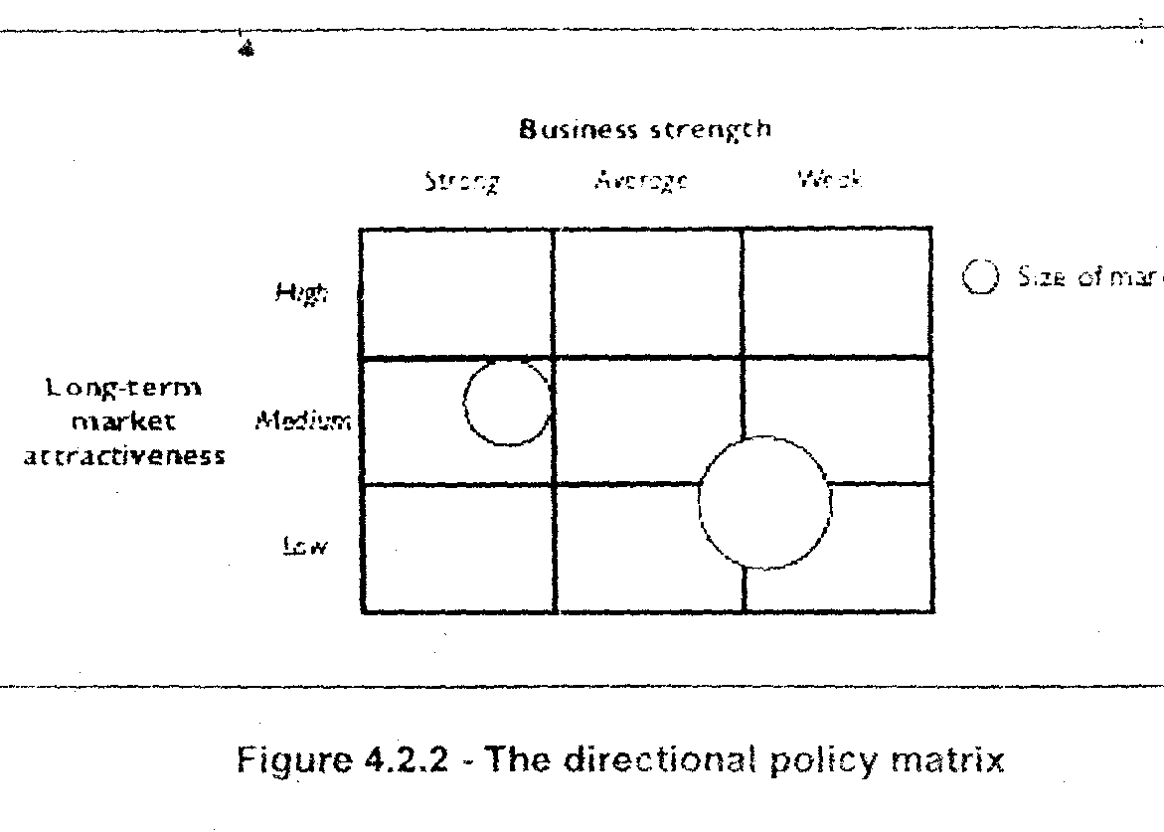

The two axes used for the chart are business strength and market attractiveness. Business strength has to be considered in relative terms, when compared to your main competitors. Market attractiveness can be measured in terms of criteria that determine the future profitability and/ or health of your business. How market attractiveness and business strength are measured must he related to circumstances of each individual company being considered and the industry in which it is operates.

Market attractiveness is measured along the following parameters

**Market factors**

* Size, Growth rate, Seasonality, Bargaining power of buyers

Competition

* Type, Number, Ease of entry to the market

**Financial economic**

* Margins, Possible economies of scale

**Technological**

* Required technology, Complexity

**Socio- political**

* Human factos, Social attitudes and trends

Business strengths are measured using other criteria

These will be determined by weighting critical success factors

* Product, Price, Service, Image

**Market dynamics model** A further way to anaiyse the competitive enronment is by using the market dynamics rnodel. This combines some of the featuresof the Porters competitive forces framework with the customer aspect of the marketpiace

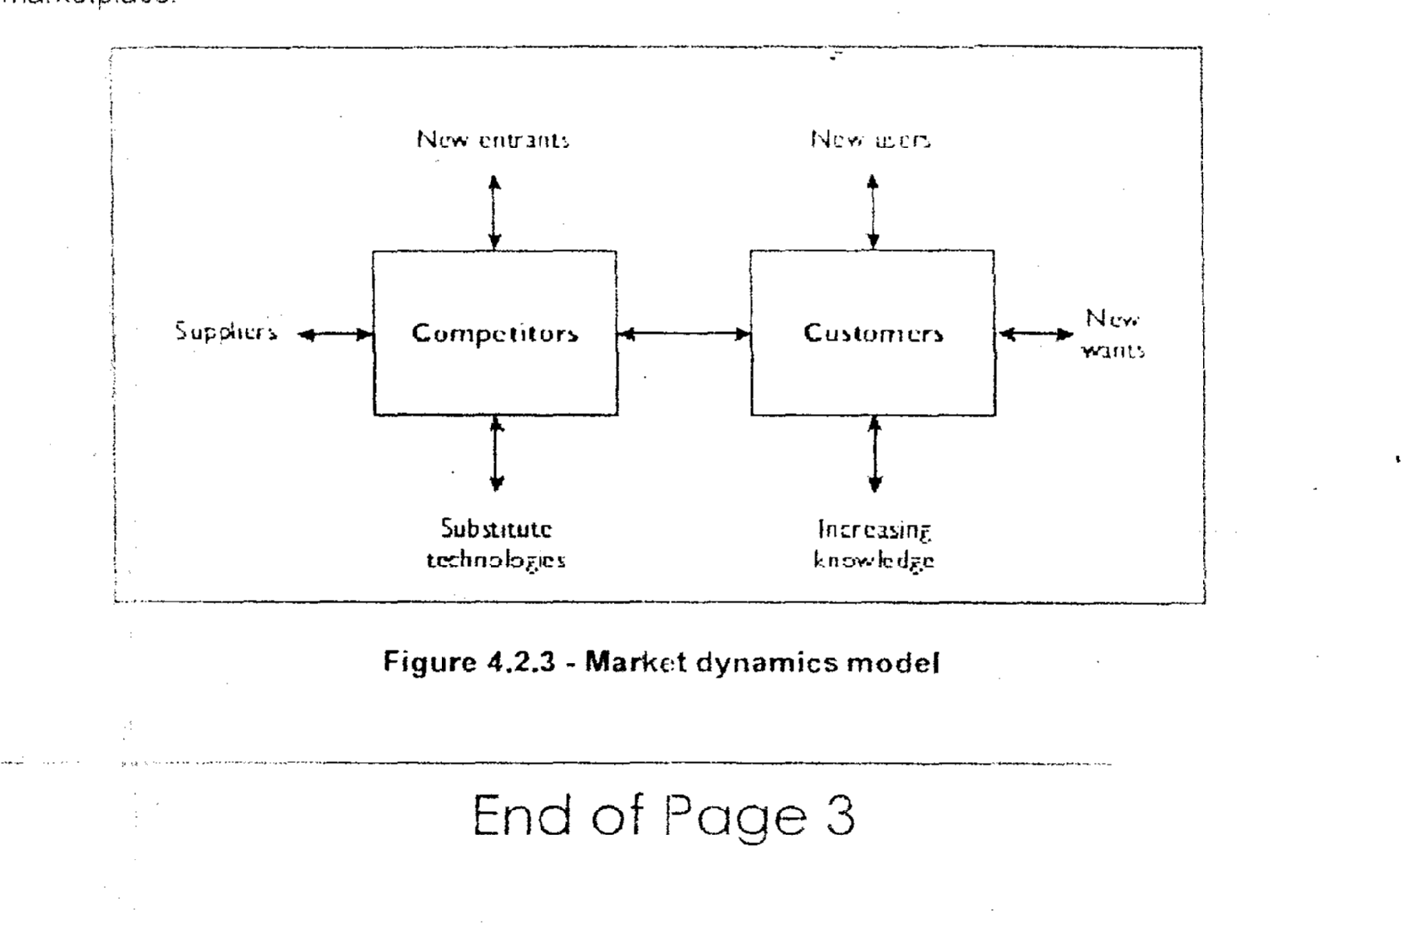 **Figure 4.2.3** - **Market dynamics model**

**GAP analysis:** Having looked at the key models used to determine a company’s competitive position in the market that it serves, our attention must now turn to looking at the strategic directions that are available for a company: strategic directions that take into account the capabilities of the business, together with the opportunities in the marketplace. GAP analysis is the first of these.

A GAP analysis (or Comb Analysis) is a useful, and remarkably simple, technique for comparing customers’ purchase criteria with their rating of suppliers. It is best illustrated by an example: let us take an example of a textile manufacturer, producing women’s clothing and selling them to retailers who are fashion specialists.

As a textile manufacturer, producing women’s clothings and selling them to fashion retailer, you would want to find out what the most important reasons are for them to choose one manufacturer rather than another. You also want to know what the retailer thinks about you and your competitors on each of the key purchasing criteria.

By setting suitable criteria, customers and retailer are able to give scores, ranging from perhaps I to 5. Criteria are chosen carefully, and might include range of garments, fashion appeal, speed of delivery, etc. These are then plotted on a graph, a different line for customers’ views, retailer’s view of your company and retailer’s view of competitors. By assessing similarities and differences, useful analytical observations can be made.

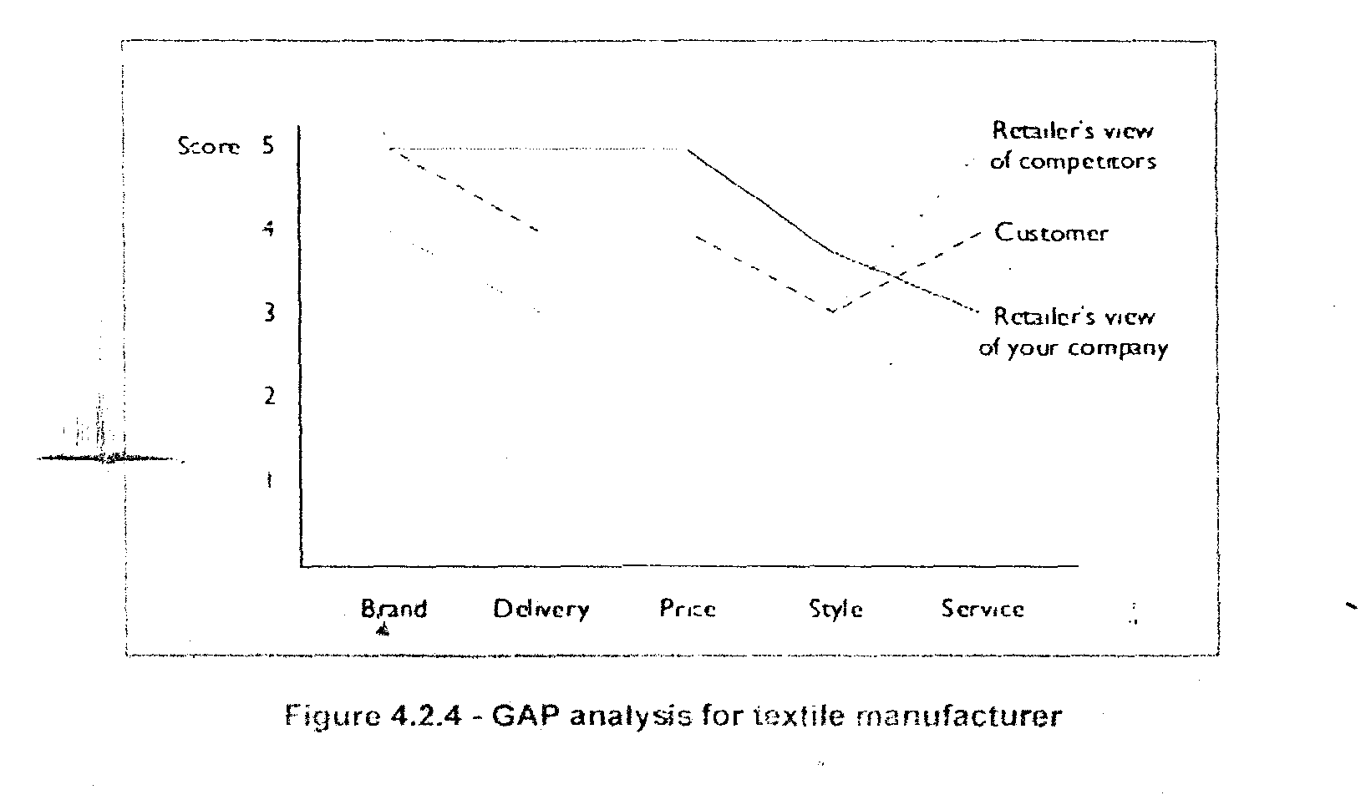

**Research Activity**: Read more about Gap Analysis at: <http://marketingteacher.com/lessons/lesson_gap_analysis.htm>

**Product life cycle**

All products whether successful or not, have a fairly typical pattern of performance, although the order of performance and the time scale over which the pattern emerges can, of course. differ radically. This is known as the product ifecycle.

Looking at product life cycles helps us to assess the stage we are at in our products life and so, to a certain extent, to predict its likely future performance. This in turn helps us to take strategic decisions (perhaps using BCG. Ansoff or others) as to what we are going to do with the product, the resources we might deploy to prolong its life, the new markets to which we might take it. etc.   
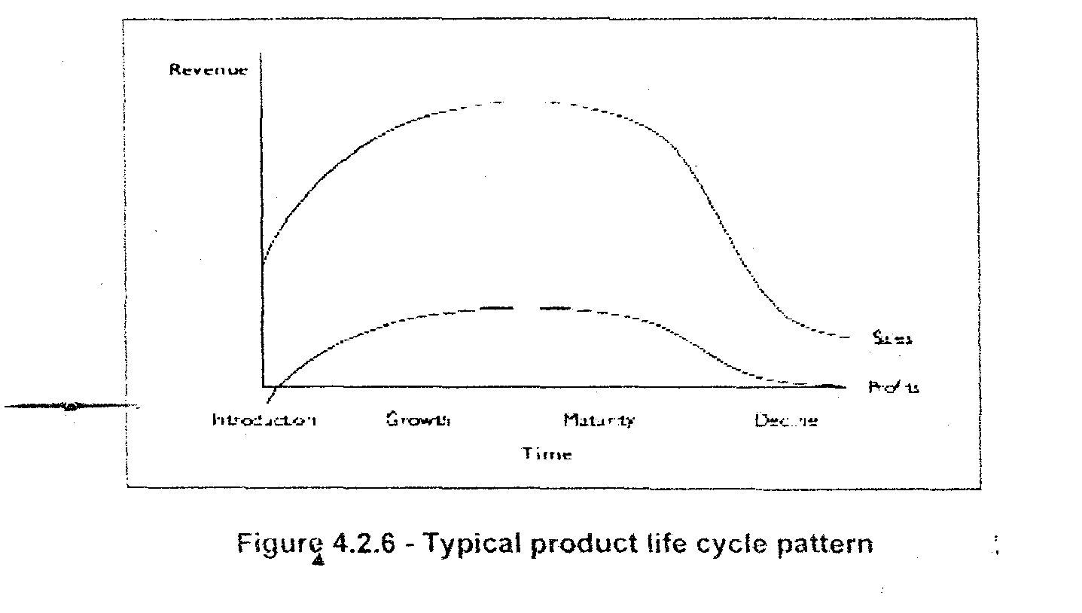 There are four stages.

**Introduction:** with theintroduction of the product re’nues will start to build, and as the re’enues start rolling in, then deelopment costs start to he recovered. In the pattern we hase used, we show a rapid initial rise in product sales early in its life. This is, of course, a desirable situation, but not necessarily essential.   
**Growth:** In any event product wilt enter a growth phase during which time it is selling more units, generating more revenue and winning itself market share. In this part of the cycle, unit costs are likely to fall as economies of scale start to emerge. Marketing costs will probably fall too as a proportion of revenue; margin and hence profitability will probably increase.

**Maturity:** In its maturity stage the product attains the maximum market share, revenue and margin it will achieve in its life.

**Decline:** Maturity is followed by the decline usually as the product is supplanted by competitors or simply, but rarely, by market saturation. Often we get a margin fall as we try to prolong the maturity with price reduction. In the car business, for example, we see special editions’ prolonging the life of ageing models. These usually carry, for **a standard model price,** a number of options which have up to then been charged as extras.

Prior to the launch or introduction of a product, there is, of course, a stage during which money is spent in product development and, as it approaches launch, on marketing and publicity as well. It is for this reason that we show the profit curve in the illustration starting below zero.

**Top tips:** Plainly the pattern of the product life-cycle changes from product to product, but the phases are fairly predictable. The strategic use of the life cycle concept revolves around the decisions the organization takes to influence the cycle.

There may be options to prolong the maturity phase through the use of pricing or market expansion. There may be reason to supplant the product, withdraw from the market, add markets and so on.

Some of the models we have looked at provide details on strategic alternatives and tactical options open to the organization to intervene and change the cycle.

**Activity:** Carry out a GAP analysis on a product or service provided by your organisation and another company (ideally your main competitor). Choose suitable critical success factors (abbreviated as CSF) and score them out of results and comment on your observations.

|  |  |  |  |  |
| --- | --- | --- | --- | --- |
|  | Critical success factor (CSF) | Market expectations | Your company | Another company |
| 1 |  | 0 | 0 | 0 |
| 2 |  | 0 | 0 | 0 |
| 3 |  | 0 | 0 | 0 |
| 4 |  | 0 | 0 | 0 |
| 5 |  | 0 | 0 | 0 |
|  |  |  |  |  |
| 5 |  |  |  |  |
| 4 |  |  |  |  |
| 3 |  |  |  |  |
| 2 |  |  |  |  |
| 1 |  |  |  |  |
| 0 | Revenues | Revenues | Revenues | Revenues |

**Fill in the table above to build the graph**

**Product breakeven analysis**

This model is really simple in concept, though it looks a bit daunting in its graphical form. It follows sensibly after the product life cycle model and seeks to determine when the organization starts to get a pay back on a new product.

Some key definitions.

The difference between the cost at which the product is sold and what it costs the organization to make and sell is called the margin.

Breakeven occurs when the margin generated by the sale of the product equals the total of fixed and variable costs it has incurred.

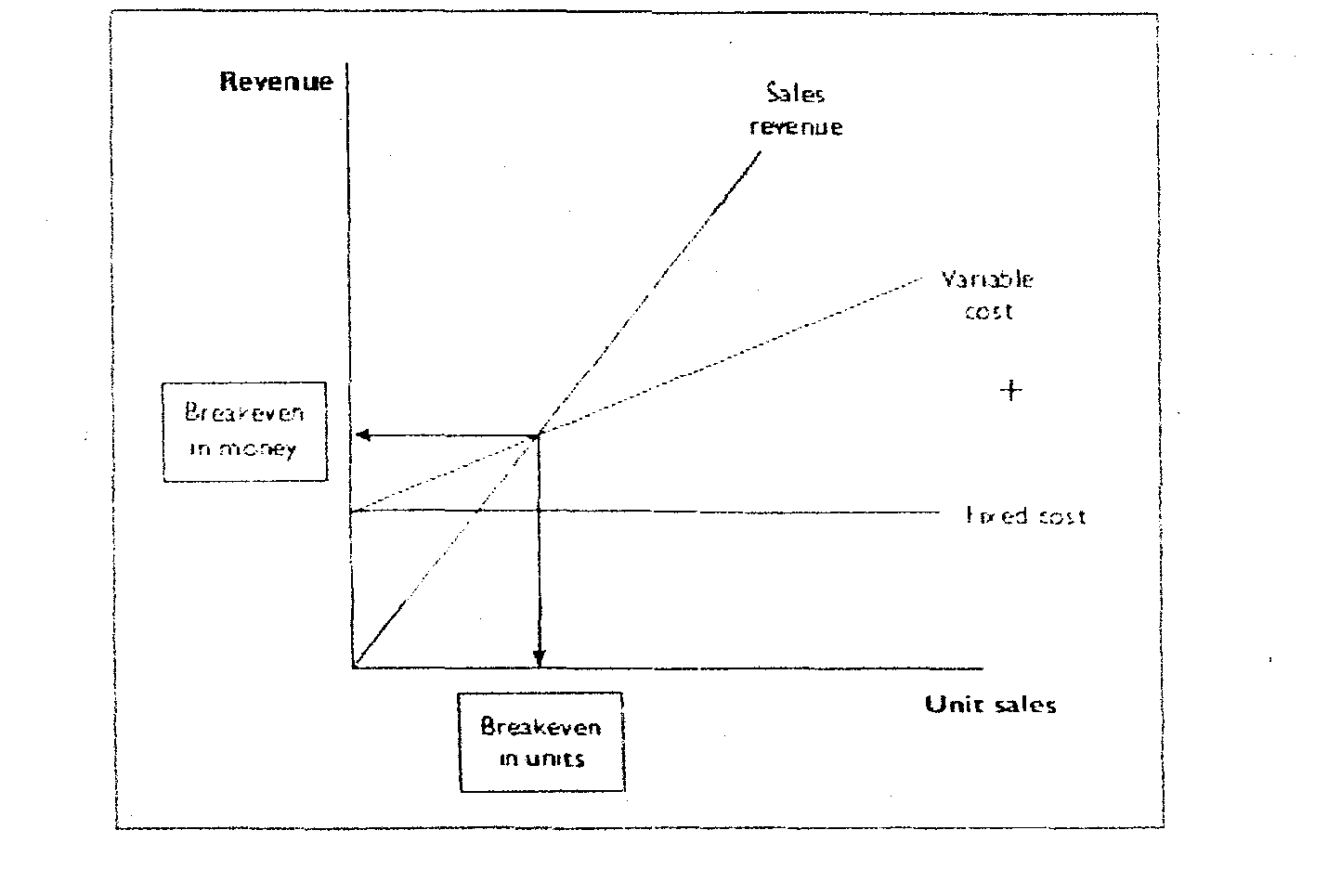

**Figure 4.2.7**- **Product breakeven chart**

In the illustration, the vertical axis represents the sales revenue, whilst the horizontal axis shows the number of units sold. As units are sold, so the sales revenue rises. However, as each unit is sold, a variable cost, usually of making the product, is charged to the company this means that the variable cost line rises as well.

The development is recovered when the sales revenue breaks through the fixed cost barrier, and the product breaks even when the sales revenue overtakes the variable cost line. When this happens you can read on the vertical axis how much is needed and on the horizontal axis how many units need to be sold to achieve breakeven.

Breakeven analysis is primarily a financial model and is used for a number of reasons.

* To determine cash flow requirements - how long to recover development costs
* To determine resource allocation - products which reach breakeven sooner may be more attractive to the company than products which may generate higher profit but breakeven later
* To balance the product portfolio in relation to the cash needed to operate
* To help choose between competing product opportunities.

Although breakeven analysis is a simple model it contributes to the strategic planning process. It reveals hard facts about the financial performance of products and can reveal new insights into existing strategy.

**The seven Ss model**

This model describes an organization as an interconnected series of elements. The names of each of the elements begins with S (hence the seen Ss model). Strategy, Structure and System are the so-called hard Ss. The remainders are soft Ss. In much of the literature superordinate goals are referred to as shared values.

What the model seeks to convey is that the seen elements of the organisation, because they are mutually interdependent, alert the strategist to the need to co-ordinate the whole organisation if change is imminent (and t usually is).

A brilliant strategy is of little value if your organisation does not have the skills or the staff to   
implement it.

The seven Ss model is asa useful organisational tool proiAding a series of headings one should think about as you embark on strategic change.

The seven Ss need to be in harmony when adopting strategic change.

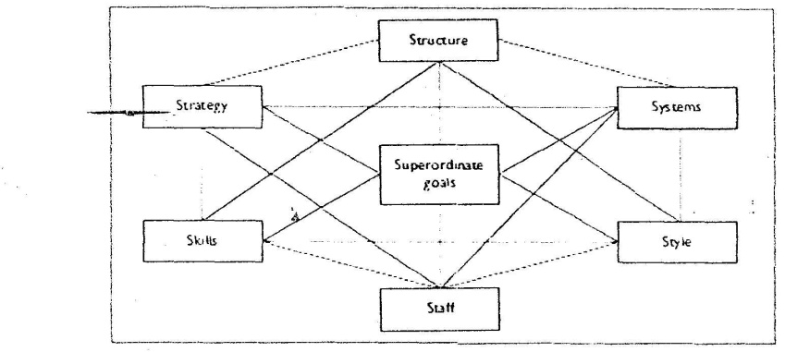

**Figure *4.2.8*** - **The seven Ss model**

**Superordinate goals:** Often referred to as shared values. These represent the aspirations of the organisation, the beliefs, the principles and aims which should pull it towards success. We spoke at the beginning of this unit of becoming clear about’ where we would like to be or what we would like to become...’. A shared view of this within the organisation is a powerful competitive advantage for an organisation to develop. Regrettably, it is absent in most organisations.

**Strategy**   
This is the plan that the organisation has developed to achieve its longer-term intention: how it will cope with its environment, how it will deal with competitors, the markets in which it will play and the products or services it will provide.

**Structure**This is the way the organisation is built, its operating decisions, its decision-making mechanisms, its planning processes, etc.

**Systems**This covers the internal processes the organisation uses to do what it has to do. These might be formal, like work-flows for example, or informal, ‘...the way things really work round here’.   
**Style**   
This is more commonly expressed as culture’. That is, the belief systems the employees have of what is rewarded in this organisation, what gets punished, what the organisation is ‘tough’ about and what it is lenient about. Style is less a matter of what the organisation says about itself, than it is a reflection of the behavour of people within the organisation, especially senior people.

**Staff**This describes the human resource of the organisation its abilities, its competencies. how it is or can be deloped. It also deals with the HR policies of tbe organisation. how staff are rewarded, how recruited, and so on.

**Skills**Tnis really describes what the organisation is especially good at. It should not be confused with the skills of the staff though its overall skills may depend on that. One of Sony’s skills might be electronic miniaturization and portability for example, another might be their ability to bring new products to market fast.

**Top tips**

At the heart of the seven Ss model lies thinking which says that you cannot change one element of this model without all the others being affected. As organisations develop their strategy, this inevitably requires changes in all other elements. The model provides at a minimal level a checklist of areas the manager will have to deal with to enact change. More appropriately, it provides a planning template that can be used to shape the organisation’s response to change.   
Some elements are of course more effective in changing the organisation than others. Change the strategy and it will be noticed. Change the systems to better support the strategy and the change becomes palpable within the organisation. Some elements take ages to change; the style of the organisation evolves from observation, so behaviour has to change before style will be affected, whatever the priorities decided upon in enacting change, the need to address all of the seven Ss cannot be escaped.

**Core competencies**

Core competencies is strictly not a model. It is a concept.

The strengthening of core competencies is a major driver in corporate strategies today. Indeed, the strengthening of core competencies is often a driver for acquisitions.

Core competencies are those capabilities that are critical to the business. Prahalad and Hamel have explored the role that competencies play in corporate strategy. They view the corporation as a collection of core competencies and core products, with competencies viewed as the root of competitiveness for the corporation across time. They define a number of tests for competencies.

The tests fcr core competencie: are:

* Core competencies provide potential access to a wide variety of markets.
* Core competencies make a significant contribution to the perceived customer benefits of the end product/ service.
* Core competencies should be difficult for competitors to imitate.

Core competencies are a blend of skills/knowledge/experience - sometimes technological, sometimes systems, sometimes expertise, or all three - which are core to the organisation’s success. A retailing or supermarket chain, for example, would require a range of core competencies to fulfill its business,

The range of core competencies for a supermarket chain might he

* Procurement capabilities - sourcing supplies at competitive prices.
* Supply chain skills - being able to distribute goods to branches to maintain high stock levels.
* Inventory control systems - usually the ability to process point of sale data rapidly and effectively.
* In-store retailing skills - display, layout, traffic control, etc
* Property procurement capabilities - finding the right site.
* Business intelligence - to detect consumer buying habits and patterns.

Today organisational capability and core competences, relative to the competition, are at least as important, if not more important, than precise strategy. Indeed, for this reason the nurturing of core competencies lies at the heart of the strategy of many successful companies - take, as an example,

In retailing, one of the most important skills is buying and merchandising, that is, procuring goods that consumers will want to buy and displaying them attractively. This very obvious statement explains in large part why some retailers, such as The Gap or Wal-Mart, are consistently more successful than their market rivals. Assessing and improving competencies (relative to competition) has rightly become the top priority for their management t

**Think about it,** If the strengthening of core competencies is a driver for acquisitions, are business activities that do not involve core competences, be a good candidates for divestment/outsourcing?

Does this apply to your organisation? Are there areas of business that are not really core?

When considering core competencies, ‘Make or Buy’ tests are crucial: can the activity be more   
efficiently carried out within a corporation, or by outside partners/contractors.

‘Outsourcing’ is a divestment strategy which recognizes that improved effectiveness might come from buying in non-core competencies. A corporation’s effecti.eness can be significantly improted by the superior skills, resources and expertise of companies for whom the activity is core business.   
**Top tips** A key consideration behind the concept is the difference between access to competencies and **core** competence.   
Access to competencies is being able to procure, buy in, rent or hire the competence one might need to carry out one’s business activities.

Core competencies are ones that prode competitive edge. An organisation’s collection of core competencies should give it unique capability; one that a competitor should not be able to imitate.   
These competencies should be developed and nurtured and not be put at risk. They form the strategic assets of the company.

One needs to look at core competencies through a number of lenses:

* Identify core competencies - sometimes a long and tortuous business. The organisation needs to take an inventory of the things which really are core. This means that they are uniquely necessary for the organsation; they contribute in some way to the particular adding of value in which the organisation is engaged. They are relevant to the organisation’s strategy, not some redundant hanger from the past.
* Establishing a plan to acquire or develop core competencies. As the strategy comes together, new markets, new products and services, and new area for adding value will determine the acquisition of core competencies. Conversely, the potential for the acquisition of core competencies will determine the markets and products and value an organisation might he capable of adding.
* Build core competencies. This means creating the organisational climate which allows competencies to be built, It implies providing the people, the resources, the momentum, the reward, etc., which will allow the competencies to develop.
* Deploy core competencies. If the organisation is to have benefit, It must have access. Often core competencies are disseminated throughout the organisation in different functional divisions. The challenge is recognizing this and creating the means by which the competencies can be focused on adding value.
* Protect the crganisations core competencies. Sometimes what we are good at is taken for granted and before long it starts to wither from neglect. The organisation needs to treat its areas of expertise with the same care and sense of responsibility it would treat its tangible assets; it needs to maintain them, to service them, to renew them: generally to look after them and keep them in good working order.

**Top tips** At a time when many organisations are shedding cost, rationalizing, outsourcing, process and value re-engineering, core competence is often overlooked.

In the modem organisation, core competencies are central to an organisations strategy in order to gain sustainable competitive advantage.

**Activity:** Think about your own organisation’s core competencies**.** If you feel that the company you work for is not suitable for this activity, select a consulting company to help you out.

1. What would you consider as its corecompetencies? How do these competences give access to a variety of markets (e.g. global, different industries/sectors).

**2.** How do your organisations core competencies benefit your customers?

3. How do your core competencies position you better for the future? to give you sustainable competitive advantage?

Now think about one of your competitors. Consider questions 1, 2 and 3 from the perspective of your competitor.

1. In what ways are your competencies (or that of your competitors) difficult to imitate.
2. How can your organsation’s core competencies be developed further? Will it give you organisational capabilities that are difficult for your competitors to imitate? Will it give you better competitive advantage?

**PIMS model ( profit impact of market strategy)**

PIMS (Profit Impact of Market Strategy) is a collective database, originating from research carried out by General Electric in the United States. It gathers data from member firms about market share, profitability and a variety of other variables that might be expected to influence profits. This data is confidential but the analyzed results are made aviilable to members in order that they may use it to raise profits. Some of the research has been published and shows conclusively that higher market share leads to higher profits, but not as predictably as had previously been thought. Each industry displays its own patterns.

**Research activity:** Read more about it at <http://www.pimsonline.com>

There are two main issues with the PIMS model. It accepts firms’ own segment definitions, which may not correctly describe business segmentation, and it does not pay enough attention to relative market share.

**Opportunity / vunerability matrix: A** development from the BCG matrix during the late 1970s and early 1980s by Ban & Co, was the opportunity/vulnerability matrix. This was later refined by The LEK Partnership to provide a means of describing the profitability of an average business segment in a particular industry. Whereas the *BCG* matrix had shown that high relative market share led to high profitability, the Opportunity/ Vulnerability matrix set out to prove that it should be possible to produce a ‘normative curve’ to investigate average segment profitability.

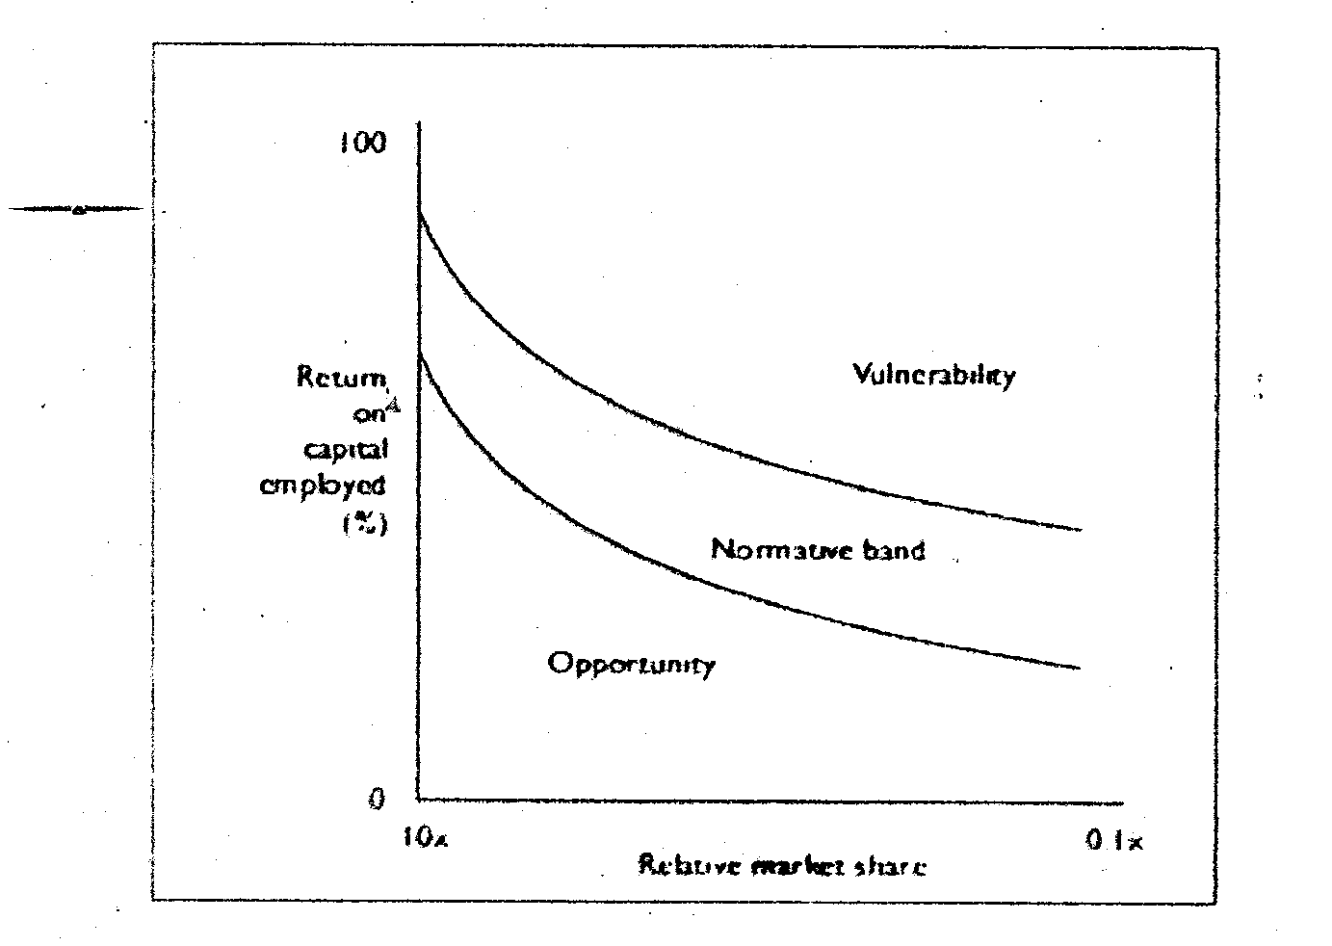

**Figure 42.9** – Opportunity/vulnerability **matrix**

**Top tips**: In today’s complex world, successful organisations rarely plan comprehensively over a 5years time period. The business environment is far too dynamic. However, there are situations where deliberate strategies can be successfully implemented. For example, a deliberate strategy to remove a competitor, or a deliberate strategy to enter a completely new market.

The opportunity /vulnerability matrix shows the relationship between return on capital employed and relative market share leading to a normative band in a convenient banana-shaped cure.

**CHAPTER TEN**

**STRATEGY IMPLEMENTION**

**Introduction**

If strategy cannot be implemented then strategy development is a pointless exercise. We now look at the significant stage of strategy implementation. Without effective measures to ensure strategies are implemented properly; the entire management of strategic deve1oprnent is wasted. The comment ‘A strategy is only as good as its implementation’ is particularly apt in this field. A strategy can bring outtstanding results to a company, but it needs to be well implemented. Strategy should be seen as a dual process the formulation of the strategy (often carried out by a senior person or team in the organisation) and the implementation of the strategy.

In the implementation phase, all levels of the organisation are involved; everyone has a role to play, ensuring that the strategy is implemented correctly and in the right order.

Get an overview of strategy implementation at: <http://www.businessballs.com/businessstrategyimplentation.htm>

The corporate strategy for a business is constructed as the guiding document for the whole organization from this highest level strategic plan, further strategic plans need to he constructed for each business unit and for individual product markets. In this way corporate organisatioral strategy is broken down to lower level tasks and plans.

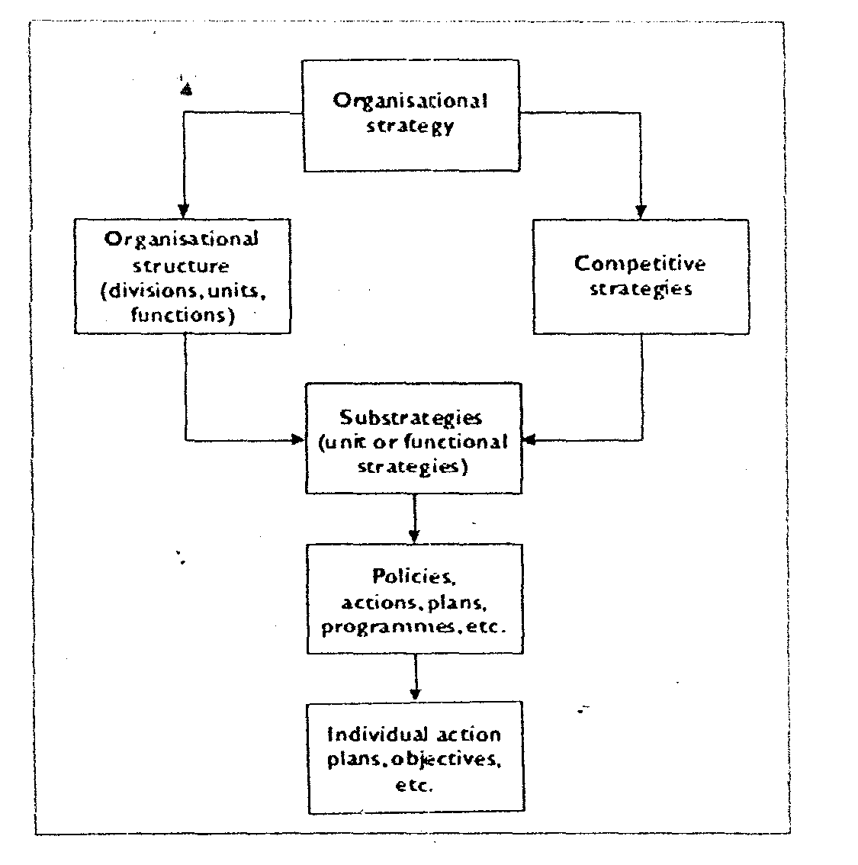

Figure 5.1-1 The transaction of corporate strategy into individual action plans

For an organization that is managed on functional grounds, each function will translate the strategies into action plans for implementation by their staff. Whether in department’s functions or business units, the idea is that staff will be working together to meet objectives, targets, plans, policies, procedures and programmes that will direct their roles and actions.

It should be appreciated that the process and actities associated with the translation of corporate strategy into action plans is a complex and dynamic process. It should further be seen as an adaptive process reacting to changes seen within the internal organisation and the broader external environment.

Thompson (1990) puts forward the argument that internal lower Ievel changes within an organisation will actually drive changes in strategy. These emergent strategies will affect the competitive strategies of the organization and will eventually reach the corporate level.

To demonstrate this, Thompson puts forward the notion that behaour of people within an organisatronal structure leads to emergent strategies in the form of a circular process. An effective strategy must be SUITABLE, ACCEPTABLE and FEASIBLE.

Strategy

Structure

**Figure 5.1.2 -Thompson’s continual circular process**

**Effective implemention of strategy**

It is evident that an organisation will only effectively implement strategy if the strategies are appropriate.

Appropriate to

* The actual organisation.
* The stakeholders of the organisation.
* The environment that the organisation is operating in:
* The resources, capabilities and competences of the organization.]

In addition the organisation should establish whether the proposed strategy is

**Knowledge check**

**Suitable**

Suitable relates to whether the strategy actually fits the situation the business finds itself in.

The PEST and SWOT discussed in the previous unit will assist in this, as with other analysis of the competitive and market arenas. The organization should also consider whether the strategy that is proposed actually represents effective use of the organisation’s resources, building on the recognized strengths of the business and the opportunities open to it.

Finally, with regard to suitalility, the question needs to be asked is the strategy suitable in terms of offering away to meet objectives set for the business by its stakeholders?

**Acceptable**   
Acceptably considers how the strategy fits with the organisation in terms of the risk level involved and whether the plan is likely to be acceptable to all stakeholders in the business:

For example stakeholders to a number of companies in the infant goods market have continually questioned the ethics of providing prepared baby milk products in third world countries, as an alternative to breastfeeding.

**Feasible**Feasibility is concerned‘flrerned with the likelihood of the strategy actually working in practice: This question of implementation further corncerns itself with the resource and capabilities of the company and whether they are adequate bearing in mind the details of the proposed strategy.

We emphasize that resources and capabilities are vital to the feasibility of any strategy, and a number of questions that should be addressed in this context.

* Is adequate finance available?
* Are the core competencies that make up the organsational capability available?
* If core competencies are not available, can they be developed quickly enough? Can the organisation gain access to core competencies (through strategic partnerships or en acquisitions)?
* Are the product output Levels intimated by the strategy actually achievable and sustainable for the lifetime of the strategy?
* Does the company have adequate management/sales/marketing resources to cope with competitor reactions to the strategy proposed?
* Will the organisation be able to achieve the levels of sales, profits and share of market that are indicated by the plan? Does it have the resources?

***There are a number of conditions for perfect strategy implementation***.

* The circumstances external to the implementing agency do not impose crippling restraints.
* Adequate time and sufficient resources are made available to the programme.
* The required combination of resources is actually available.
* The policy to be implemented is based on a valid theory of cause and effect.
* The relationship between cause and effect is direct and there are few, if any, intervening links.
* Dependency relationships are minimal
* There is understanding of, and agreement on, objectives.
* Tasks are fully specified in correct sequence.
* There is perfect communication and co-ordination.
* Those in authority can demand and obtain perfect compliance.

**Activity:** To what extent do you consider that perfect implementation of a particular strategy in your organisation is impossible?

**FEEDBACK / LIKELY IMPLEMENTION CHALLENGES/PROBLEMS**

Your response will be personal and dependent on your organisation, its planning capabilities, its execution capahilites and its corporate culture. You may, however, wish to read the ten most frequent strategy implementation problems as discovered by a recent study;  
1, Implementation took more time than was originally allocated. 2. Major problems surfaced during implementation that had not been identified beforehand. 3. Co-ordination of implementation activities was not effective enough. 4 Competing activities and crises distracted attention from implementing this decision. 5. Capabilities of employee’s involved were not sufficient. 6. Training and instruction given to Iower level employees were not adequate enough. 7 Key implementation tasks and activities were not defined in enough detail. 8 Information systems used to monitor implementation were not adequate. 9. Changes in roles and responsibilities of key employees were not dearly defined.   
10. Key formulators of the strategic decision did not play an active enough role in implementation.   
It is unlikely your organisation will have had no implementation problems, and it is hoped that you will only have been able to identify a small number of these. If you noted a significant number, then the management of strategy may be proving ineffective!

**The strategy document:** Deciding on the deliverables of the strategic management process is dependent on organisational circumstances. It may include presentations, workshops, education and training for improved understanding, a strategy methodology, a steering committee, focus groups and a strategy document.

.

Contents

Managements….

Terms of reference

Methodology

Corportate gsoals objectives and mission

Corporate strategy

Critical factors

Key performances indicators

Critical data sets

Information technology arctecture

Information systemsinventory

Appraisal of current information systems

Results of brain storming sessions

Cost benefits analysis

Short listed systems

Action plan.

Hardware purchases

Software purchases

Communications development

Office information

Data development

Staffing requirments

Training requirement

Protect champions

Figures to budget

How to measure sucess

**Figure 5.1.3** - **Sample** strategy contents **page**

The contents of the strategy document will vary depending on the sector. Just as an example, you may wish to examine the topics and checklist from an information management strategic development.  
Topics covered (information management strategic deveIopment):

* Strategic use of IT.
* Application development policy.
* High level architecture.
* Organsation of the IT function.
* Investment planning.

Checklist (information management strategic development):[**See Figure 5.1.3]**

**Resource allocation**

The allocation of adequate resources is a crucial part of the strategy implementation process of an organisation. In allocating resources, the organisation need to determine its approach in a number of areas:

* The level of resources required, and how the performance of these resources should be measured.
* The availability of resources at any one time.
* The scheduling of resources over a period of time

Resource allocation to strategic actions needs to be seen as a balance of efficiencies and effectiveness. An organisation needs to make strategic choices based on the relative costs and benefits attached to the various resources available for a project at any one time.

The returns to be made on the financial investments afforded to each task should also be worked out. Further financial measures such as ‘accounting rate of return, ‘payback period’ and ‘net present value can also be used by a company to assess the relative merits of allocating resources to different strategic tasks at any one time.

Johnson and Scholes outline the two most important factors that should be used in determining the approach that should be taken to resource allocation:

1. The degree of change required in the resource base for strategy to be implemented successfully - this may involve an overall change in the quantity of total resources required by the organisation, or it may involve a reallocation between different resource uses within the organisation.
2. The extent of central direction of the allocation process, i.e. to what extent the allocation process is determined by the center of the organisation, or by the individual units within the organization.

Adding to this, Johnson and Scholes (1998) in an earlier edition of their leading text on strategy offer three further questions that need to be addressed in operational resource planning.   
1 Exactly what resources will a strategy require for its implementation? - Resource identification.   
2. To what extent do these required resources build on.or are a change trom, existing resources? Fit with existing resources.

3. Can the required resources be integrated with each other? - Fit between the required resources.   
It is at the operational level where much of the implementation of a company’s chosen strategic direction will take place.

In summary, resource planning needs to include certain key actions:

* The definition of the key tasks that need to be performed.
* Prioritizing the tasks in what order do the actions need to be carried out?
* The allocation of responsibilities as outlined in the defining and prioritizing stages.
* The setting out of the action plan based on a sequence of actions, as well as the timelines and specific individual and team responsibilities for implementing the actions.

In carrying through the key actions, certain assumptions are likely to be made about, for example, the comparative times needed for different tasks, or the number of resources needed by the tasks that have been considered. Such assumptions will become less problematic over time, as similar tasks carried out under the guise of new strategies replace previously performed tasks.

Obviously, there are going to be different resources used in the implementation phase of a company strategy. Let us consider these next.

**Finance**Finance is a part of the key resource requirement of any strategy. In most organisations it will be financial objectives that will serve as the acid test of the particular business’s performance, and that will drive the allocation of other resources.

Generally a company will use budgeting as a method of resource allocation, with the primary purpose of forecasting what expenditure is necessary in order to achieve the profitability objectives of the business. Budgets will be expressed and allocated in a variety of ways

* Units of production.
* Employment costs.
* Administration expenses.
* Sates values.
* Sales volumes.
* Overhead expenses.

When an organisation introduces a new strategy, this may entail the allocation of new budgets to the different levels of the firm. This may then lead to conflict if they see a fall in the allocated budget when compared to previous budgetary periods.

Whatever the changes being made, financial resourcing is all about ensuring the finance of the business is allocated effectively to ensure the strategy is effectively implemented.

Most private sector organisations will allocate financial resources on the basis of the key profitability objective. Different teams and functions involved in the strategic implementation will then need to ‘fight it out’ to ensure they get an adequate financial allocation.

In each case it is being able to highlight the cost to profit returns attributable to each element of the strategy that will win the financial backing of the organisation.

Many commentators argue that the concentration on profit or the bottom line of the business is not always the most effective approach to financial decision-making. The argument is that skilled human resources and the right equipment can be most influential in the achievement of the desired strategic objective of the business. If the concentration of the particular organisation is founded on the profitability objective, then the HR and equipment resources may not be able to be paid for - delivering a detrimental effect to the business in the long run.

This argument as to the most appropriate allocation of financial resources is one that is likely to carry on for as long as organisations exist. It is only when a cross secticn of the decision makers in an organisation get involved that objectivas other than just profit are likely to be both taken seriously and acted upon.

**Human resources**

The human resource function should play a key part in resource planning at every stage of strategy. As discussed in the HR module of this course, the role of HR has become much more ok and actions in the more effective companies of our economy.

The role of HR planning is to ensure that the organization has the right of staff going forward. In addition, it should be the role of the HR department to ensure the necessary skills and experiences are in place to enable the strategic objectives to be met

The purpose of HR planning is to manage the process whereby people enter, move through and leave business organisations- in accordance with the overall objective of the business.

The chosen strategy taken for human resource planning in a firm will depend largely on the values of those who hold the power in the organisation. In many organisations, particularly in the private sector directors and other employment policies are very often focused on corporate objectives of profit and growth. In such a case, the planning of human resources entails a search for those individuals who now will contribute most to the success of the organisation.

There are number of key elements involved in creating the HR resources plan.

* Generating a forecast of the future staff requirements.
* Estimating any shortfall in supply of staff, and developing a plan to bring in the additional identified resources

Identify staff that could be more effectively used in the future, used in the future, and identifying ways to develop these b future needs of tne business.

**Activity:** Your HR manager has identified a serious problem with customer service in your organisation. Noting that quality custorner service is a main thrust of the compaany’s strategic plan, the HR manager has asked you to come up with ideas on how to close the gap on customer service for the future.

Make a list of actions that you feel the company could take to improve the situation. Explain your reasoning for each of the actions

Review the responses of your colleagues and make suggestions for improvement, where appropriate.

Today superior customer service is a key customer buying criteria and, therefore should be a strategic focus area. The first step in providing excellent customer service is to determine whether there is issue currently. Only then can plans be formulated to deliver actions for improvement in the future. Example actions could include:

* Training to improve customer – handing skills
* Tratomer ownership skills – if appliacable
* The use of delegation and the necessary training of managers and staff to use the delegation tool effectively.
* Where applicable, training of staff in interpersonal skills.
* Where applicable, the training of staff to enhance their customer handling skills using the telephone.
* Examining the rewards structure for employees and developing ways to reward staff for effective customer handling.
* The use of quality circles and other performance improvement teams that encourage staff to ir own solutions to customer handling issues.

The HR remain should include taking a strategic view o the organisation of work in the oraganisation company, and the organization of staff and managernent to deliver work effectively. A key emphasis in this should be to applicable management controls are built in so that staff effectiveness can be measured.

The nature of the proposed corporate strategy is going to play a big influence in the methods employed to ensure the most effective HR implementation. As n example, consider a company that has developed as strategy based around the phasing out o some old products and the deselopment of new ones. The role of HR in a circumstance such as this is to develop a number of plans to manage the change.

* HR planning
* Recruitment and selection of new staff and current staff moving into a new position
* Professional development and training ( and re-training)
* Redundencies.

**Materials**

Many organisations rely on the use of materials in order to operate. Materials can be used in the manufacture of goods or to support the manufacture of goods and the provision of services. It is crucial for an organization to have an effective material resources management strategy. This is also known as supply chain management.

Effective materials resources management should include:

* Effective logistics
* Effective and efficient physical handling
* Efficient stock holding policies – with just –in –time (JIT) offering advantage to many organisations.
* Management of the value chain for the organization.

Note that three of the primary activities included in the value chain – inbound logistics, operations and outbound logistics are all directly focused on the handling and processing of materials in an organization.

**Top tips:** Strategy is as dependent on the operations function for effective implementation, as operations is depends on top management for making the correct strategic choices.

**Time**Drucker (1973) refers to time as being one of the primary features of strategy implantation.

Management always has to consider both present and the long- range future. A management problem is not solved if immediate profits are purchased by endangering the long – range profitability, perhaps even the survival of the company.

Recent examples of ‘distressed’ companies like Sainsbury’s, Marconi. and Equitable Life, could perhaps be used to illustrate the points being made by Peter Drucker.

Time needs to be well organized and successful managers have been shown to be expert time, people, and task, managers. These managers are able to concentrate their focus on the task in hand, and in such a way that all activities get done in a prioritized order.

Needham et al [2002] offer a method of time management that enables the prioritizing of activities into A,B and C tasks. These are described as:

**A tasks** Very important tasks that must be carried out by the particular person and cannot be delegated

**B tasks** Important tasks that can be allocated to someone else.

**C task** Less important tasks that possibly take the most time. These include routine tasks , paper work, etc.

**VALUE OF ACTIVITY**

65% 20% 15%

A tasks B tasks C tasks

45% 20% 65%

**ACTUAL USE OF TIME**

**Figure 5.1.5 –ABC value analysis**

**ACTIVITY:** Time management is a crucial skill for anyone holding a management position. Identify variety you believe are the main time wasters in a manager’s position.

What elements of your current position could be considered to be time wasters? Capture your thoughts below.

How can tasks be allocated as high, medium and low priority tasks? Again capture your thoughts below:

**FEEDBACK**

Research suggests that the top twenty time wasters are:

Time wastage due to poor organization

1. Failure to plan ahead
2. Failure to plan a head
3. Failure to delegate
4. Failure to set realistic standards
5. Trying to do too much
6. Failure to control meetings
7. Failure to control interruptions
8. Crises reactive management

Time wasters due to personal circumstances.

11. Failure to communicate clearly

12. Failure to listen.

13. Putting of things you don’t like

14. Being sloppy ord making careless mistakes

15.Being to much of a perfectionist

16. Taking before thinking and talking too much.

17 Saying yes when you ought to say ‘no’

18. Lack of concentration

19. Fatigue and poor health

20. Overlong breaks or no breaks at all.

There are a number of questions that can be used in order to review how you are spending your time

* Are there any surprises in terms of how I am spending my time?
* What appear to be my time wasters?
* How can ideal with these?
* Have got the balance right between different aspects of my job?
* Is there one part of my job on which I spend too much /too little time?
* Am responding to changes which occur or am I still doing my old job?
* What work am I still doing that could be delegated to others.
* What are the people that I ought to be seeing? Am I spending too much or too title time with any of them?
* What are my key priorities? How can improve on my current working practices to focus on these better?
* What are my personal action points for change

**Urgent**

Priorityn 1

Types that areboth urgent and important

Priorityn3

Types that are not import but are urgent

**Important**

**Not –important**

Priorityn 4

Types that are neither urgent not important but are not urgent

Priorityn 2

Types that areimportant but are not urgent

**Not –urgent**

One method of determing high priority activities and medium - low priority activities is to use a set of indicators to single out the high priority ones.

**Knowledge check**

High priority activities

High priority activities are those activities that:

* Help you to achieve your objectives
* Maintain or improve staff performance
* Provide information to aid the management of the business.

They should be tackled first. Uninterrupted time must be planned, set a side and protected.

Once started you must stay on high priority tasks until they are completed.

You must set yourself personal targets and deadlines and stick to them.

**Medium and low priority activities**

* These are the activities that you should be trying to delegate.
* Question why the items are on your list.
* If you must get involved set some time limits for each of these activities.
* Don’t waste time on detailed or lengthy discussions
* Set aside times at the end of the day or at end of the week to clear lower priority items.

**Project management**

Use of Project Teams: Project teams represent one of the most effective strategy implementation methods for a business. A project team is made up of individuals who have certain skills and experience that can be utilized to deliver specific objectives within the overall strategy. Some projects teams will be created short term to deliver certain objectives, whilst other teams will last for a much longer time.

Project teams can be positioned at any level of the business, from a team made up of Directors –managing the total strategy implementation through to a project team on the shop floor who are developing an individual part of strategy. Individuals may be part of more than one Project Team. Movement between project teams is healthy – not only to resource, the changing requirements of the business, and the current project needs, but also for cross-functional integration in strategy. Project teams are generally temporary in nature: assembled to achieve a particular objectives, over a given time and against an agreed budget. Once the objective has been achieved the team is disbanded.

***So why are project teams so effective in strategy implementation? What role do they play? How best teams be managed?***

Project team represents a way to achieve the buy-in of people within the organisation to the vision, mission, and corporate objectives. It allows staff within the organisation to see the contribution they are making to the overall success of the business.

With any project team it is critical to ensure that integration and coordination are developed and ‘politics’ and individual ‘agendas’ need to be avoided if a team is to deliver the required results. A strong project leader (with project management skills) is a pre-cursor for successful implementation see <http://www.businessballs.com/project.htm>.

Although project teams are appreciated as a very effective method to achieve a company’s strategy, it is important to recognize that there will also be some individual roles to play in the achievement of strategy. Not east there will be a requirement to appoint a leader of each team.

Teams are able to bring both greater and quicker implementation of strategy. Within the team though, some individuals need to be assigned specific responsibility for certain of the tasks that are to be performed with the overriding requirement centered on the ‘sum of the whole being greater than the sum of the individual path’. In other words, it is the team that will deliver the overall requirement - but only through completion of designated actions by individuals.

It is evident that any project team and any individual within the team will only perform to their greatest effectiveness if they have been given clear responsibilities. A clear definition of role, responsibilities and objectives of the role are essential. This not only serves as a clear ‘Terms of Reference’ for the individual, but also enables the company to assess the performance of the teams and the individuals. It is also important for individual to be empowered to ‘make a difference’. This ‘difference’ comes from being given the opportunity to generate new ideas and suggest changes that will benefit the business and develop strategy proposed.

It is suggested that allowing individual and teams to develop new working practices and processes, not only enables strategy to be implemented, but also enable the lower levels in an organtsation to develop ideas that can adapt or change the future strategies developed by the business.

As we have seen, accountability is key when it comes to assessing the performance of people within an organization. Objectives are necessary to ensure that teams don’t follow their own agenda, and that everyone pulls in the same direction. Ways to do this include.

* Clear definition of Project’s scope and objectives.
* Setting budgets – with targets levied on individuals and teams. For example, sales and profit targets advertising expenses and productivity targets.
* Timelines for achievement of specific objectives to guide a project to a natural conclusion through a series of actions.

You will appreciate that project management skills are therefore critical to successful strategy implementation. Indeed, many leading companies now recognize that project management skills are themselves a core competency.

Visit http://www.businessballs.com/project.htm

**Top tips:** Implementation of strategy relies on people, people at every level of organization, whether through individual team effort.

Project management plays a key role in mobilizing people in the direction and focusing them on strategic goals

**Feed back**

**Your list might include some of these;**

1. What are their individual skills and aptitudes
2. What is their background and experience?
3. What are their images externally?
4. Are they risk averse or risk taking?
5. Have they specially groomed people to take over? Are they all the same age?
6. Are they dynamic?

**Research activity**

To find out more about effective change management go to the following website: http:/www.buzinessballs.com/changemanagement.htm

**Internal communication**

The purpose of communication, in the context of strategic change, has been describe as ‘Clean communication of ideas helps people to see the need and logic for change’. Understanding about the future also allows people to worry less about specific change and helps them to think how they can contribute to the plan, not fight it.

To be successfully implemented, a strategy needs to be effectively and efficiently communicated to all who will play an active role in the strategy, or will be affected by it. It is also necessary for communication to flow freely from workforce back to senior management. Two -way communication is essential.

Clear aims and objectives

Communicate and sre these same and objective ha

Formulate executive plans and policies

Effectively carried resource intoves activities some and object

**Figure 5.1.7 – A two -way flow of communication.**

Communication sees to translate the objectives of a business into the details needed to carry out the actual implementation of the strategy. Two-way communication is essential, with the operations function of the business communicating the activities at the ‘coalface’ back into the objective setting phase of the business.

**My learning space activity**

Why is it important to gain buy-in to a proposed strategy?

With which stakeholders would a company need to achieve this buy-in? List the re1ent stakeholders and indicate for each stakeholder why you belie buy-in needs to be achieved

**FEEDBACK**  
It is not the strategy that brings success to a business, but the implementation of the strategy. Any strategy needs to be delivered effectively and in very large part this will rely on the stakeholders of the business.

As these stakeholders are the ones that will deer the strategy, it is crucial to obtain their buy-in in every quarter. Ibis buy-in can be archived if the stakeholders are able to completely understand the reasons and purpose behind the strategy direction. If this buy-in is achieved then the implementation is much more likely to bring the required results.

Timely and accurate communication of the strategy is therefore paramount in this.

The list of stakeholders that need to be taken account of will be largely dependent on the nature and content of the proposed strategy. The stakehoiders include:

* The management and other employees - the people who will be implementing the strategy
* The shareholders or other owners of the company - they must be fully conversant with the aims of the strategy and strongly believe that it will bring the required results. These stakeholders will further examine the cost to benefit advantages offered by the strategy - does it represent a wise investment of the company’s funds?
* The company’s customers - is the strategy likely to endear itself to customers, or could **it** have a detrimental effect on the company’s relationship with customers?
* Other publics - questions need to be answered regarding the impact of the strategy on the general public and companies that are neighbors to the firm - as applicable. In addition, the company needs to examine whether the proposed strategy could need local authority approval, or will fall foul of any regulations and legislation. For many companies, ‘lobbying’ of these publics well in advance of the proposed strategy implementation can mean less hassle, time and subsequent costs in the long run.

The key role communication plays in strategy implementation cannot be overemphasized. Of particular significance is employee involvement. ranging from managers putting in place a mechanism whereby employees are able to put forward their ideas, through to the creation of a more format role being set up for employees to take part n the strategic decision making process of the firm.

Empowerment is often used to describe employee involvement. For example, McDonald’s employees are trained to spot disgruntled customers using body language techniques. The strategy of customer service stretches to every level of staff, and in each case the employee is empowered to make a decision as to how to remove or at least ‘make right’ the customers concern.

There are three key ways in which management can gain the support and commitment of the world force in strategic initiatives:

The three key ways to gain workforce support and commitment are:

* Setting out The implications of the proposed strategy.
* The creation of both awareness and understanding
* Ensuring reward systems and employee incentives are big to back up the new strategy.

The first two points require highly effect he internal communication.

To support employee inherent in the strategic direction of the firm, companies should use innovation and creativity.

Here is a simple example of an innovative approach to encourage employee involvement In order to   
achieve employee buy-in to the new strategy proposed by the company, the company asked all employees to write down a phrase that described the vision of the company going forward.

Practically all employees entered the ‘competition’ - which offered the chance to win a Jaguar XK8 for a weekend. The competition was judged to be very successful in gaining employee commitment to the company’s strategy going forward.

**TOP TIPS:** It is not strategy that brings success to a business, but the implementation of the strategy.   
Communication with stakeholders is key to successful implementation.

CHAPTER ELEVEN

STRATEGIC CONTROL AND JUSTIFICATION

**Strategic Control**

**Reporting and feedback systems**

Control is always an important function of the architecture of an organization. Nowhere is this more so than in the case of strategy; to determine whether objectives have been met, and to what degree. They also allow for appropriate alterations to the strategy to be made in a timely way.

Drucker, in The Practice of Management, states that to be able to control performance, a manager needs to be clear about the objectives and must be able to measure performance and results against these objectives. To achieve this measurements must be available that are clear, simple and relevant.

They need not necessarily be very complex nor even exact. Each manager should be able to direct attention to a particular area and obtain sufficient information to make a valid decision.

An adequate feedback system will allow an effective review of the performance of the organisation, as controlled by different levels.



**Figure 5.2.1 - Control mechanisms within an organization**

There are three levels of control within the organisation, as illustrated by an example of an overseas expansion.s

**Three levels of control:**

* Strategic level control.
* Management level control.
* Operational level control.

**Example of overseas expansion:**

Johnson and Scholes give an example of a move into a new overseas market which would need controlling 'at a strategic level by an overall budget, at a management level by monitoring expenditures and motivating employees, and at the operational level by ensuring that routine tasks are properly

performed'.

Different types of analysis are required an organisation for control purposes. These are shown in Figure

5.2.2.



**Figure 5.2.2 - Analysis for control purposes**

**Performance review**

The final sections of this unit are concerned with the review and evaluation of strategy. Evaluation and review needs to take place at each level of the organisation, and should centre around three key areas.

Business strategy evaluation centres on three key areas:

1. An assessment of the appropriateness of objectives set.

2. An assessment of the appropriateness of the plans put in place to achieve the objectives.

3. An assessment of the results obtained up to the time of the evaluation.

Whenever an evaluation of a business strategy is undertaken, it is crucial to take account of the context of the business. It is this context that should drive the manner of the evaluation undertaken by a firm, with the key emphasis placed on avoiding any conflict between those setting the strategy and those implementing it. Rumelt (1980) suggests that evaluation of strategy effectiveness should include examination of the following:

**Consistency** all goals and policies of the strategy must be consistent.

**Consonance** the strategy must represent an adaptive response to the external environment and to the criticalchanges occurring within it.

**Advantage** the strategy must provide for the creation and/ or maintenance of a competitive advantage in the

selected area of activity.

**Feasibility** the strategy must neither overtax available resources nor create unsolvable sub-problems.

An organisation's MIS (management information system) can play a crucial role in accurate and timely evaluation of strategy progress.

GAP analysis can be used as an additional tool to measure the level of desired performance for a business against the forecasted performance (if no conditions are altered). This gap analysis can further

enable the company to see how the present and desired performance benchmarks against the industry 'norm'. In essence, gap analysis allows a company to see where it is going - if it doesn't bring in new strategies for the future.

**Activity:** In Unit 4 we noted that strategic partnerships and alliances form an important part of strategy - particularly in the context of gaining core competencies and increasing organisational capability.

However, many such strategic alliances fail due to poor implementation and poor monitoring and control.

Go to

<http://www.accenture.com/Global/Research_and_Insights/Outlook/By_Alphabet/StrategyAlliances.htm>

and read the following article Strategy: Building Better Alliances, paying particular attention to managing relationships, the role of the alliance management team and performance management imperatives.

**Benchmarking**

A further way to deliver effective individual and team performance in the organisation is through the use of benchmarking or benchmarks. In this way, an organisation can set performance targets that match with the best in an industry. It involves an audit being taken of a company's performance, and this being compared to other competition in the industry.

A Coopers and Lybrand (now Price Waterhouse Coopers) research report from the mid 1990s, cited in

Needham et al (2002) highlighted the main functions that companies regularly benchmark. These are:

Customer service - 72%.

Manufacturing - 68%.

Human resources - 60%.

Information services - 35%.

For any organisation adopting benchmarking as a performance diagnosis tool, there is a need to examine the best practices of other businesses. This needs cooperation between what can often be seen to be competing businesses.

Outline the benchmarking approaches undertaken by your organisation. What other organisations does it compares itself against.

If your current company doesn't use benchmarking, use your contacts to arrange an interview with an appropriate person in a firm where benchmarking is used. Make notes to outline the findings from your interview.

**ACTIVITIES:**

[a] Benchmarking is not only used in the private sector. Identify public sector organisations that use benchmarking.

Are there any apparent differences between the benchmarks used in these two different sectors of the economy?

Compare your findings against that of your colleagues in the class.

[b] Read the following statements and decide whether you agree or disagree with each one. Comment on your decision in each case.

1. Implementation is arguably the most important part of the strategy process.

2. If strategy cannot be implemented then it is a pointless exercise.

3. Implementation is a separate part of strategy.

4. Implementation is a continuous process.

5. Implementation is the last stage in the chain.

**FEED BACK**

In many private companies, the concentration with regard to benchmarking performance may well centre on hard profitability and sales measures. Customer satisfaction and customer retention levels may also be used, alongside other financial measures such as stock turn and debtor collection days.

In the public sector, performance targets will centre much more on value for money of the services provided. The NHS, schools and local authorities have come under increasing scrutiny in recent years, with the government demanding increasing performance to match 'customer' needs.

In the case of hospitals, league tables have been set up that examine waiting list times and mortality rates between different illnesses and different population sectors. In this way, comparisons of performance are made between different medical care providers. This comparative information is then made available to the 'customers' so that informed choices of provider can be made. Of course, it is not clear to what these 'informed choices' actually refer.

Schools and local authorities are also subject to scrutiny and comparison against certain league tables.

Reading, writing and academic standards of achievement are examples from school league tables. In

addition, truancy and absenteeism rates are also compared.

Local authorities, meanwhile, are compared against criteria as diverse as recycling statistics and councillors' expense budgets.

The adoption of best practices from the commercial world are now being applied in the public sector to raise efficiency, quality and customer care. But is it realistic for the public sector to perform on par with the private sector?

Read the article Raising the Bar at

http://www.accenture.com/Global/Research_and_Insights/Outlook/By_Issue/Y2005/RaisingTheBar.htm

to find out more about how benchmarking practices are being used in the public sector. The article also addresses how to undertake benchmarking.

**Justification**

Why carry out strategic management in the first place? This question brings us back to our opening thoughts at the beginning of the module.

The purpose of a strategy is to identify where the organisation is at the moment and to help direct it towards the intended objective. Before proceeding to implementation, management must check that its strategy has a realistic chance of success and fulfills a number of justification criteria.

**Justification criteria**

The business strategy must concur with the overall corporate objectives and strategy so that the organisation is truly pointing in the same direction.

It must be designed to integrate all functions of the organisation. Each function will need to have a clear understanding of the future goals, and how they will affect each function.

The needs of the customer and the market must be fulfilled and satisfied.

The strategy must achieve its objective in a simple and clear manner. Unnecessary complexity will only increase the likelihood of strategic failure.

The cost of implementation must be adequately measured to ensure that there is a financial benefit of the new strategy.

The strategic plan must address timing, legal implications, social responsibility and feasibility.

If strategy can be justified, its implementation can move to the next stage. With adequate control mechanisms, it stands every chance of achieving its objectives.

Read the following statements and decide whether you agree or disagree with each one. Comment on your decision in each case.

1. Implementation is arguably the most important part of the strategy process.

2. If strategy cannot be implemented then it is a pointless exercise.

3. Implementation is a separate part of strategy.

4. Implementation is a continuous process.

5. Implementation is the last stage in the chain.

Whatever your views to the statements you will no doubt agree that there are several key issues arising (in no order of importance, in terms of implementing strategies), all of which must be satisfactorily answered in order to justify the whole approach;

**Key tasks:** What has to be done?

**Key actors:** Who will undertake the tasks?

**Key timings:** When will the tasks have to take place?

**Control:** Control processes and systems needed

**Structural issues:** Does the organisational structure need adapting?

**Information needs:** What must be known by whom, in what form and when?

**Behavioral aspects:** What sort of responses will the strategy provide?

**Political aspect:** Is the strategy likely to disturb political balances?

**Strategies for change:** How will the change issues be handled?

**Reward system:** Are they adequate and appropriate for the new strategy?

REFERENCES

[1]ResearchDevelopmentInternational  
[2]StratfordAcademy  
[3] Strategic Management By Dr. Martin Oparaocha