Study unit 10: Motivation

Introduction
Motivation started at the advent of industrial revolution when scientists in management pre-occupied themselves with best way of performing various jobs. How to match people with jobs and how to attain organizational productivity and efficiency. Here at this stage motivation was not all that much pronounced but it was implied.
Motivation means different things to different people but it is better to say what motivation is not. Many people view motivation as a personal trait, but it is certainly not. Because it presupposes that while others have it others do not have it. Also luck of motivation does not and cannot constitute laziness like some managers think. . What most research reveals is that motivation is a product of interaction between the situation and the individual. Certainly individuals differ in their motivational drives and therefore what motivates an individual X may be very far from motivating another person Y simply because of differences in personality, background, temperaments, environment and even age.
Motivation can be defined as set of internal and external forces that initiate work related behavior determine its form, direction, intensity and behavior.
On a given day an employee may choose to work very hard, to do only acceptable amount of work, or do just enough to get by. Motivation is the willingness to exert high levels of effort towards organizational or individual performance. This is conditioned by the efforts ability to satisfy some individual need. The effort element is a measure of intensity. It serves to indicate the ways or number of times we attempt to achieve goal. There are three key elements in the definition. These are the Effort which is directed towards a goal, the direction of the effort, because at times some time and effort can be wasted in the wrong direction, and the finally the ability of the effort to satisfied a need. Hence motivation becomes a goal directed behavior.

Learning Outcomes of Study Unit 10
By the end of this topic you should be able to:
10.1 Define key concepts, terms in motivation
10.2 Explain the different types of motivation
10.3 Examine the purpose of motivation
10.4 Explain the major theories of motivation
10.5 Challenges of motivation in organizations

10.1 Define key concepts, terms in motivation
Scientists have defined motivation as the process of arousing, directing, and maintaining behavior toward a goal. As this definition suggests, motivation involves three components. The first component, arousal, has to do with the drive, or energy behind our actions. For example, when we are hungry, we are driven to seek food. The direction component involves the choice of behavior made. A hungry person may make many different choices--eat an apple, have a pizza delivered, go out for a burger, and so on. The third component, maintenance, is concerned with people's persistence, their willingness to continue to exert effort until a goal is met. The longer you would continue to search for food when hungry, the more persistent you would be.
Box 10.1: Motivation

Motivation is a goal-directed behavior or it is a force that inspire a person at work to intensify his willingness to use the best of his capability for achievement of specify objectives

Motivation is a process that starts with a physiological or psychological deficiency or need that activates a behavior or a drive that is aimed at a goal or incentive. Thus, the key to understanding the process of motivation lies in the meaning of, and relationships among, needs, drives, and incentives.
Needs set up drive aimed at incentives; this is what the basic process of motivation is all about. In a systems sense, motivation consists of these three interacting and interdependent elements:
Needs – Drives – Incentives
1. Needs – Needs are created whenever there is a physiological or psychological imbalance. For example, a need exists when cells in the body are deprived of food and water or when the personality is deprived of other people who serve as friends or companions. Although psychological needs may be based on a deficiency, sometimes they are not. For example, an individual with a strong need to get ahead may have a history of consistent success.
2. Drives – With a few exceptions, drives or motives (the two terms are often used inter-changeably), are set up to alleviate needs. A physiological drive can be simply defined as a deficiency with direction. Physiological and psychological drives are action oriented and provide an energizing thrust toward reaching an incentive. They are at the very heart of the motivational process. The examples of the needs for food and water are translated into the hunger and thirst drives, and the need for friends becomes a drive for affiliation.
3. Incentives – At the end of the motivation cycle is the incentive, defined as anything that will alleviate a need and reduce a drive. Thus, attaining an incentive will tend to restore physiological or psychological balance and will reduce or cut off the drive. Eating food, drinking water, and obtaining friends will tend to restore the balance and reduce the corresponding drives. Food, water, and friends are the incentives in these examples
Satisfied Need

Reduction of Tension or Escalation of Tension
Unsatisfied Need
Drives
Search Behavior
Tension
Unsatisfied Need

Figure 10.1: Motivation Process
Source: https://www.chegg.com/flashcards/day-3-pp-consumer-motivation-personality-and-consumer-behavior

10.2 Explain the different types of motivation
There are only two types of motivation in management to day. These are
1. Intrinsic motivation which is innate and originates from the inner feelings and aspirations of the individual. The satisfaction also comes from performing such tasks which are considered important and adding value, status and prestige to the individual.
2. Extrinsic motivation which is the type of motivation external to the individual. It comes from external characteristics of the job such as the type, nature, location, rewards and social-technical environment.

10.3 Importance of Motivation
While performing a job two things are required. The ability to work and the willingness to work. Without willingness to work, ability to work cannot produce results. The importance of motivation lies in converting this ability to work into willingness to work. Performance depends on ability as well as willingness; and willingness depends on motivation. Thus, motivation is a key element in directing people to do the job. Some of the other benefits or importance of motivation are:
- With proper motivation, there can be maximum utilization of the factors of production like humans, land, raw material etc.
- If employees are motivated it will reduce employee turnover and absenteeism
- Motivation fosters a sense of belongingness among the employees towards the organization
- It improves their morale.
- Motivation helps in reducing the number of complaints and grievances.
- The wastage and accident rate also come down.
- With proper motivational techniques management can attract competent and best quality employees
- Creates a good relationship between management and employees
- Brings about confidence of managers
- It creates a good image the organization.
- Brings about commitment of employees.
- Leads to improved quality and quantity.

10.3 Explain the major theories of motivation
1. Maslow’s Hierarchy of Needs
The best-known theory of motivation is Abraham Maslow’s hierarchy of needs. 5 Maslow hypothesized that within every human being, there exists a hierarchy of five needs:
Maslow's need hierarchy specifies that the five needs shown here are activated in order, from lowest to highest. Each need is triggered after the one immediately below it in the hierarchy is satisfied.
Physiological Needs
The lowest-order is defined by physiological needs, those that satisfy fundamental biological drives, such as the need for air, food, water, and shelter. These are understandably primary to humans, as even newborn babies express these basic needs. For this reason, they are depicted at the base of the triangle in Exhibit 1.
There are many things that companies do to help meet their employees' basic physiological needs. Probably the simplest involves paying them a living wage, money that can be exchanged for food and shelter. But, there's more to satisfying physiological needs than giving employees a paycheck. There are also coffee breaks and opportunities to rest. Even the cruelest, slave-driving bosses know the importance of giving workers time to relax and recharge their systems.
Safety Needs
After physiological needs have been satisfied, the next level of needs is triggered--safety needs. These are concerned with the need to operate in an environment that is physically and psychologically safe and secure one free from threats of harm. Organizations help satisfy their employees' safety needs in several ways. For example, they protect shop workers from hazards in the environment by fitting them with goggles and hard hats.

Social Needs
Once physiological and safety needs have been satisfied, the social needs are activated. These refer to the need to be liked and accepted by others. As social animals, we want to be with others and to have them approve of us.
Many companies provide health club facilities for their employees. Besides keeping employees healthy, it's easy to see how such opportunities also help satisfy social needs. "Playing hard" with those whom we also "work hard" provides good opportunities to fulfill social needs on the job.
Esteem Needs: Not only do we need to be liked by others socially, but we also need to gain their respect and approval. In other words, we have a need for self-esteem—that is, to achieve success and have others recognize our accomplishments. Consider, for example, reserved parking spots or plaques honoring the "employee of the month." Both are ways of promoting esteem within individual employees. So too are awards banquets in which worthy staff members' contributions are recognized.
The practice of awarding bonuses to people making suggestions for improvement is another highly successful way to help employees' satisfy their esteem needs. A genuine “thank you” can be enough recognition to foster respect and esteem. Or, as Mark Twain said, "I can live for two months on a good compliment." Some companies are highly creative in their efforts to
Self-Actualization Needs
What happens after all an employee's lower-order needs are met? According to Maslow, people will strive for self-actualization—that is, they will work to become all they are capable of being.
When people are self-actualized they perform at their maximum level of creativity and become extremely valuable assets to their organizations. For this reason, companies are interested in paving the way for their employees to self-actualize by meeting their lower-order needs.

EXHIBIT 10.1: NEED HIERARCHY THEORY:

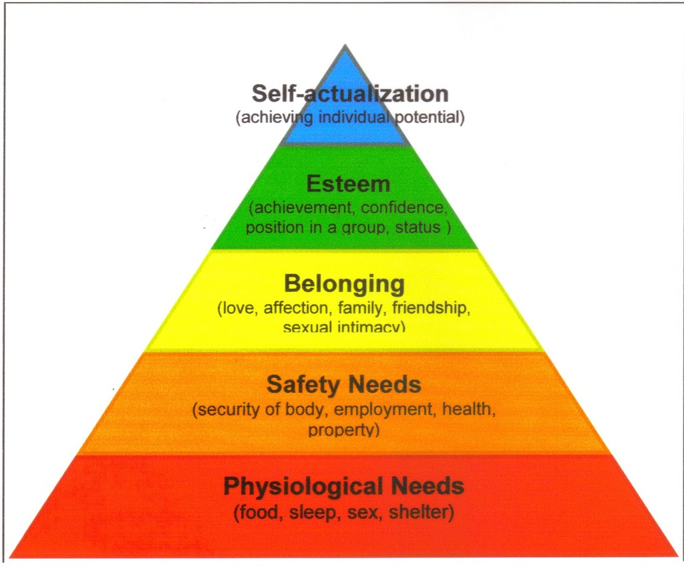
Source: https://rajivvij.com/2008/09/maslows-hierarchy-revisitedthe-eastern.html
Although no need is ever fully gratified, a substantially satisfied need no longer motivates. Thus as each becomes substantially satisfied, the next one becomes dominant. So if you want to motivate someone, according to Maslow, you need to understand what level of the hierarchy that person is currently on and focus on satisfying needs at or above that level, moving up the steps in.
Implications of Maslow’s Hierarchy of Needs Theory
This model helps the managers to understand and deal with issues of employee motivation at the workplace. This model can be applied to motivate people at all levels in the organization. Managers who understand the need patterns of their staff can help the employees to engage in the kinds of work activities and provide the types of work environment that will satisfy their needs at work. For instance, the employees love and belonging needs can be fully satisfied by organizing yearly dinner and dance program, office week end parties, creating recreation clubs or social clubs etc. Fortunately, the workplace has the potential to offer need gratification for several different types of needs, and mangers can motivate employees by giving appropriate organizational support which will gratify individual’s needs. Thus, despite its drawbacks, Maslow’s theory offers managers a good technique on understanding the motives or needs of individuals and how to motivate organizational members.
2. Herzberg’s Two-Factor Theory of Motivation
Herzberg’s Two-Factor Theory is also called motivation-hygiene theory.
A theory that relates intrinsic factors to job satisfaction and associates extrinsic factors with dissatisfaction
Hygiene factors: Factors such as company policy and administration, supervision, and salary that, when adequate in a job, placate workers.
Herzberg argued that improvement in the hygiene factors would only minimize dissatisfaction but not increase satisfaction and motivation
Motivating Factors
The presence of motivating factors always ensures job satisfaction and happiness among the employees. They are: achievement, recognition, responsibility, advancement, growth and the work itself. These motivating factors are relating to the work content factors.
Implications for Managers
In Herzberg’s framework, these managerial reactions have focused primarily on the hygiene factors surrounding the job, which has resulted in bringing individual to the theoretical “zero point” of motivation. The two-factor theory would predict that improvements in motivation would only appear when managerial action focused not only the factors surrounding the job but on the inherent in most assembly line jobs and developing jobs that can provide increased levels of challenge and opportunities for a sense of achievement, advancement, growth and personal development

3. ERG THEORY:
ERG Theory:
Alderfer proposed a modified version of Maslow’s need hierarchy and labeled as ERG theory.
Alderfer’s ERG refers to three groups of core needs – Existence, Relatedness and Growth (ERG).
Existence Needs:
These needs are various forms of physiological needs, such as hunger, thirst and shelter. In organizational settings, the need for pay, benefits, and physical working conditions are included in this category. This category is comparable to Maslow’s physiological and certain safety needs.
Relatedness Needs:
These needs include interpersonal relationships with others in the workplace. This type of needs in individuals depends on the process of sharing and mutuality of feelings between others to attain satisfaction. This category is similar to Maslow’s safety, social and certain ego-esteem needs.
Growth Needs:
These needs involve a person’s efforts toward personal growth on the job.
Satisfaction of growth needs results from an individual engaging in tasks that not only require the person’s full use of his or her capabilities, but also may require the development of new capabilities. Maslow’s self-actualization and certain of his ego esteem needs are comparable to those growth needs.
Implications of ERG Theory:
Alderfer has proposed two sets of views on individual’s aspirations and fulfillment. One is satisfaction-progression and other frustration-regression. Satisfaction-progression is similar to Maslow’s model in which once an individual’s basic needs are satisfied, he/she will progress to the next level to satisfy the succeeding higher level to have them satisfied.
Alderfer proposed yet another view of individual’s aspirations and fulfillment. If people eventually become frustrated in trying to satisfy their needs at one level, their next lower level needs will re-emerge and they will regress to the lower level to satisfy more basic needs. This is called as frustration-regression. For manages, ERG theory provides a more workable approach to motivation in organization. Because of the frustration-regression approach component, it provides the manager with the opportunity of directing employee behavior in a constructive manner even though higher order needs are temporarily frustrated. In summary, ERG theory argues that satisfied lower-order needs lead to the desire to satisfy higher-order needs; but multiple needs can be operating as motivators at the same time and frustration in attempting to satisfy a higher-level need can result in regression to a lower level need.
ERG theory has received better research support than Maslow’s need hierarchy mainly because human need cluster more neatly around the three categories proposed by Alderfer than the five categories in Maslow’s hierarchy. The combined process of satisfaction progression & frustration regression also provide a more complete explanation of why employee needs change over time. However, scholars increasingly doubt that human beings inherently have the same needs hierarchy. Instead, some argue that people prioritize their needs around their personal values. Other suggest that people change their needs priority as they alter their personal and social identity. Specifically employees tend to be driven by growth needs when they see themselves as unique and by relatedness needs when they define themselves in terms of their group memberships.
4. Porter – Lawler Model of Motivation- They proposes a multivariate model to explain the complex relations that exists between job attitudes & job performance. Their model encounters some of the simplistic traditional assumptions made about the positive relationship between satisfaction & performance. The various elements of this model are –
1. Effort – Effort refers to the amount of energy exerted by an employee on a given task. Perceived reward probability refers to the individual’s perception of the probability that differential rewards depend upon differential amount of efforts. These two factors value of reward and perception of effort reward probability – determine the amount of effort that the employee will put in.
2. Performance – Performance is determined by the amount of effort and the ability and role perception of the individual. Thus, if an individual has little ability and inaccurate role perception his performance may be ineffective in spite of his putting in great efforts.

3. Rewards – Performance is seen as leading to intrinsic rewards (such as sense of accomplishment and actualization) and extrinsic rewards (such as working conditions and status). However, the intrinsic rewards are much more likely to produce attitudes about satisfaction that are related to performance. In addition, the perceived equitable rewards vitally affect the performance satisfaction relationship.
4. Satisfaction – Satisfaction derived from the extent to which actual reward fall short, meet or exceed the individual’s perceived level of equitable rewards. If it exceeds, the individual will feel satisfied if less than equitable rewards, he will be dissatisfied.
Thus, this provides two implications – (1) satisfaction is only in part determined by actual rewards. (2) Satisfaction is more dependent on performance than performance is an satisfaction.
Implication of the theory – Porter & Lawler point out those variables presumed to affect performance turned out to show relations to performance and those variables presumed to result from performance also typically were related to performance. The model suggests that managers should carefully assess their reward structures & that through careful planning & clear definition of role requirements, the effort-performance – reward – satisfaction system should be integrated into an entire system of managing.
5. Equity theory – This theory was propounded by J.S. Adams. It is based on the assumption that members of an organisation experience strong expectations of justice, balance and fairness in treatment by the organisation. When a person feels that he is being treated unfairly by the organisation, these feelings can have a variety of adverse effects on the person’s motivation and performance on the job. The equity theory of motivation helps in understanding both the causes & the consequences of feelings of inequitable treatment among organisation members.
According to equity theory, two variables are important, i.e. inputs & outcomes. Inputs are the efforts & skills which a member of an organisation perceives that he puts into his job. Outcomes are the rewards which the member receives from the organisation& his job. Inputs & outcomes are important elements in the exchange relationship between the organisation& its members. When the individual finds equity in the situation or feels that he receives from the organisation in terms of treatment & compensation is fair in terms of the effort & skills he contributes to the organisations he is satisfied with the arrangement and is normally committed to the organisation and its goals.
Four terms are important in the theory.
1. Person – The individual for whom equity or inequity exists.
2. Comparison other – Any group or individual used by a person as a referent regarding inputs & outcomes.
3. Input – Characteristics which individuals brings with them to the job: education, skills, experience, and the like.
4. Outcomes – Pay promotion & fringe benefits received from a job.
The theory proposes that the motivation to act develops after the person compares inputs/outcomes with the identical ratio of the relevant other. Inequity is defined as the perception that person’s job input/outcomes ratio is not equal to the inputs/outcomes ratio of the comparison other.
The basic equity proposal assumes that upon feeling inequity, the person is motivated to reduce it. Further the greater the felt inequity, the greater the motivation to reduce it. When attempting to reduce inequity, the person may try a number of alternatives, some of which are
1. Altering his or her inputs.
2. Altering his or her outcomes.
3. Distorting his or her inputs & outcomes cognitively.
4. Leaving the field.
5. Trying to alter or cognitively distort input & outcomes of the comparison other, or force him or her to leave the field.
6. McClelland’s theory of needs
McClelland’s theory of needs was developed by David McClellard& his associates the theory focuses on three needs, defined as follows:

- Need for Achievement (n Ach) is the drive to excel, to achieve in relation to a set of standards, to strive to succeed.
- Need for Power (n Pow) is the need to make others behave in a way in which they would not have behaved otherwise.
- Need for affiliation (in Aff) is the desire for friendly & close interpersonal relationships.
He contended that individuals acquire these needs from the culture of a society by learning from the events that they experience, particularly in early life. Once learned, these needs may be regarded as personal predispositions that affect the way people perceive work (and others) situations and that influence their pursuit of certain goals.
Critical Appraisal: This theory has significant implication for managers. If the management can identify the need, it can motivate the people by imparting, training, improving its selection & placement procedure & few organizations have been willing to invest time & resources in measuring McClelland’s concept. The model has the following limitations:
- High achievement seekers expect similar results from other & cannot be effective managers.
- The use of protective techniques is objectionable.
- Achievement motivation training is time consuming the various needs do not motivate workers.
7. GOAL SETTING THEORY:- BY EDWIN LOCKE
Goal-setting theory focuses on the process of setting the goals themselves.
The natural human inclination to set and strive for goals is useful only if the individual both understands and accepts a particular goal. Further more workers will not be motivated if they know they do not possess the skills required to achieve the goal.
According to the goal setting theory, individuals are motivated when they behave in ways that move them to certain clear goals that they accept and can expect to attain. So goal setting theory joins expectancy theory and reinforcement theory as difference ways to explain why people behave the way they do.

The goal setting theory can be described in four phases.
- Establishment of a standard to be achieved
- Evaluation of whether the standard can be achieved.
- Evaluation of whether the standard matches personal goals.
- The standard is accepted, the goal is thereby set and behavior proceeds towards the goal.

10.5 Challenges of motivation in organizations and How to overcome them
Poor Leadership Structure
When no one appears to be in charge, or worse, everyone thinks they're in charge, it can be hard to perform at peak levels. A lack of hierarchy or direct reporting structure leads to confusion, resentment and an overall lack of direction. Employees are demotivated because their objectives are unclear, and therefore, difficult to work toward. Here are some issues that contribute to this employee motivation problem:
- Unclear or nonexistent job descriptions.
- No clear chain of command.
- Disorganized directives.
- Hazy goals and objectives.
The employee motivation problem can be solved by writing detailed job descriptions, creating an internal organizational chart and setting clear organizational goals, both individually and by the department.
Lack of Challenging Work
Employees who are bored are typically unmotivated. They may not take an interest in tasks they consider mundane or may perform poorly at the work they do attempt. Some reasons for this motivational problem include:
-Inappropriate hires.
- Not taking advantage of an employee's skill set.
- Lack of professional development opportunities.
-Failure to promote from within.
This issue can be addressed on several fronts, including the interviewing stage, when you should strive to ensure the person you hire is a good match for the job. Once someone is in their position, provide proper training and the tools the individual needs to do their job effectively. If they appear to master tasks quickly or don't show an interest, consider cross-training, mentoring, job-shadowing or even a different position that better utilizes their talents.
Workplace Conflict
When employees are at odds with one another, or with management, it's not only demotivating, it's also unproductive and could lead to a toxic work environment. Signs of workplace conflict include:
-Bickering and open disagreement.
-Open sabotage of the work product.
-Gossip and clique formation.
-Constant complaints to human resources.
Resolve workplace conflict by setting clear directives about the types of behavior that will not be tolerated, and taking action accordingly. Address conflict as it arises and set in place a mediation approach to ensure employees have the ability to work out their differences in a professional setting.
Lack of Confidence in the Company
If employees don't feel the company is "going anywhere," or perceive the business is mismanaged to the point of potential job loss, this feeling of insecurity can manifest as poor motivation. Signs of this lack of confidence may be demonstrated in the following ways:
- Disinterest in long-term projects.
- Unwillingness to cross-train or develop professionally.
-High turnover as people search for new jobs.
-Poor quality of the work product.
This issue can be addressed by sharing corporate objectives with staffers. Develop a strategic long-term business plan and solicit employee feedback. Demonstrate how their roles will be augmented with teamwork and growth to get buy-in about the company's future. If gossip develops about closure, mergers or other altering factors, communicate sooner rather than later so staffers feel you are being upfront about the company's future.
No One-on-One Attention
Regardless of the company's size, employees need regular feedback to be motivated to do their jobs properly, and well. Some things that might make a staffer feel left out in the cold include:
- No regular performance evaluations.
- Irregular one-on-one management meetings.
- Lack of personal goal-setting.
-The absence of regular feedback.
Resolve this potential motivation issue by regularly scheduling brief private appointments with staffers to touch base on both work and professional development issues. Hold regular employee performance reviews, annually or bi-annually, and in these discussions, set specific goals and objectives.
Employee motivation is directly tied to productivity and operational success. If you are concerned about whether your staffers are motivated, invite them to share their feelings on the subject via a focus group, employee committee or survey. You will generate a lot of feedback you can use to your advantage, as well as reassure employees their input is valued.

