Study unit 4: Occupational Health

Introduction
Organizations are concerned about employees’ health and safety while they are at work. Employee health and safety boosts employees’ morale and loyalty. Managers realize that a healthy employee is a productive one.
Employee health refers to the physical, social and psychological wellbeing of employees.
Safety refers to activities undertaken to safeguard employees from dangerous work practices that may be faced at work. Therefore, safe practices can lead to a state of health among employees.
Security refers to activities undertaken to ensure that employees are protected at the work place.

Learning Outcomes of Study Unit 4
By the end of this lesson, you should be able to:
4.1 Identify the occupational health conditions at work place
4.2 Explain the concept of Occupational hygiene
4.3 Identify hazards at the workplace

4.1 identify the occupational health conditions at work place
Employee Health
Employee health can be understood by examining conditions of the work in the organization. Conditions of work can be categorized as; physical, chemical, biological, temporal and psychological.
1. Physical conditions
The physical working environment includes location and design of the building, parking features, amount of light and noise coming into the work place.

a. The design and size of the office
The design and size of the office(s) affects employees’ job satisfaction and productivity. For example the layout of offices can affect the behavior of managers who rely on spontaneous meetings with other managers as a way of obtaining information or solving problems.
b. Noise
Noise in the work environment makes employees irritable and nervous. It interferes with sleep and produces physiological defects like deafness. Certain loudness levels can be threatening to hearing. Hearing loss is a recognized job hazard for workers like airport personnel. People who work in extremely noisy environments are aggressive, destructive and irritable compared to those who work in quieter environments.
c. Illumination
Continued exposure to inadequate light while reading or performing detailed operations can be harmful to one’s sight. Research shows that inadequate lighting is a source of stress and constant exposure to dim light can have a negative impact on job performance. A suitable arrangement for light is to uniformly be distributed throughout the entire work area.
d. Temperature and Humidity
Some people are happier and more hardworking in cold weather whereas others prefer hot weather. Studies have shown that uncomfortable temperature and humidity levels can influence the quality and quantity of work performed. Production can slow down under extremely hot conditions.
e. Colour
In industry, colour can provide a pleasant working environment and can aid with safety e.g. colour can be used in factories as a coding device that is fire equipment can be yellow while danger areas can be red. This allows for such equipment's and areas to be quickly identified.
2. Biological conditions
Biological agents that may be found in the working environment include bacteria, parasites, viruses and other parasites. These may thrive in the working environment if the conditions prevailing in that environment are conducive for their survival. Some workers may be exposed to certain diseases through foods taken at the place of work.
3. Chemical conditions
In many organizations, workers handle potentially dangerous, toxic substances in the course of doing their work i.e. the degree of risk of handling any substance will normally depend on the magnitude of the exposure to that substance.
4. Temporal conditions
These can be described in terms of hours of work and rest pauses.
a. Hours of work
The number of hours worked daily or weekly and the amount of rest allowed during working hours are potential sources of improved satisfaction and productivity of employees. Studies have demonstrated that the longer the workday, the lower the actual production per hour. Employees adjust longer hours by working at a slower rate.
Work schedules that can be adopted by managers;
- The four day work week
One way to alter the workload significantly is to reduce it to only four days. This usually involves 4 days at 10 hours a day. Reports from companies that have adopted a 4 day workweek have indicated improved job satisfaction, productivity as well as reduced absenteeism.
- Flexible working hours
A more radical change in work scheduling is to let employees decide for themselves when they will be available for work on a particular day. Industrial psychologists have found out that workers may not change their habits so much under flex-time. However, employees feel that having choices of when to arrive and leave enhances their sense of personal freedom.
- Flex time can also be described in terms of shift work. Shift work is also a temporal condition that affects many employees in terms of work period i.e. day and night. Many companies are in operation more than 8 hours a day (some operate around the clock e.g. petrol companies, hospitals, mass media firms, police, fire fighting departments).

b. Rest pauses
The most urgent reason for companies to provide rest pauses or breaks is that employees take rests whether or not they are offered. When breaks are authorized, unauthorized breaks decline although they do not disappear altogether like tardiness. The potential benefits of formal rest pauses include increased morale, reduced fatigue and boredom, improved attitudes of workers towards the employer. When a rest program is introduced, workers may feel that it is an expression that management has concern for employees.
5. Psychological conditions
These include factors that relate to the nature of the job itself and the impact it has on the workers’ performance. Jobs designed to be simple that they make no demands on the workers’ intelligence or need for achievement result in boredom, monotony, fatigue and less efficient production. Employees holding such jobs normally report a higher level of anxiety and irritability.
Simplified and repetitive jobs or work can lead to a deterioration of the mental function e.g. such workers are prone to absent mindedness and forgetfulness. In assembly line work, personal value and meaningfulness of work are destroyed.

4.2 The concept of Occupational hygiene
Occupational hygiene is the anticipation, recognition, evaluation, control, and confirmation of protection from hazards at work that may result in injury, illness, or affect the wellbeing of workers. These hazards or stressors are typically divided into the categories biological, chemical, physical, ergonomic and psychosocial. The risk of a health effect from a given stressor is a function of the hazard multiplied by the exposure to the individual or group.
Occupational hygiene is both an aspect of preventive medicine and in particular occupational medicine, in that its goal is to prevent industrial disease, using the science of risk management, exposure assessment and industrial safety.

Box 4.1: Industrial Hygiene

Occupational hygiene is about the prevention of ill-health from work, through recognizing, evaluating and controlling the risks.

The industrial hygienists use various environmental monitoring and analytical methods to establish how workers are exposed. In turn, they employ techniques such as engineering and work practice controls to control any potential health hazards. Anticipation involves identifying potential hazards in the workplace before they are introduced. The uncertainty of health hazards ranges from reasonable expectations to mere speculations. However, it implies that the industrial hygienist must understand the nature of changes in the processes, products, environments, and workforces of the workplaces and how they can affect workers' well-being. Recognition of engineering, work practice, and administrative controls are the primary means of reducing the workers` exposure to occupational hazards. Timely recognition of hazards minimizes the workers' exposure to the hazards by removing or reducing the hazard's source or isolating the workers from the hazards. Evaluation of a worksite is a significant step that helps the industrial hygienists establish jobs and worksites that are a potential source of problems. During the evaluation, the industrial hygienist measures and identifies the problem tasks, exposures, and tasks.
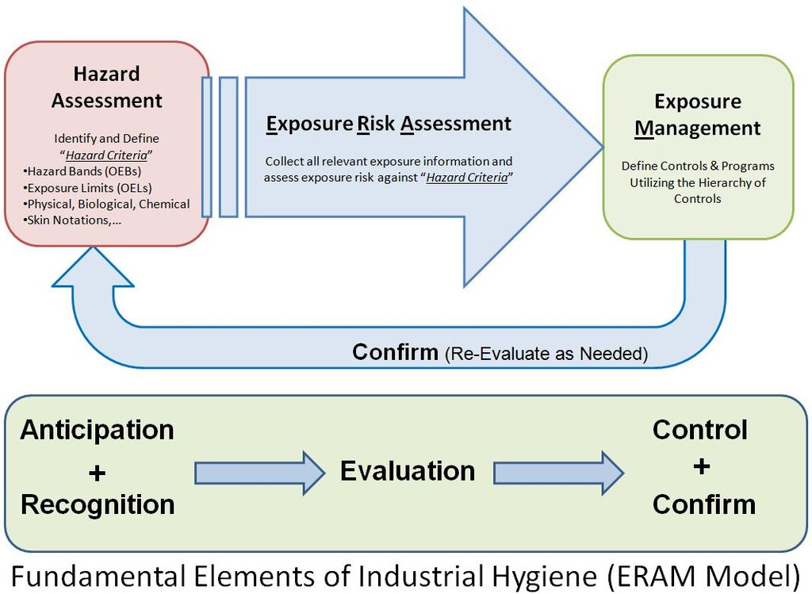
Source: https://en.wikipedia.org/wiki/Occupational_hygiene#/media/File:Exposure_Risk_Assessment_and_Management

4.3 Hazard Recognition and Assessment
There are an unlimited number of hazards that can be found in almost any workplace. There are obvious unsafe working conditions, such as unguarded machinery, slippery floors or inadequate fire precautions, but there are also a number of categories of insidious hazards (that is, those hazards that are dangerous but which may not be obvious)
Workers do not create hazards - in many cases the hazards are built into the workplace. The trade union position on occupational health and safety is to ensure that work is made safer by modifying the workplace and any unsafe work processes. This means that the solution is to remove the hazards, not to try to get workers to adapt to unsafe conditions. Requiring workers to wear protective clothing which may not be suited or designed for the climate of your region is an example of forcing workers to try to adapt themselves to unsafe conditions, which is also shifting the responsibility from management to the worker.
Box 4.2: Hazard

A hazard is any agent that can cause harm or damage to life, health, property or the environment.

4.3.1 Types of Hazards

i) Physical Hazards
This is the most common type of workplace hazards. Examples of physical hazards include slips, trips, falls, and exposure to loud noises, working from heights, vibrations, and unguarded machinery.
ii) Ergonomic Hazards
Every occupation places certain strains on a worker’s body. Ergonomic hazards occur as a result of physical factors that can harm the musculoskeletal system. This type of hazard is not easily identified; examples of this hazard are poor lighting, repetitive motion, awkward movements, and poor posture.
iii) Chemical Hazards
Chemical hazards are present anytime workers are exposed chemical substances. Examples include cleaning solutions and solvents, vapors and fumes, carbon monoxide and any other gases.
iv) Biological Hazards
Healthcare professionals are at most risk for this type of hazard. A biological hazard occurs due to working with people, animals or infectious plant material. Examples include blood or other bodily fluids, animal care, insect bites, bacteria or viruses.

v) Psychosocial hazard
Psychological or Psychosocial hazards are hazards that affect the psychological well-being of people, including their ability to participate in a work environment among other people. Psychosocial hazards are related to the way work is designed, organized and managed, as well as the economic and social contexts of work and are associated with psychiatric, psychological and/or physical injury or illness.
vi) Natural hazards
Natural hazards such as earthquakes, floods, volcanoes and tsunami have threatened people, society, the natural environment, and the built environment, particularly more vulnerable people, throughout history, and in some cases, on a day-to-day basis.
The biggest threat to worker health and safety is their work environment. Please take necessary precautions to protect yourself and your employees by maintaining a safe work environment.
ITQ
Identify hazards in the workplace based on the sample provided

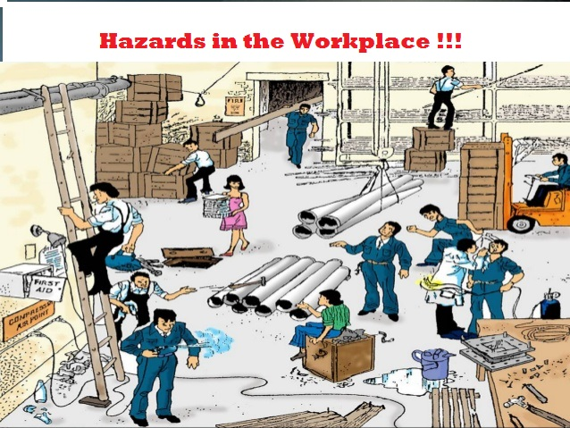
Source: https://safetyhelpline.wordpress.com/2015/07/27/safety-toolbox-talk-hazards-in-the-workplace

4.3.2 Looking For Occupational Hazards:
Health specialists, experts and managers suggested areas and activities where risks are very high and accidents too.
These are:-
- Receipt of raw materials like lifting, carrying;
- Stock taking and storage e.g. falling materials;
- Movement of people and material, e.g. falls, collisions;
- Processing of raw materials, e.g. exposure to toxic substances;
- Maintenance of plant and machinery e.g. lifting tackle, installation of equipment;
- Maintenance of building, e.g. roof work, gutter cleaning;
- Using electricity, e.g. using hand tools, extension leads.
- Operating machines e.g. operating without sufficient clearance, unsafe speed or not using safety devices.
- Failure to wear protective gears like hats, clothing, boots, gloves
- Distribution of finished goods like cars, machines.
- Dealing with emergencies like spillages, fires, explosions
- Health hazards from the use of equipment or working methods like repetitive strain injuries from poorly designed work station or working practices

4.3.3 Ranking of hazards:
Hazards should be ranked according to their potential severity as a basis of producing one side of the equation. Thus a three point scale can be used as low, moderate and high. More complex severity rating scale was put forward by Holds and Andrews (1993) as follows;
- Catastrophic; high danger exists; hazards are capable of causing death and illness on a wide scale.
- Critical; hazards which can lead into serious illness, severe injury, property and equipment damage.
- Marginal; can cause injury, property damage.
- Negligible; hazards that will not result in a serious injury, illness or possibility of minor first aid.

