Two Variable Regression Analysis Trial Question (Submit on 13th Sept 2021)
The data in Table below reports the aggregate consumption (Y, in billions of U.S. dollars) and disposable income (X, also in billions of U.S. dollars) for Uganda economy for the 12 years from 1988 to 1999.

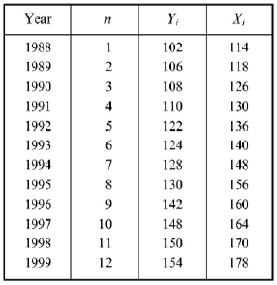
- Draw a scatter diagram for the data and determine by inspection if there exists an approximate linear relationship between Y and X.
- State the general relationship between consumption Y and disposable income X in (a) exact linear form and (b) stochastic form. (c) Why would you expect most observed values of Y not to fall exactly on a straight line?
- State the assumptions of the classical regression model (OLS) and give an intuitive explanation of the meaning and need for each of them.
- Starting from equation below, calling for the minimization of the sum of the squared deviations or residuals, derive (a) normal equations, (b) formulas for ${\hat{b}}_{0}$ and ${\hat{b}}_{1}$
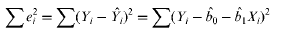
- Find the regression equation or model for the consumption schedule in Table above to find ${\hat{b}}_{0}$ and ${\hat{b}}_{1}$. Plot the regression line and show the deviations of each $Y_{i}$ from the corresponding ${\hat{Y}}_{i}$.
- State the null and alternative hypotheses to test the statistical significance of the parameters of the regression equation estimated.
- Test at the 5% level of significance for (a) $b_{0}$ and (b) $b_{1}$
- Construct the 95% confidence interval for (a) $b_{0}$ and (b) $b_{1}$
- Derive the formula for $R^{2}$
- (a) What does the correlation coefficient measure? (b) What is its range of values?
- Find r for the estimated consumption regression

Write, scan, create a pdf and send to e.mwebesa@muni.ac.ug
If you know how to type this, please do

